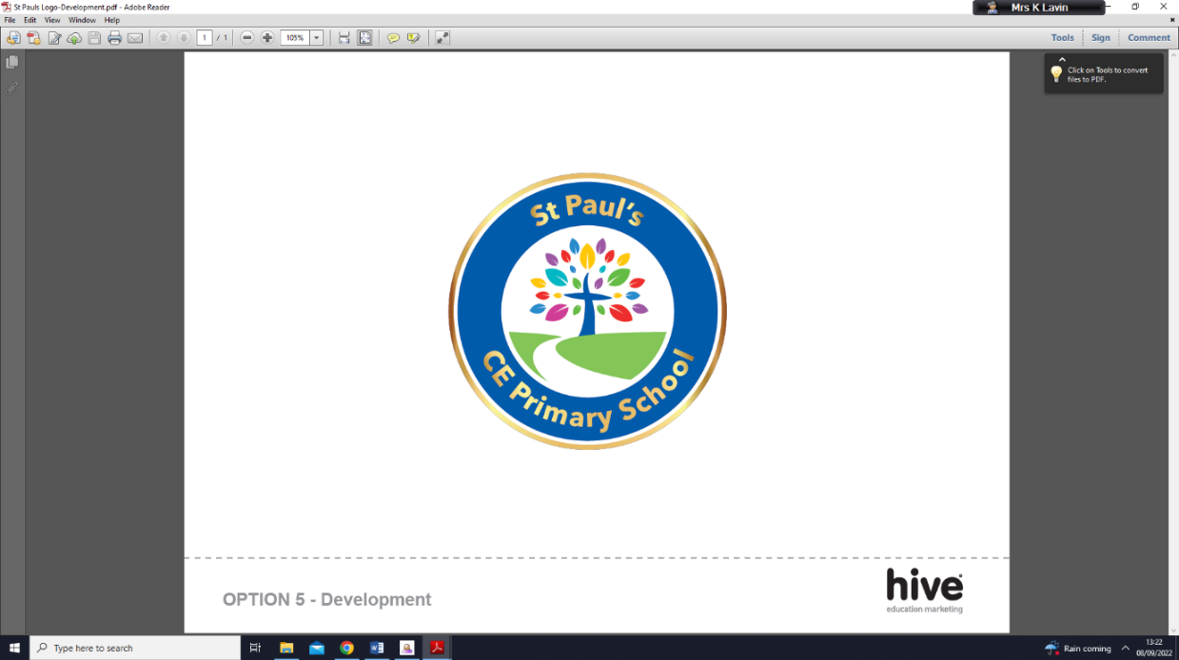     |  | Executive Headteacher: Mrs J. Tyers  Deputy Headteacher: Mrs K Lavin  ST. PAULS C.E. PRIMARY SCHOOL  Nevile Road,  Kersal, Salford,  M7 3PT  Telephone: 0161 921 2065  Date: 2/9/25
Dear Parents and Guardians,

Year 3 marks the end of Key Stage 1 as your child enters Key Stage 2. Now, children begin to develop increasing independence and also secure their knowledge, skills and understanding. All Year 3 children are expected to produce longer, more detailed pieces of work in every lesson. They will also start to take more responsibility for improving their own work, correcting any mistakes.
Reading continues to be incredibly important for your child’s progress. We will read with your child once a week and they will bring an Oxford Reading Tree or library book home daily. Please read with your child at home using the books from the scheme and any other books that they enjoy. Make sure you sign the reading diary every time your child reads so they move up the balloons in our Reading Competition.
In English this term, we will be writing a narrative based on The Secret of Black Rock by Joe Todd-Stanton and an explanation based on a non-fiction piece How the Robot Dog Works. Handwriting is important across all lessons, in Year 3 all children have the opportunity to earn their pen licence.
In Maths this term we will be learning about place value up to 1000. We will be partitioning, representing, comparing and ordering numbers, counting in 50s and using number lines. We will then begin exploring Addition and Subtraction focusing on 1s, 10s and exchanging.
This term our Learning Means the World theme is ‘That’s all folks!’. It is based around the history and development of animation and cartoons. It primarily takes in elements of history, art and computing / ICT and starts with learning about the beginnings of animation, looking at zoetropes and ip books, before moving on to the dawn of the Disney age. Then, the process of animation is explored further, with an opportunity for pupils to exchange their own design ideas and create their own animated films.
Our PE lesson is every Thursday, so please make sure your child leaves their school PE kits in a bag in school. This consists of, black jogging bottoms/leggings/shorts, white t-shirt and the blue school jumper.
Please remember water bottles need to be brought in every day. Please also remember that the school gates open at 8:40-8:55am and finishes at 3.30pm prompt for Year 3.
If you have any questions or queries, please do not hesitate to contact me on Class Dojo.
Yours faithfully,
Mr Atkinson

