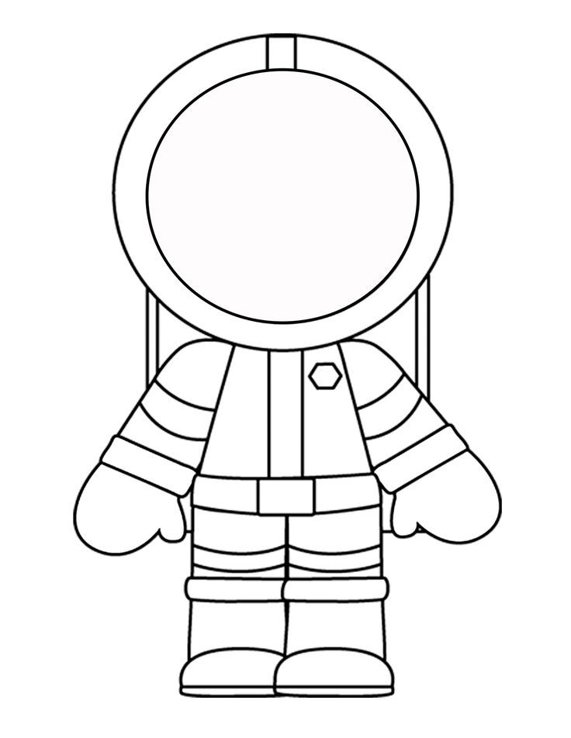
If I were an astronaut…
I would go to…..
_________________________________________________________________________________________________________________________________________________________________________________________________________________________________________
Equipment I would need _____________________________________________________________________________________________________________________________________________________________________________________________________
Astronauts are important because….
_____________________________________________________________________________________________________________________________________________________________________________________________________

