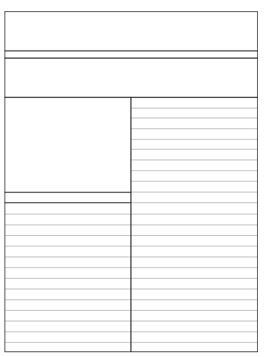
Caption
Image
Headline
St. Peter’s Post

