Wednesday 20th May 2020
English: Writing
Following on from VE Day and some of the very moving writing that you sent me, this week’s writing task explores what it must have been like to experience war firsthand. As we have seen, in today’s world where there are lots of War games and films that make war seem exciting, it is hard to imagine just how horrific it must have been to live through one.
I would like you to watch another clip from The Literacy Shed – make sure you watch right to the end of the animation and read what it says.
Google: The Literacy Shed

Then click: Home – The Literacy Shed
Scroll down the page until you see The War & Peace Shed:
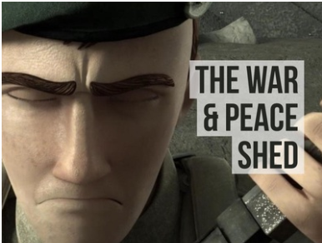
Click on: The War and Peace Shed.
Scroll down again until you get to a video called Germans in the Woods – it looks like this:
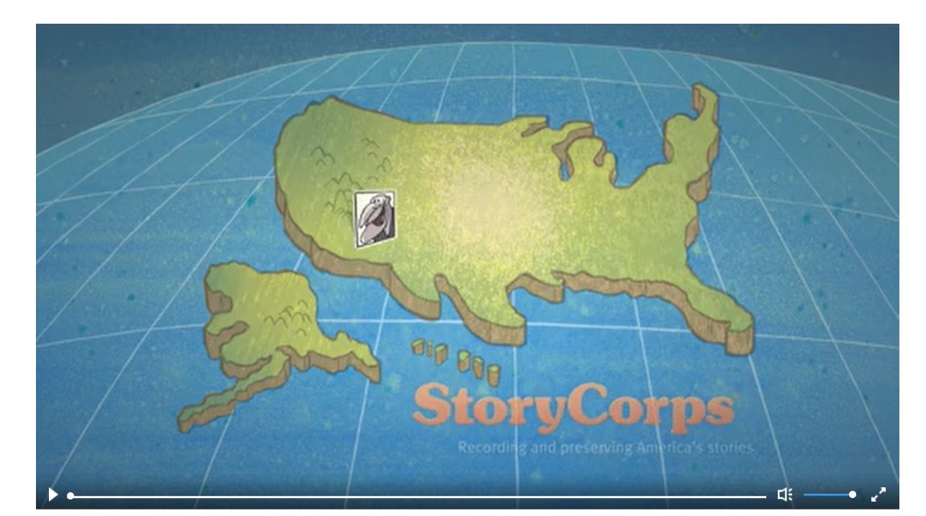
Watch the animation as a war veteran, Joseph Robertson, tells you his story.
This is what it says at the end of the clip….
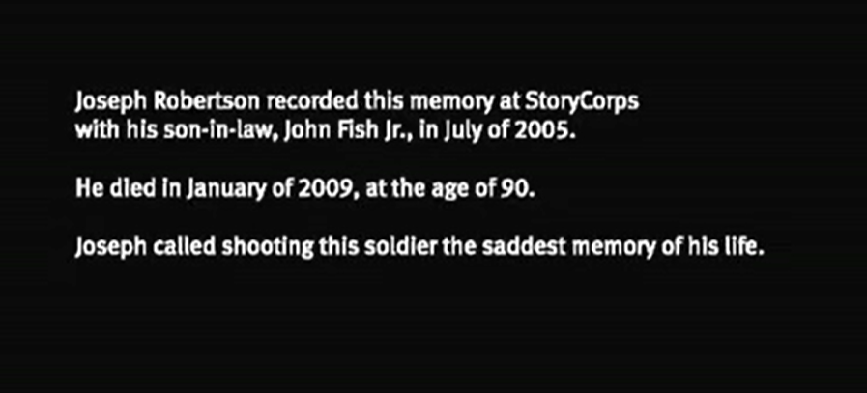

For your task today I want you to try and write this event from the perspective of the young German soldier. Imagine that he survived the shooting. What would his version of what happened sound like? Would he be bitter and angry at being shot by the American? Would he think that this was just part of war? If you don’t want to write it as a narrative, could you write it as a conversation – like an interview? Or maybe you have your own idea as to how you’d like to tackle this task?
Remember, you have the rest of the week to work on this then please send me your work!

