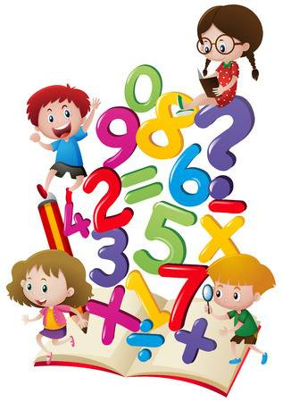
Year 2 Maths from Mrs.Ainsworth

21.4.20
4-a-day
- 82+??=101
- 62-31=
- 8 X 3 =
- 1/3 0f 21 =

We will revise some of our work on fractions this week.
Watch this video lesson week 2, lesson 5

(If you wish, and have time, you could also recap some of the previous lessons)

https://whiterosemaths.com/homelearning/year-2/

Print and complete the worksheet (or discuss with an adult and make notes)
Check your answers on the same website.
If you can, take a photo of Monday’s and Tuesday’s Maths work to tweet (@Y2Mrsa) or email (stpetersy2@sthelens.org.uk)

