Welcome to your New School…



Insert the school logo

St Peter’s
CE. Primary
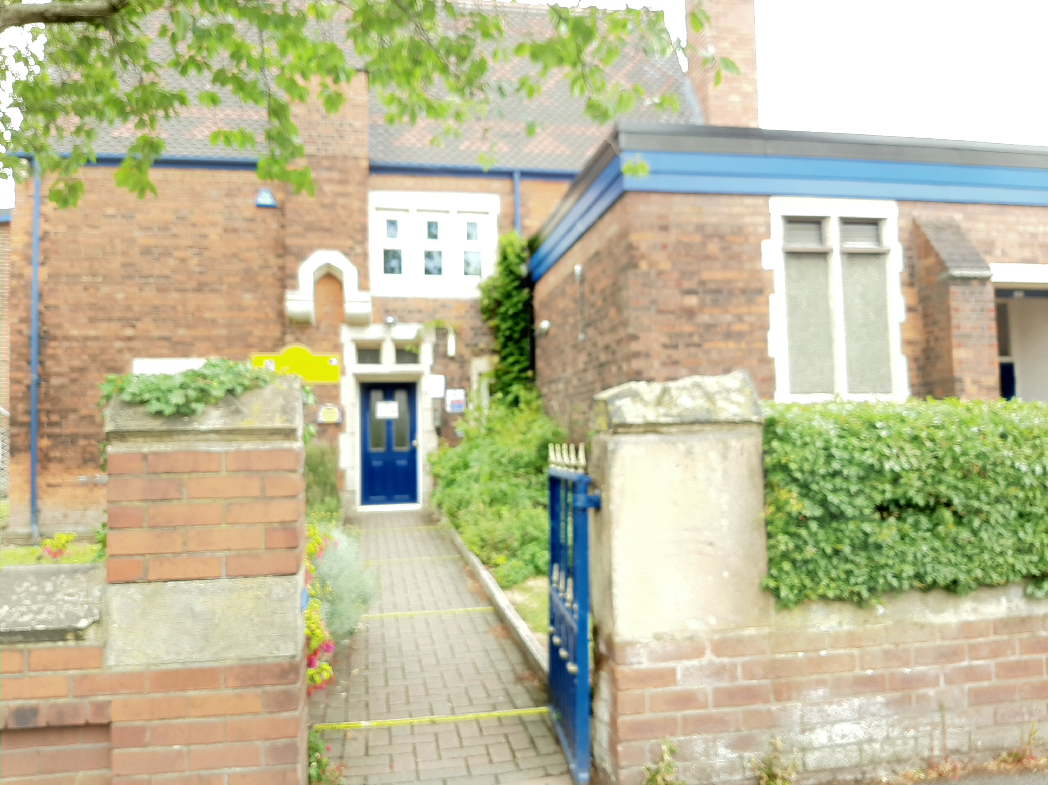

Insert external image of the school building

This is a transition story created just for you.
It will help you learn about your new school.
Please ask a grown up to share it with you and we look forward to seeing you in September.

Welcome to your Classroom…
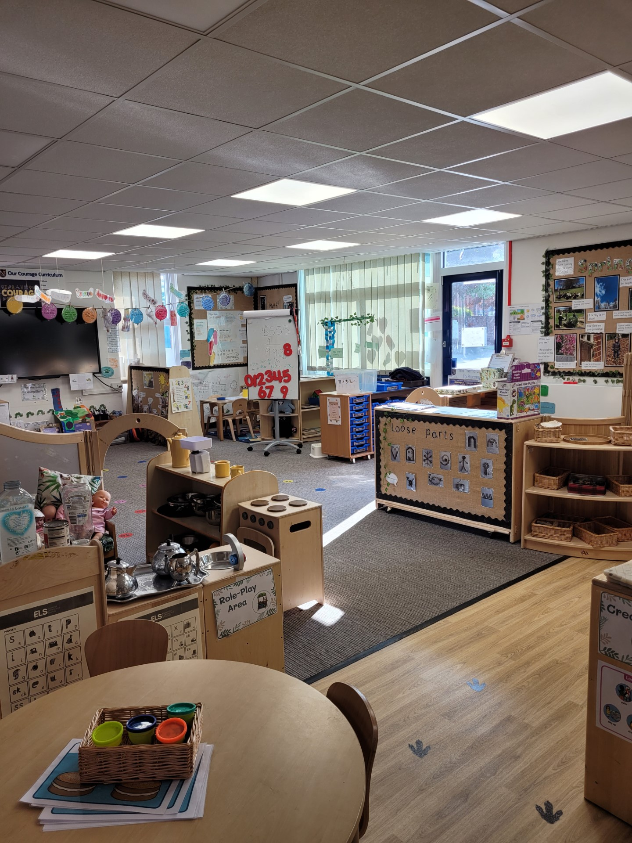

Insert image of the classroom

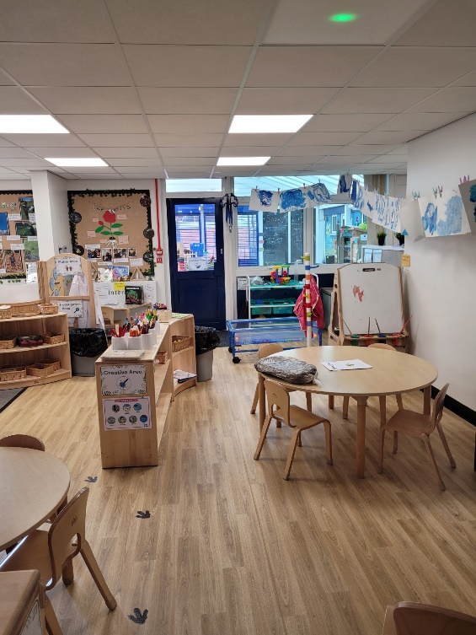
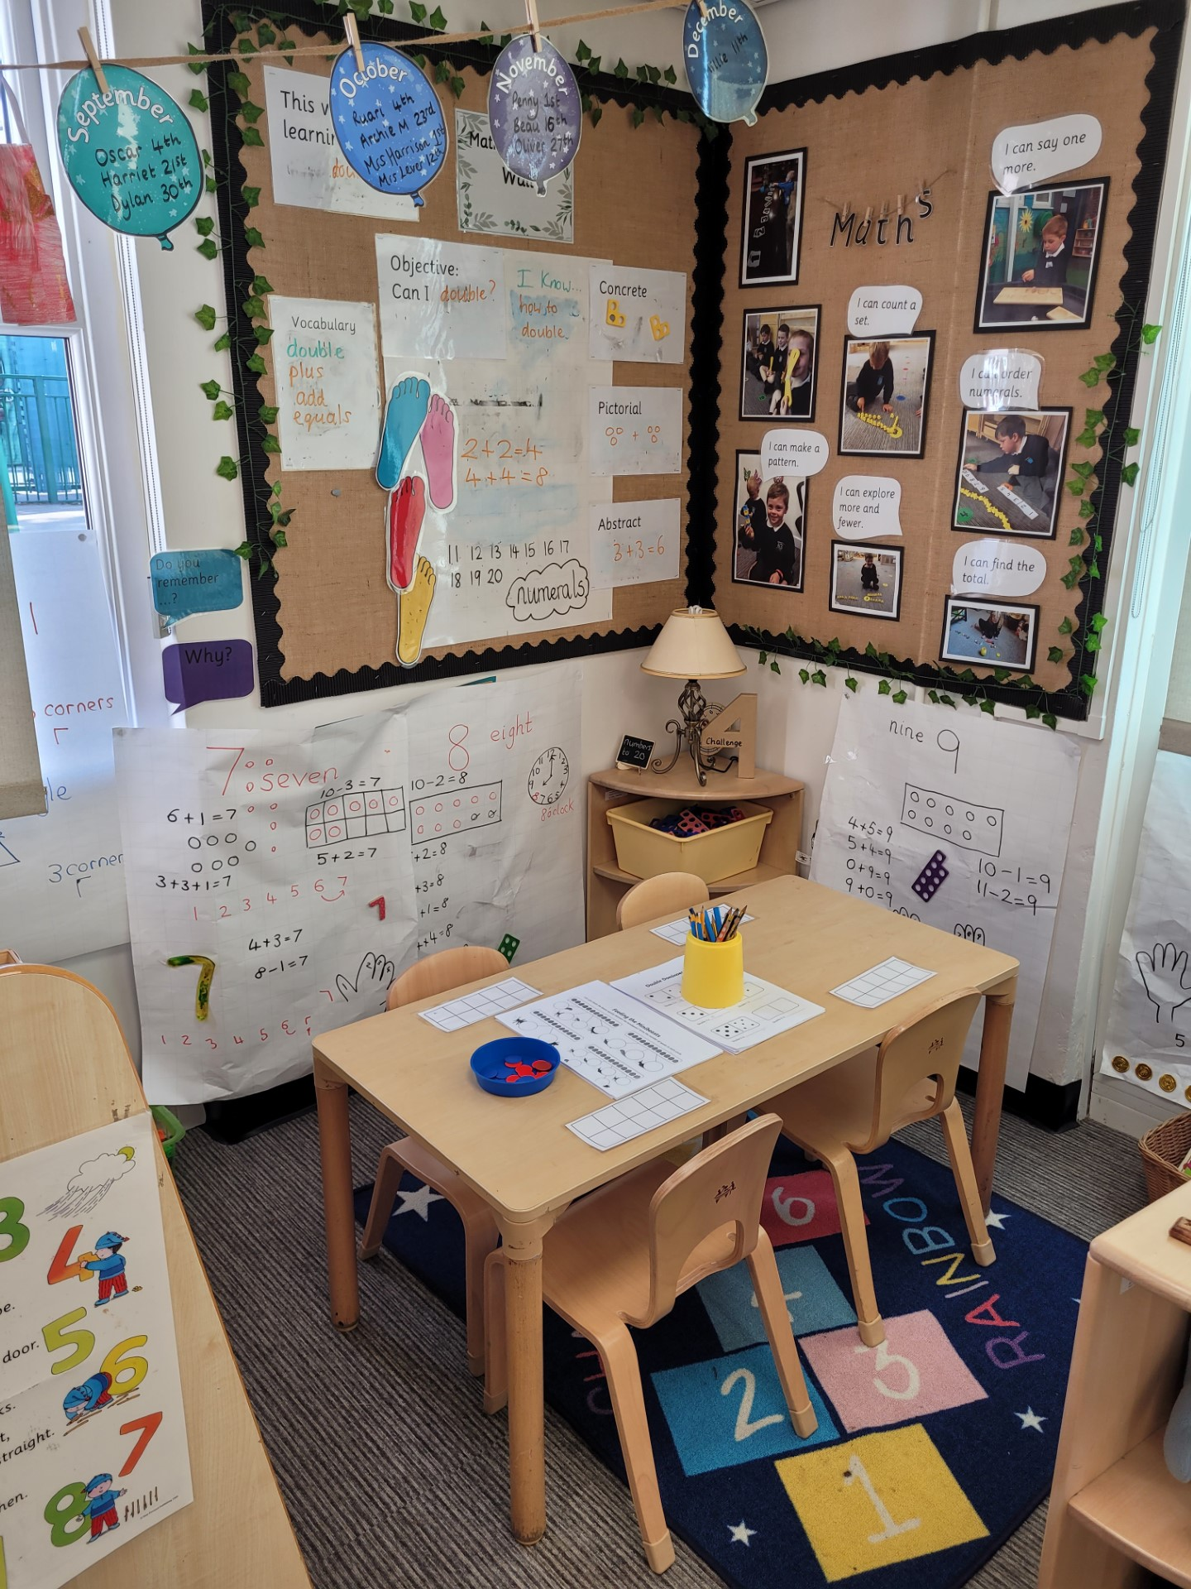

Insert image of the classroom

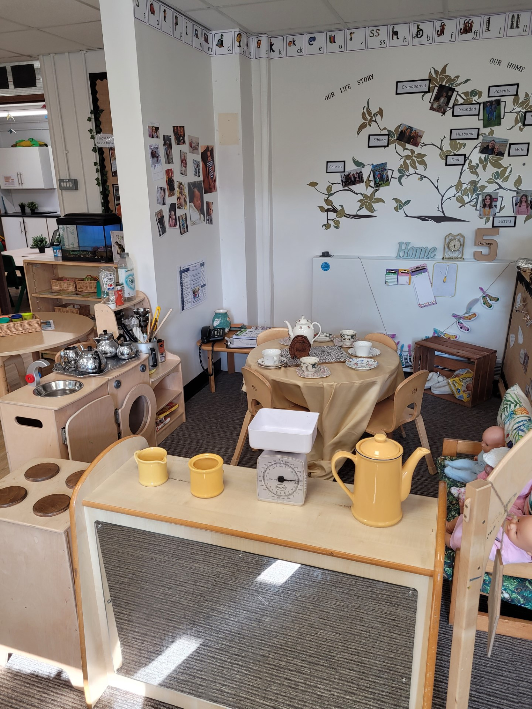

Insert image of the classroom

Insert image of the classroom

There are lots of different areas for you to explore and learn in. We have the outdoor classroom and the indoor classroom.

Welcome to your Outdoor Classroom…
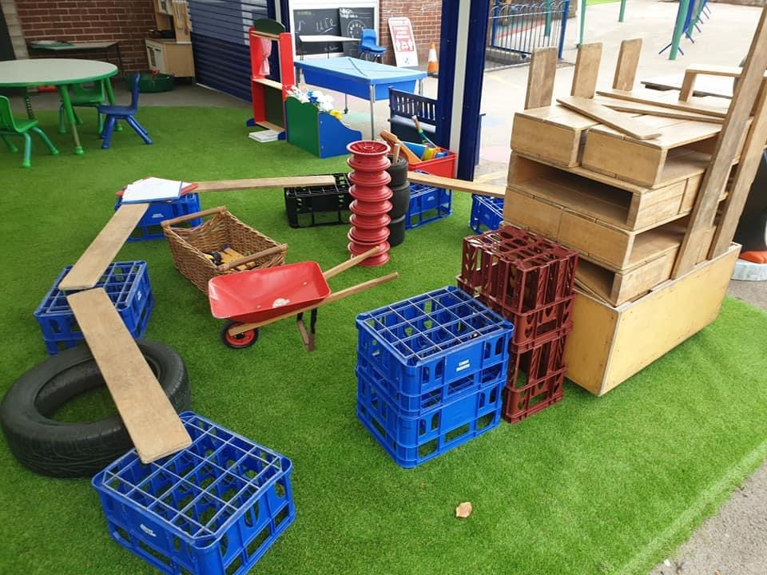

Insert image of the outdoor area

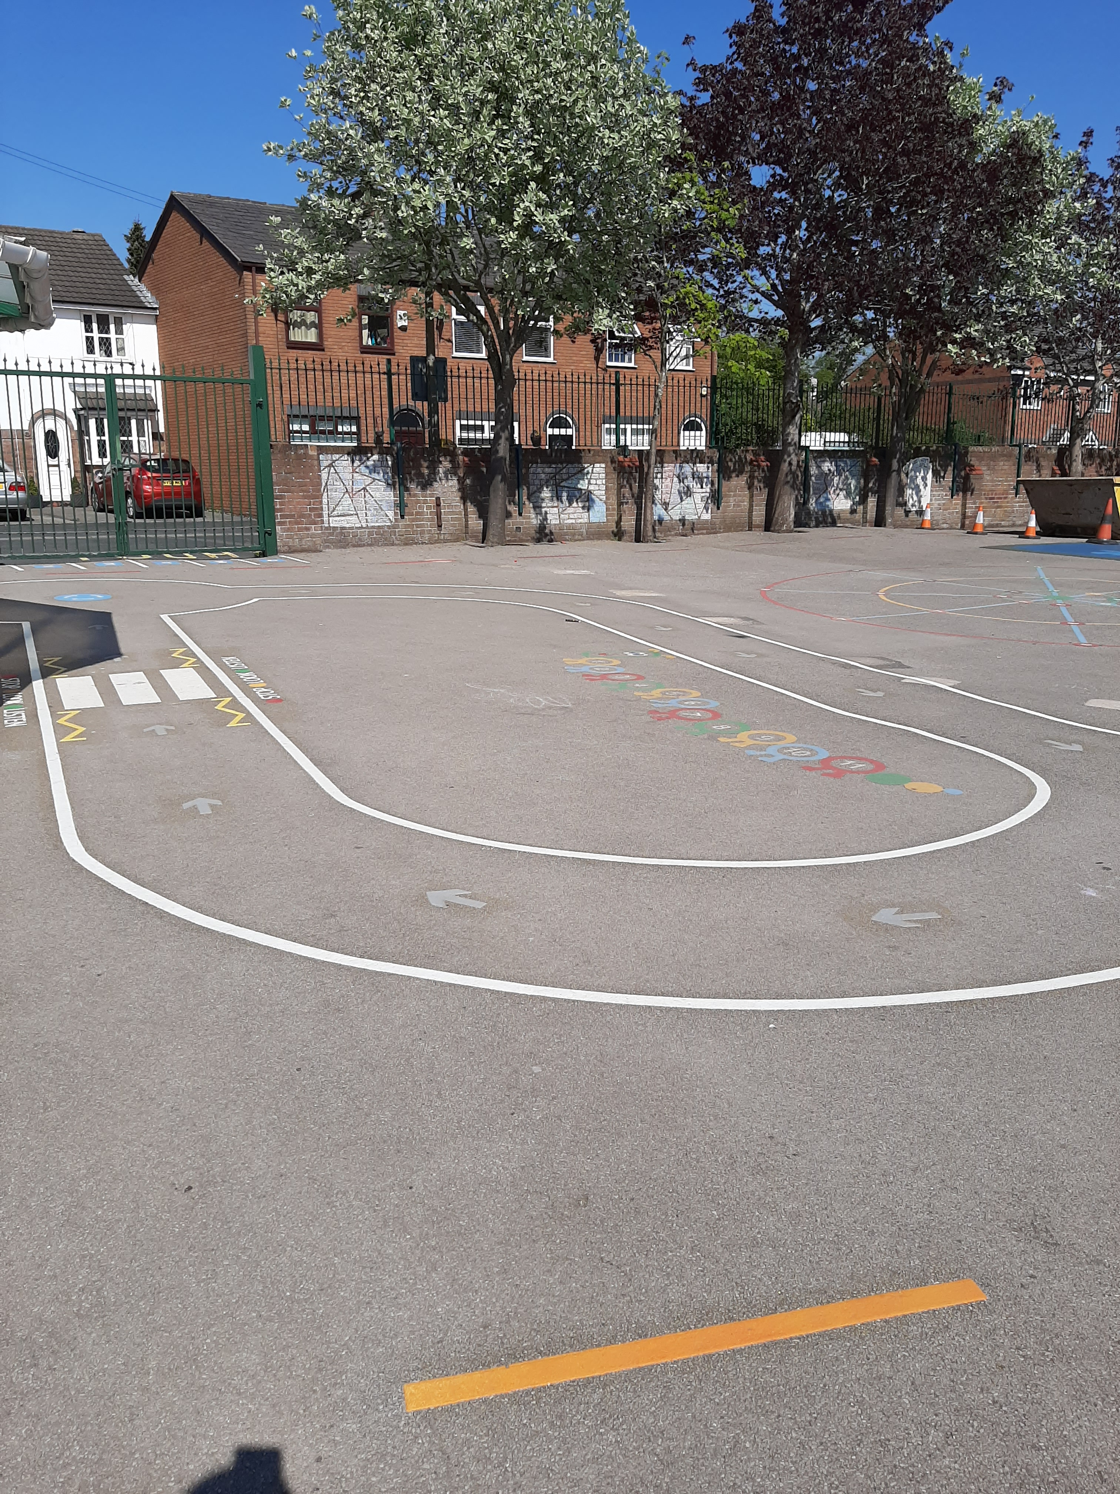

Insert image of the outdoor area

There are lots of different areas outdoors for you to explore and learn in.

Here are the adults who will be working with you …

Mrs Harrison teaches the Reception class.
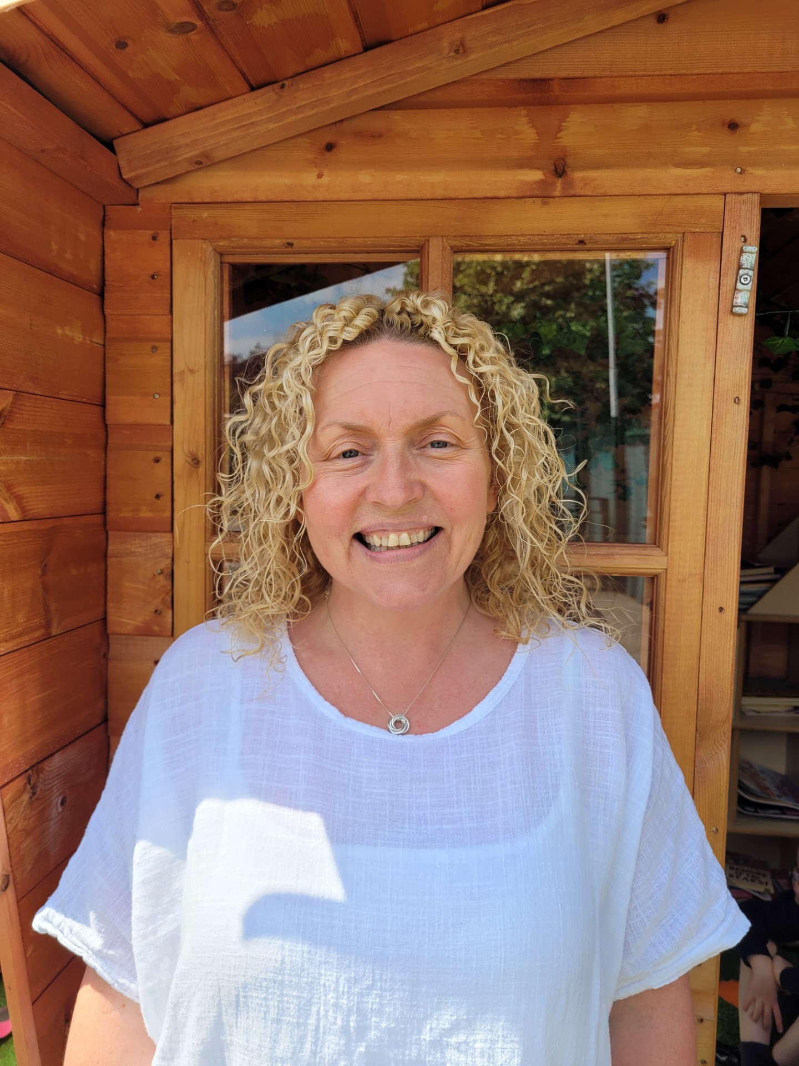
Ms Harrison teaches the Reception children one day every week.

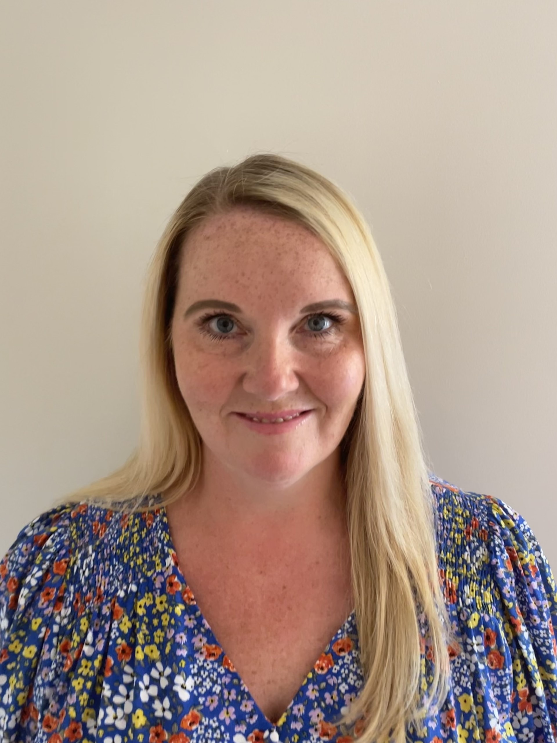
Mrs Lever is the Teaching Assistant in Reception.

You will get to know all the adults in the Early Years team. We all play and learn together. You will form a close relationship with your Key Person.

This is the uniform you will be wearing…

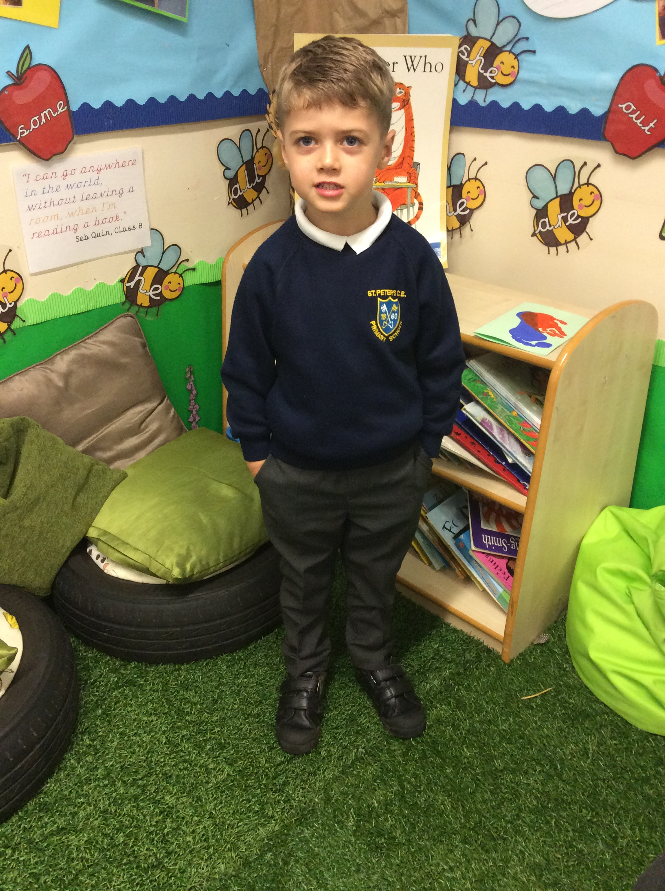boys
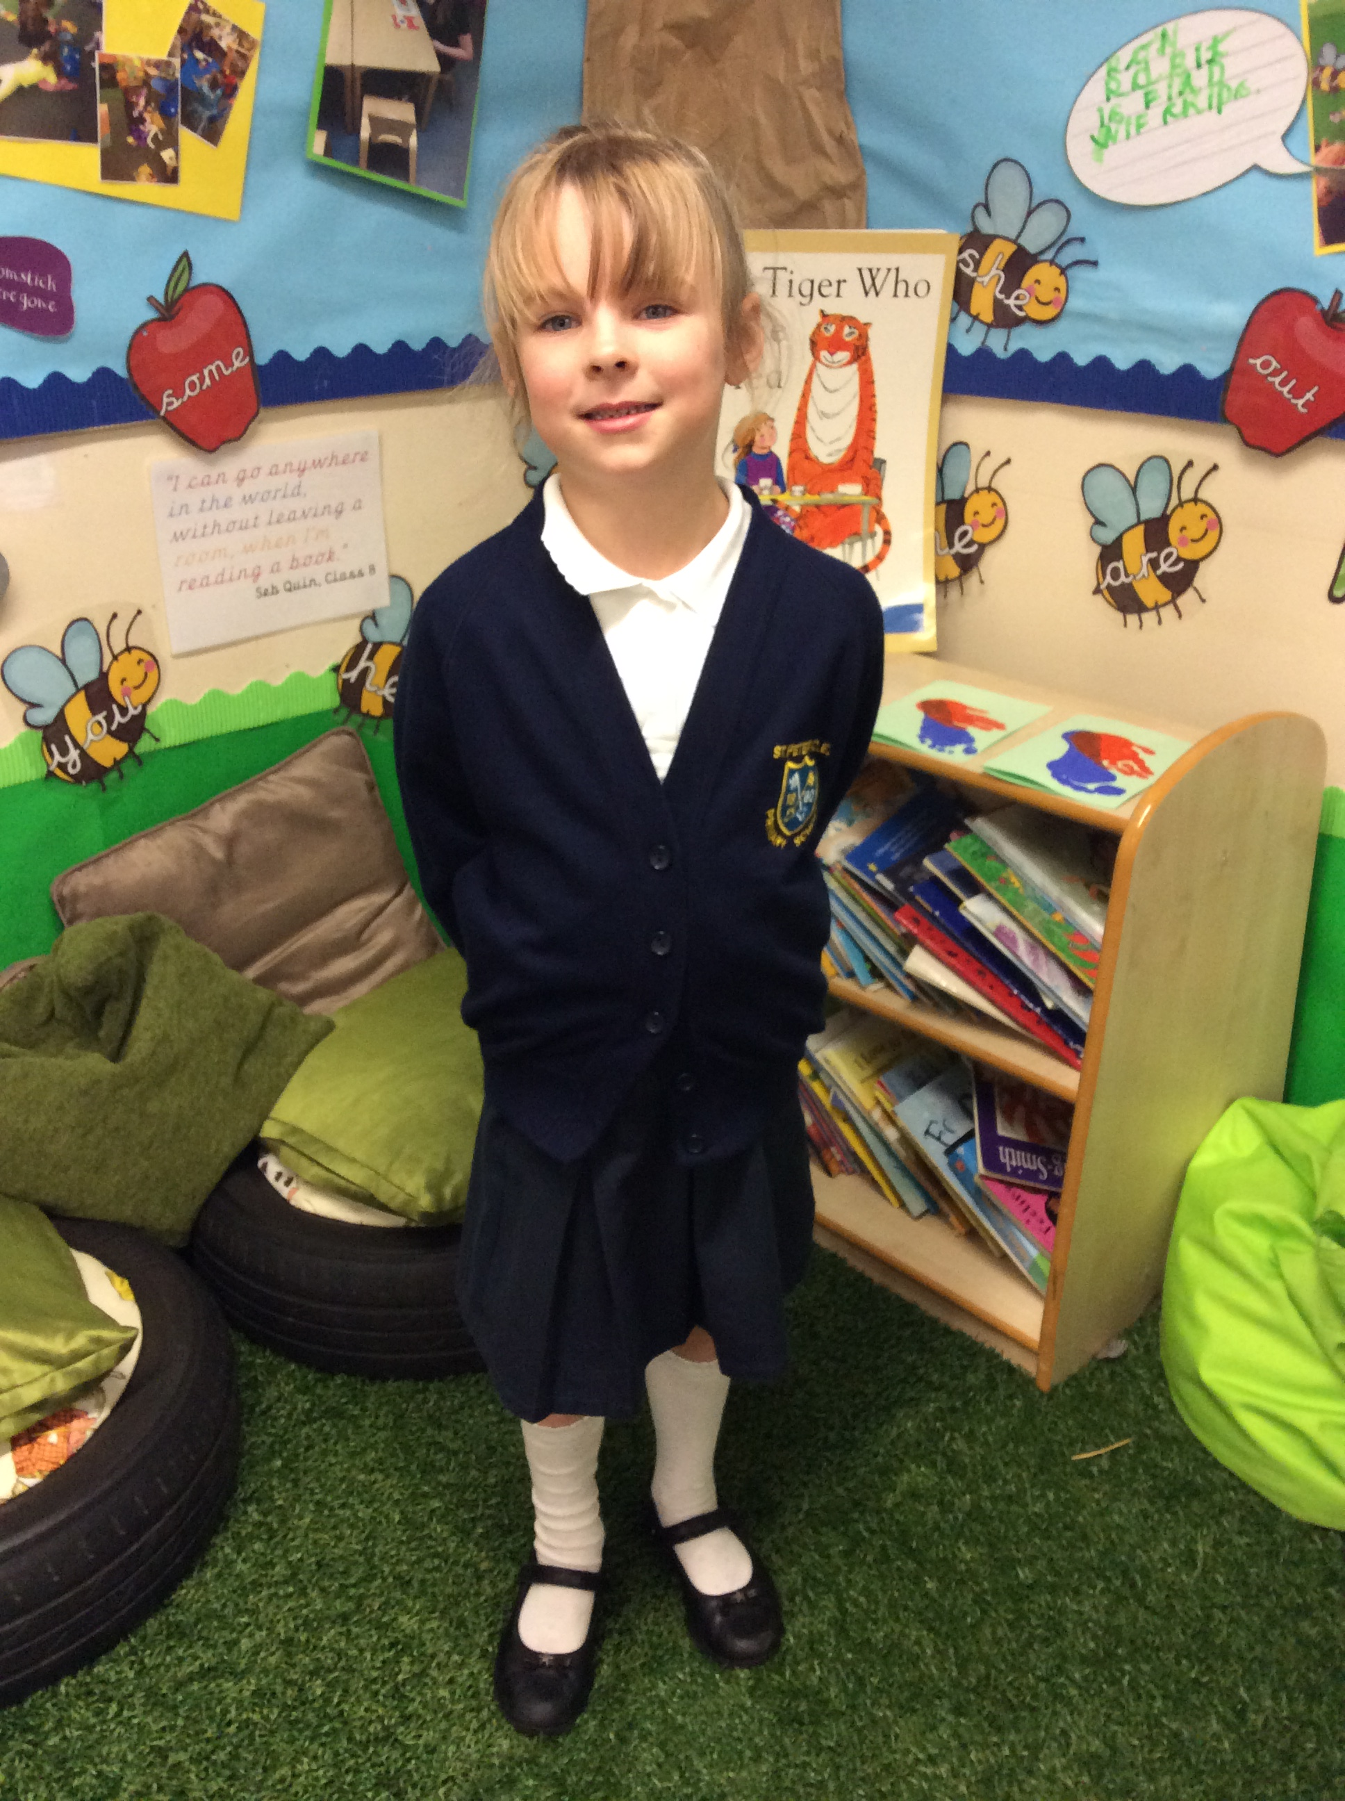girls

Insert image of the school uniform

This is your school bag, where you can keep your belongings…
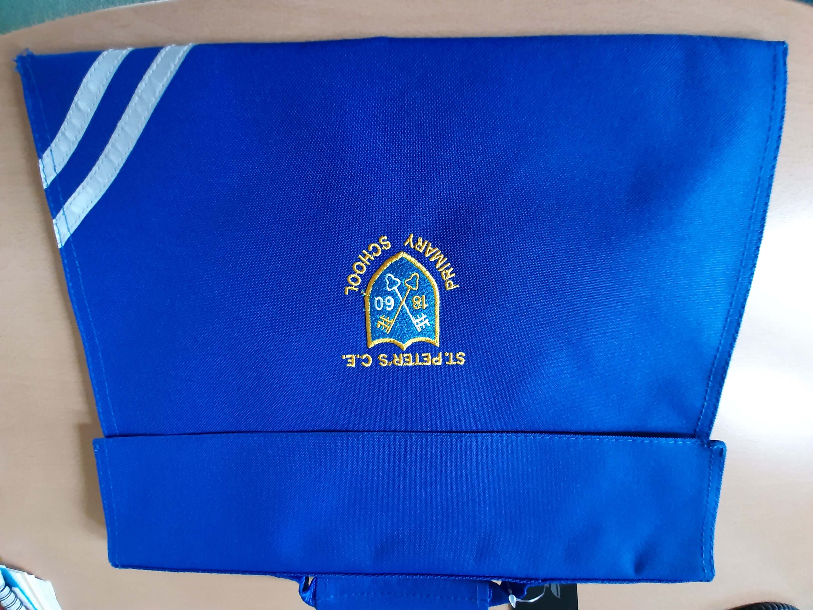

Insert image of a school bag

This is your bag, where you can keep spare clothes.
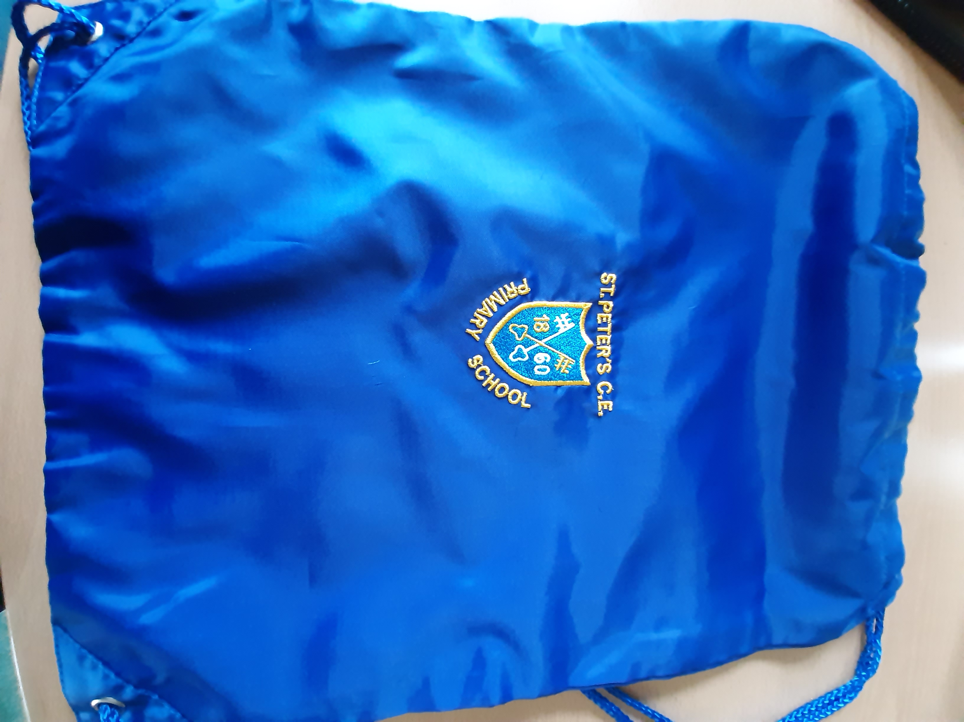

Insert image of a P.E. bag

This is the school hall where you will eat your lunch …

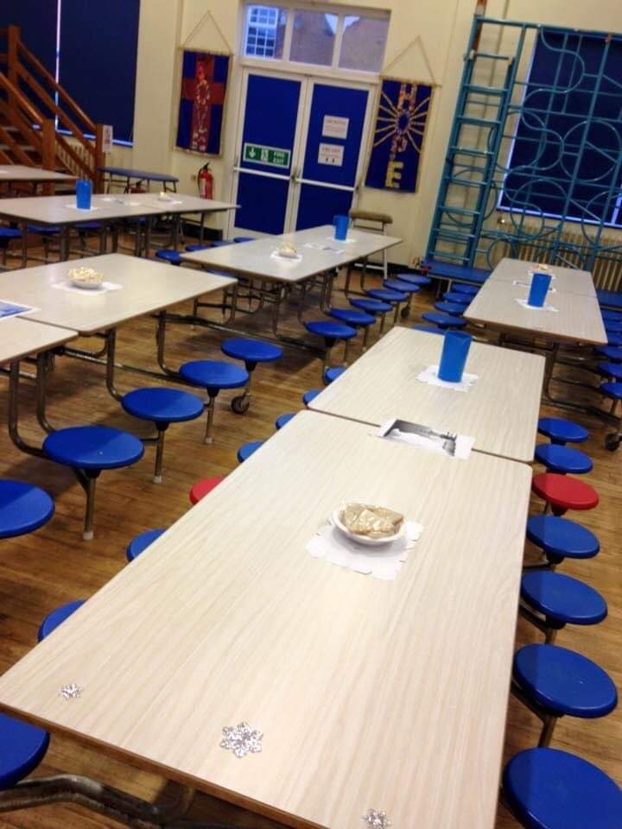

Insert image of the school hall

You will line up and choose your lunch at the hatch. Then you will carry your tray to the drinks station, choose a drink and pudding and add anything from the salad/fruit bar. You will sit with your friends and enjoy lunch! If you are on packed lunches, you will take it to the hall and sit down straight away. If you need help, the lunch time staff will help.

This is what the children of
St Peter’s Primary School said they enjoy most…
I like to see my buddy!

I love to play with the dinosaurs!

I like the bikes!

Phonics is my favourite!

Have a lovely summer and we look forward to seeing you in September!

