Design and Technology – Lesson sequence with suggested content.
Lessons
Year 1
Year 2
Year 3
Year 4
Year 5
Year 6
Understand what a
Understand what a
Identify who made the
Identify who made the
product, when it was
made and what its
purpose is
Identify who made the
product, when it was
made and what its
purpose is
Identify who made the
product, when it was
made and what its
purpose is
Background Research –
product is and who it is for product is and who it is for product, when it was
made and what its
Understand how a product Understand how a product purpose is
Lesson 1
Exploring context and
existing products
works and how it is used
works and how it is used
Identify what the product
has been made from
Identify what the product
has been made from
Identify what the product
has been made from
and how environmentally
friendly the materials are
Identify what the product
has been made from
and how environmentally
friendly the materials are
Identify where you might
find this product
Identify where you might
find this product
Evaluate the product on
Evaluate the product on
design and use
Identify the materials used design and use
to make the product
Evaluate the product on
design, appearance and
use
Evaluate the product on
design, appearance and
use
Brain Builders: Research
facts about famous
inventors/ chefs /
designers etc linked to
product
Brain Builders: Research
facts about famous
inventors/ chefs /
designers etc linked to
product
Express an opinion about
the product
Identify the cost to make
the product
Identify the cost to make
the product and whether it
has any other purposes eg.
Leading innovation of the
time, trend setting
Brain Builders: Research
facts about famous
inventors/ chefs /
designers etc linked to
product
Brain Builders: Research
facts about famous
inventors/ chefs /
designers etc linked to
product
Explain what product they
Design Criteria – Lesson 2 will be designing and
Use own experiences and
existing products to
develop ideas
Brain Builders:
Brain Builders:
Brain Builders:
Brain Builders:
Understand and gather
information about what a
particular group or people
want from a product
Understand and gather
information about what a
particular group or people
want from a product
Understand and gather
information about what a
particular group or people
want from a product, using want from a product, using
questionnaires, surveys etc questionnaires, surveys etc
Understand and gather
information about what a
particular group or people
making
Understanding their
intended users and their
own product
Explain who their product
will be used by
Explain what product they
will be designing and
making
Describe the purpose of
their product and how it
will work
Describe the purpose of
their product
Describe what their
product will be used for
Describe the purpose of
their product
Describe the purpose of
their product
Explain who their product
will be used by
Identify design features
that will appeal to
intended users
Identify design features
that will appeal to
Identify design features
that will appeal to
Identify design features
that will appeal to
Describe what their
1

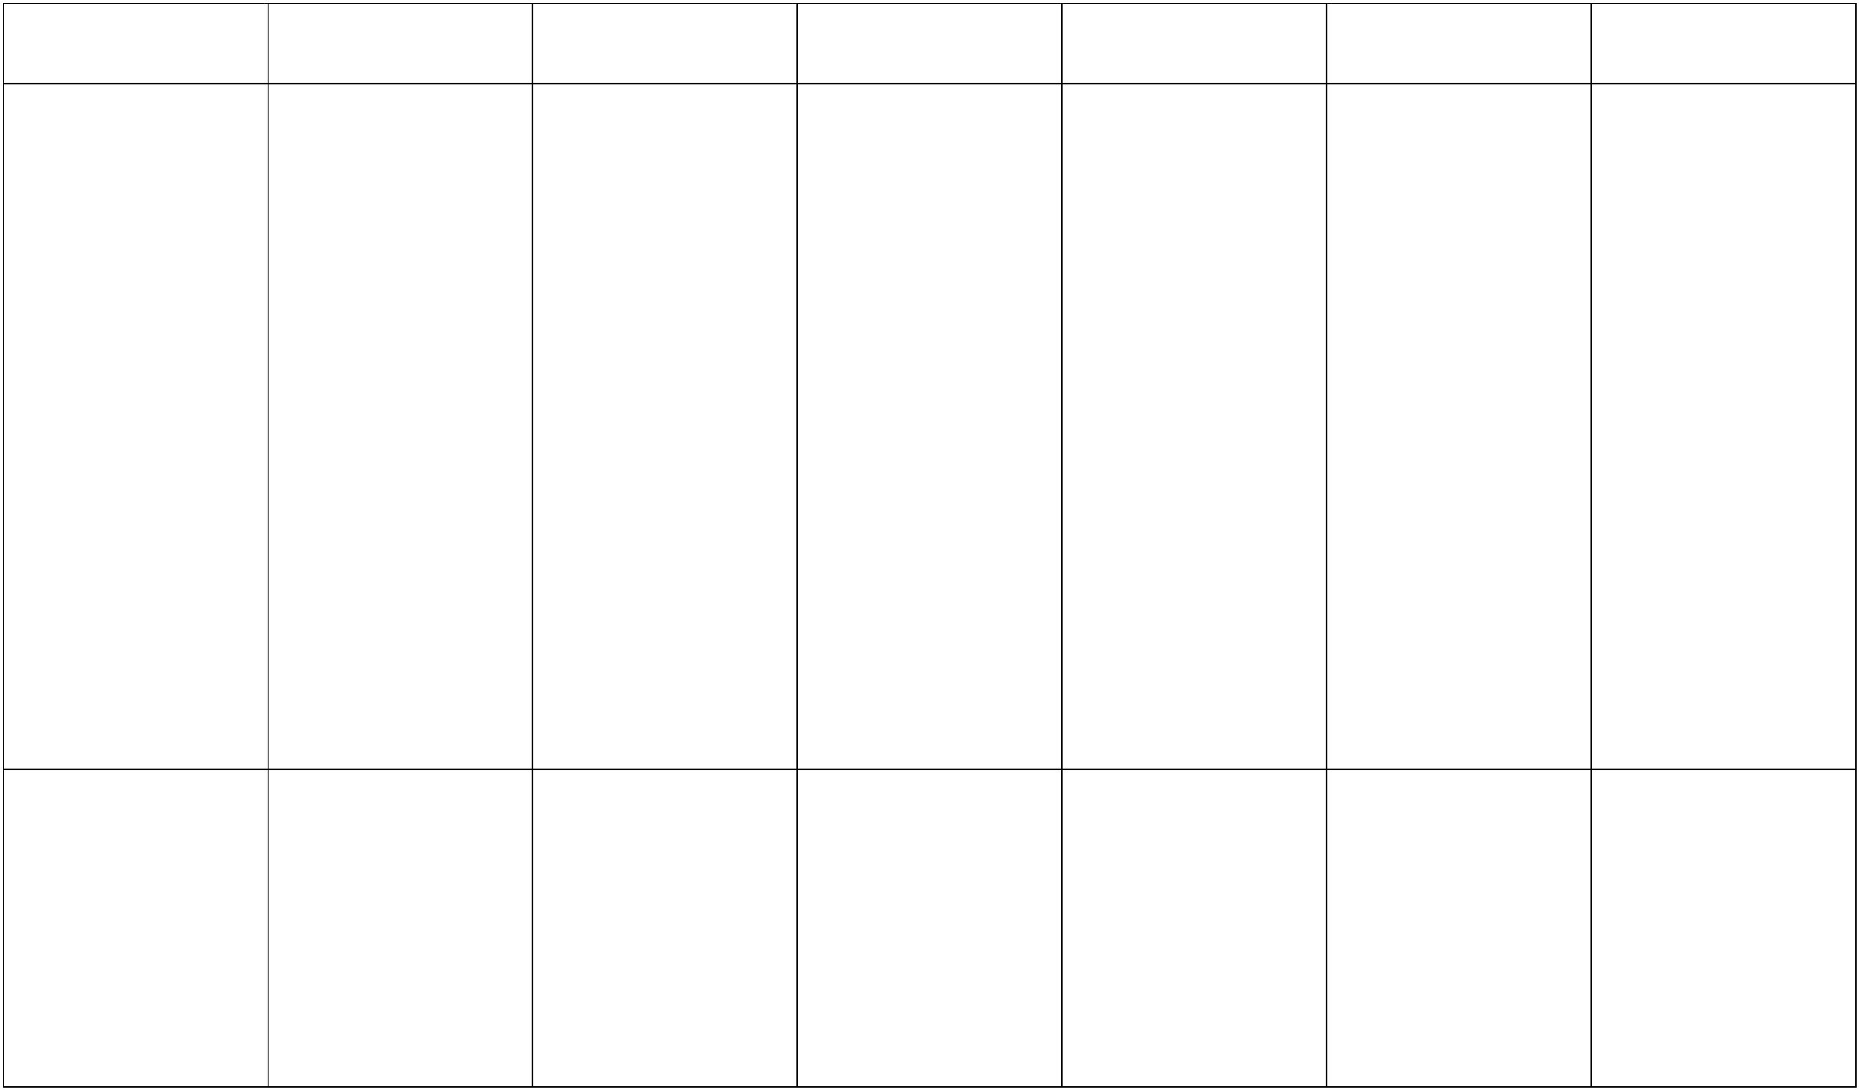

product will be used for
and how it will work
intended users
Explain how parts of their
product works
intended users
Explain how parts of their
product will work
intended users
Explain how parts of their
product will work
Explain how parts of their
product works
Explain why their product
is suitable for the intended Generate realistic ideas
Develop their own design
criteria and use for
planning ideas
Develop their own design
criteria and use for
planning ideas
Create a design description
for their product
user
that meet needs of user
Highlight the impact of
time, resources and cost
within their design ideas
Generate realistic ideas
that meet needs of user
and take into account
availability of resources
Generate innovative ideas
that meet needs of user
and take into account
availability of resources
Generate innovative ideas
that meet needs of user
Share and discuss ideas
with others
Discuss what their steps
for making could be
Discuss what their steps
for making could be
Share and discuss ideas
with others
Share and discuss ideas
with others
Share and discuss ideas
with others
Planning –
Lesson 3
Represent ideas through
Communicating ideas and talking and drawing
creating prototypes for
Represent ideas through
talking, drawing and
computing – (where
appropriate)
Order the main stages of
making
Order the main stages of
making
Record a step by step plan
for making
Record a step by step plan
for making
product
Choose materials to use
based on suitability of
their properties
Choose materials to use
based on suitability of
their properties
Produce lists for the tools,
equipment and materials
they will be using
Produce lists for the tools,
equipment and materials
they will be using
Choose materials to use
based on suitability of
their properties
Represent ideas in
Represent ideas in
Choose materials to use
based on suitability of
their properties and
aesthetic qualities
Choose materials to use
based on suitability of
their properties and
aesthetic qualities
diagrams, annotated
sketches and computer
based programmes
(where appropriate)
diagrams, annotated
sketches and computer
based programmes
(where appropriate)
Create templates/pattern
pieces and explore
materials whilst
developing ideas
Represent ideas in
Represent ideas in
Create pattern pieces and
prototypes
Create pattern pieces and
prototypes
diagrams, annotated
sketches and computer
based programmes
(where appropriate)
diagrams, annotated
sketches and computer
based programmes
(where appropriate)
Create pattern pieces and
prototypes
Create pattern pieces and
prototypes
Across KS1: Use materials - Across KS1: Use materials - Across KS2: Use materials - Across KS2: Use materials - Across KS2: Use materials - Across KS2: Use materials -
2
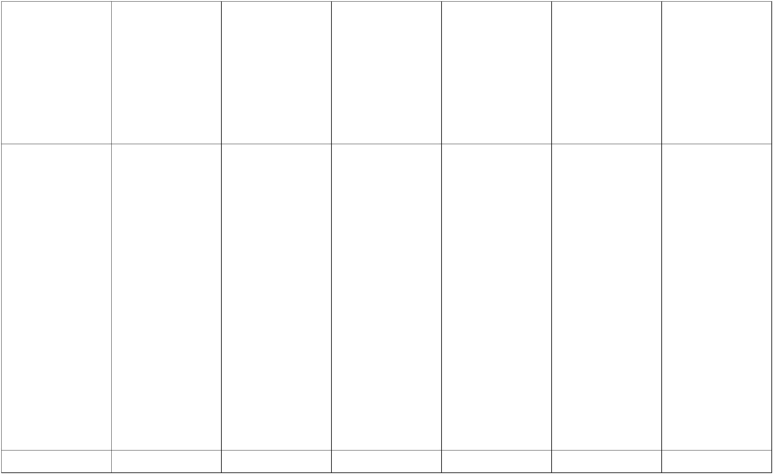

construction materials and construction materials and construction materials and construction materials and construction materials and construction materials and
Making –
Lesson 4-5
kits, textiles, food and
kits, textiles, food and
kits, textiles, food,
mechanical and electrical
components
kits, textiles, food,
mechanical and electrical
components
kits, textiles, food,
mechanical and electrical
components
kits, textiles, food,
mechanical and electrical
components
mechanical components
mechanical components
Selecting the tools and
applying the practical skills making
and techniques
Choose suitable tools for
Choose suitable tools for
making whilst explaining
why they should be used
Choose suitable tools for
making whilst explaining
why they should be used
Use design criteria whilst
making
Choose suitable tools for
making whilst explaining
why they should be used
Use design criteria whilst
making
Choose suitable tools for
making whilst explaining
why they should be used
Use design criteria whilst
making
Choose suitable tools for
making whilst explaining
why they should be used
Use design criteria whilst
making
Follow safety and food
hygiene procedures
Follow safety and food
hygiene procedures
Measure, mark, cut and
shape materials and
components
Measure, mark, cut and
shape materials and
components
Follow safety and food
hygiene procedures
Follow safety and food
hygiene procedures
Follow safety and food
hygiene procedures
Follow safety and food
hygiene procedures
Join, assemble and
combine materials and
components
Measure, mark, cut and
shape materials and
components with some
accuracy
Measure, mark, cut and
shape materials and
components with some
accuracy
Measure, mark, cut and
shape materials and
components accurately
Measure, mark, cut and
shape materials and
components accurately
Join, assemble and
combine materials and
components
Join, assemble and
combine materials and
components accurately
Join, assemble and
combine materials and
components accurately
Use finishing techniques,
including skills learnt in Art combine materials and
components with some
Join, assemble and
Join, assemble and
combine materials and
components with some
accuracy
accuracy
Demonstrate problem
solving skills when
Demonstrate problem
solving skills when
Use finishing techniques,
including skills learnt in Art including skills learnt in Art practical problem
Use finishing techniques,
encountering a mistake or
encountering a mistake or
practical problem
with some accuracy
with some accuracy
Use finishing techniques,
Use finishing techniques
including skills learnt in Art that involve a number of
accurately
steps, including skills
learnt in Art accurately
Talk about their design
ideas and what they have
made
Talk about their design
ideas and what they have
made
Use design criteria to
evaluate product –
identifying both strengths
Use design criteria to
evaluate product –
identifying both strengths
Use design criteria to
evaluate product –
identifying both strengths
Use design criteria to
evaluate product – looking
at quality of end product
Evaluation –
Lesson 6
and areas for development and areas for development and areas for development and design and whether it
is fit for its intended
Consider the views of
others, including intended
user, whilst evaluating
product
Referring to planning and
initial ideas in evaluating
their product
Make simple judgements
of how the product met
their design ideas
Make simple judgements
of how the product met
their design ideas
Consider the views of
others, including intended
user, whilst evaluating
product
Consider the views of
others, including intended
user, whilst evaluating
product
purpose
Consider the views of
others, including intended
user, whilst evaluating
product
Suggest how their product
could be improved
3
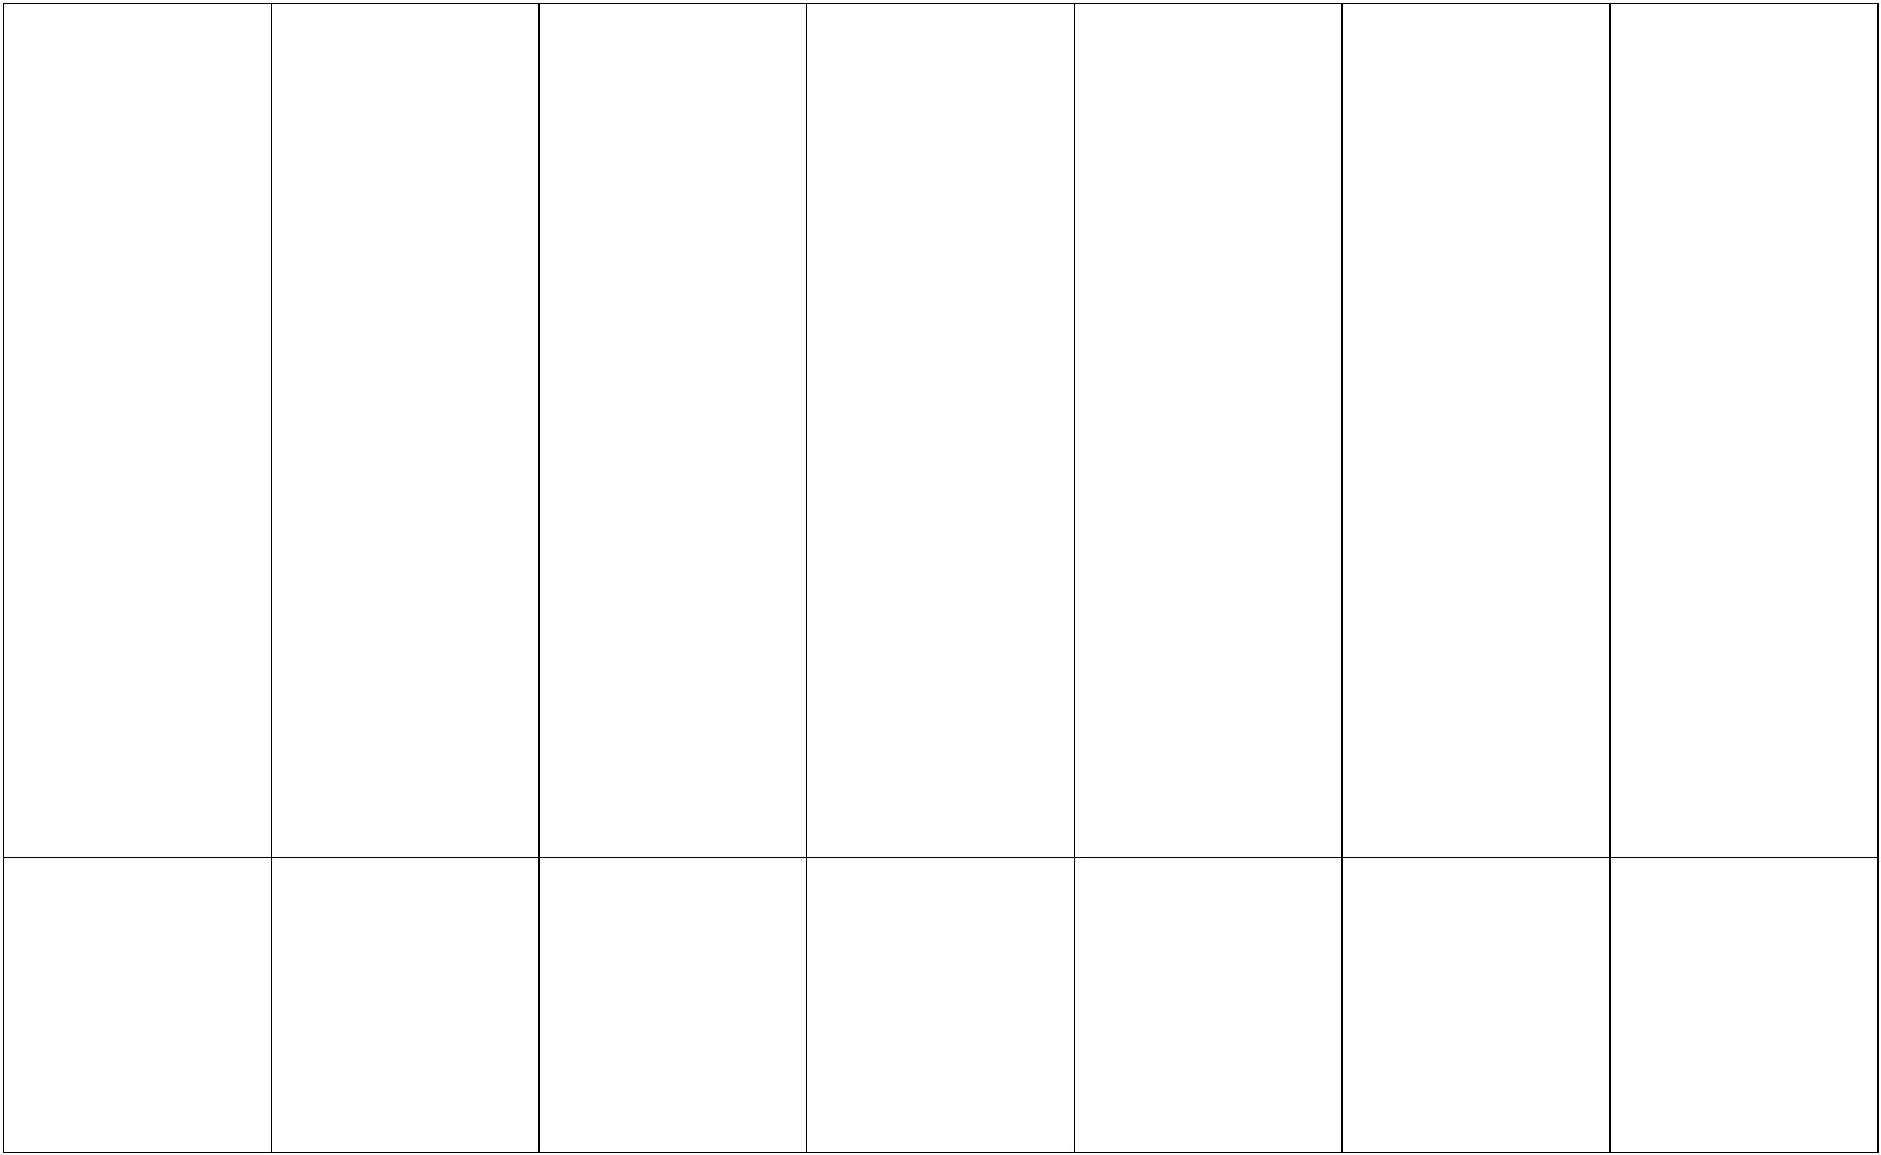

Across KS1:
Lower KS2:
Upper KS2:
Teaching cooking and
nutrition
Understand that food
comes from plants or
animals
Understand which foods
are reared, caught, or
grown and that this
happens in the UK and
across the globe
Understand which foods
are reared, caught, or
grown and that this
happens in the UK and
across the globe
Understanding food and
food preparation
Understand that food has
to be farmed, caught, or
grown
Understand that recipes
can be changed by adding
or taking away ingredients
Understand that the
seasons can affect food
produce
Understand that the
seasons can affect food
produce
Understand that
sometimes raw ingredients
need to be processed
before they can be used in
cooking (eg. De-feathering
a chicken)
Understand that recipes
can be adapted to change
the appearance, taste and
aroma of a dish
Across KS1:
Lower KS2:
Upper KS2:
Teaching cooking and
nutrition
Sort foods into the 5
Sort foods into the 5
Sort foods into the 5
groups using The Eatwell
Food preparation, cooking Plate
and nutrition
groups using The Eatwell
Plate and identify that this
makes up a healthy diet
groups using The Eatwell
Plate and identify that this
makes up a healthy diet
Identify that people should
eat at least 5 portions of
fruit and vegetables a day
Identify that food and
drink are needed to
provide energy for a
healthy and active lifestyle
Identify that food and
drink provide certain
nutritional and health
benefits which support a
healthy lifestyle
Prepare simple dishes
hygienically and safely
without a heat source
Identify that people should
eat at least 5 portions of
fruit and vegetables a day
Identify that people should
eat at least 5 portions of
fruit and vegetables a day
Use cooking techniques
such as: cutting, peeling
and grating
Prepare simple dishes
4
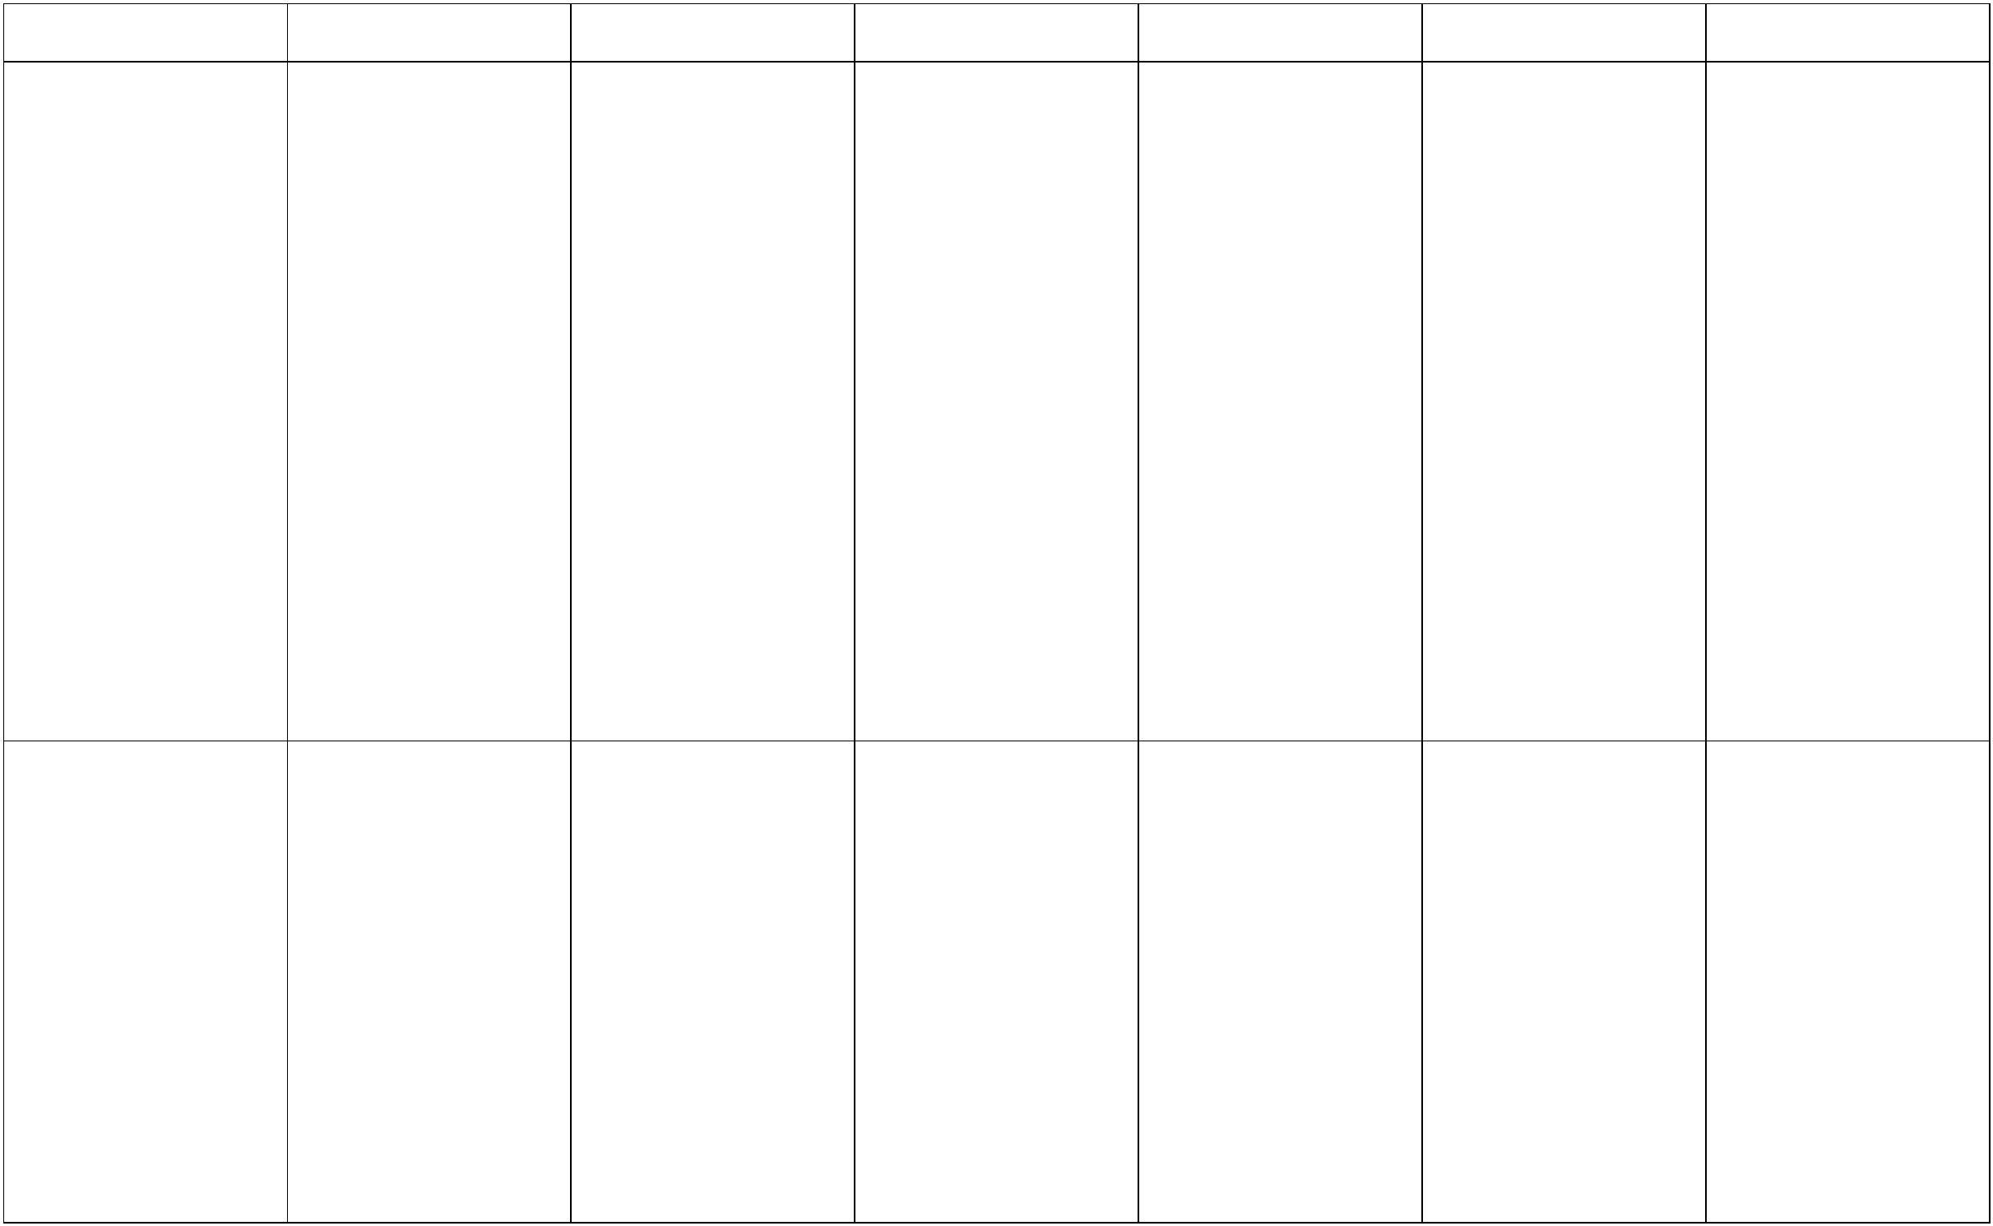

hygienically and safely,
where needed with a heat
source
Prepare simple dishes
hygienically and safely,
where needed with a heat
source
Use cooking techniques
such as: chopping, peeling,
grating slicing, mixing,
spreading, kneading and
baking
Use cooking techniques
such as: chopping, peeling,
grating slicing, mixing,
spreading, kneading and
baking
5


