
St. Peter’s CE Primary School
Reception Newsletter.
Mrs Harrison welcomes you!
NOTICES
Please ensure your child brings a labelled water bottle to school each day. Water only please.
Please could all clothing be clearly labelled with children’s full name?
We will be holding a parents’ EYFS workshop after school this half term. Letters will follow soon.
We are a cashless school. All payments are through School Money.
We know there will be BIRTHDAYS coming soon…we love to celebrate and always make a fuss of the birthday child! However, we cannot accommodate a cake in school. We also cannot give out class lists for party invites due to GDPR.
Children should bring their book bag each day, so that we can read as much as possible at school.
PE day is MONDAY and children come to school dressed in their PE kit on 14th September for their first session.

Welcome to St Peter’s!
We are so pleased with how the children are settling into their new school and class.
This half-term our theme in Reception is
‘Myself and My School’. The first book we will read as a class over the coming weeks
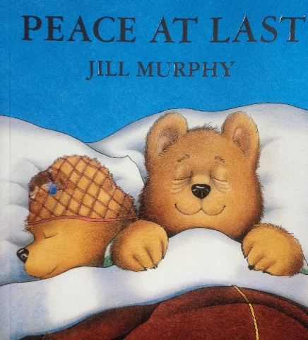
is ‘Peace at Last.’

Books
We are beginning to send reading books home. Children will have two books each week- a story book for you to read to them at bedtime perhaps (they will not be expected to read this book) and a reading scheme book that they will read. Lilac books may be sent to begin with, that have no words but encourage speaking and retelling skills. They are very valuable for vocabulary and speech. Children can talk about what is happening in the pictures and make a story up themselves. Please look after the books and read as much as possible. We recommend at least 3 times each week. Write in the reading record each time your child reads to you, to tell us how your child did- did they enjoy the book? Did they retell the story, learn any new words or read any words, say any sounds etc? If you need any help at all with the reading books, please ask. As soon as we begin formal phonics, we will begin to send home books with sounds in. This will be very soon!

Myself and My School
English
We will read stories and talk about characters, story structure and link the story to feelings and emotions. We will also look at the book, ‘Homes.’ Reception will begin to learn their letter sounds in phase two phonics.
Maths
Reception will learn about their numbers to 5 and ensure that they can recognise the numbers, count with objects and select correct numerals to match sets. We will represent the numbers in different ways. We will learn to subitise, recognising amounts without counting.
Understanding of the World
We will learn about the Bear Family in ‘Peace at Last’ and how they live, hunt etc. We will explore nocturnal creatures. We will investigate the change in seasons as we move to Autumn time and go to the field to explore these environmental changes. We will look at our own families and how they are all different.
Outdoor learning
Reception will explore ‘big write’ outside with water, chalk and ribbon sticks. We will follow the children’s requests and ideas, setting up activities to engage them. We will investigate numbers to 5 outside, using large frames and natural counters, in our ‘messy maths’ area. We will also explore the field and the large open space.
Expressive Arts and Design
We will use different materials to explore collage this half term and also make models using junk materials. We will paint self-portraits and we will use ‘loose parts’ and the construction area to make models and combine different media. We will draw homes and compare homes around the world.
PSHE
We are learning about school life and how to be together happily as a class. We are being supported to talk about our feelings, understand how we can keep ourselves safe and practise social skills, such as waiting our turn, taking turns and sharing. In Jigsaw lessons, we will be learning about ‘Being in my World.’ We will discuss our similarities and differences.
Tapestry
We use Tapestry, an online learning journey and communication tool in Reception. We will add photos and observations. We live in the moment and spending time with your little one is sometimes more important than documenting it, so there may not be endless pics. Some weeks, more than others. We will update when we can. You can also upload photos or text, to let us know what your child is doing at home or on the weekend!
Many thanks for all your support. What a great start! Please check the class webpage for information. I update every half term. The class email to contact me directly is; stpetersreception-y1@sthelens.org.uk I check it most days. However, urgent messages, send to the office. Mrs Harrison

