Home Activities-Summer 2
Complete the activities in any order and add photographs on Tapestry or add the work into your home book. Bring it in on Wednesdays.
Make a Father’s Day card for Dad or Grandpa, or even a special uncle.   | Can you look for signs of Summer in your garden, as we move into a new season? What did you see? How is it different to Spring? Take a photo for Tapestry!  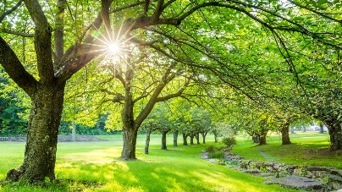 | Explore number bonds to 5 and 10. Write them in your book. Can you recall bonds to 5 quickly?  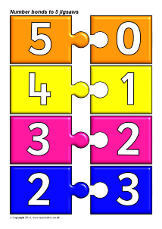
Can you practise doubles?  Try to write the number sentences to show what happened when you doubled numbers?  1+1 4+4  2+2 5+5  3+3 6+6 | Look at the map of the UK and think about the coast. What do we see on the coast? Have you been to anywhere by the sea? Can you find it on the map?  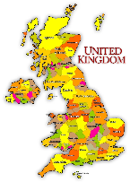 | Our tadpoles have changed so much! Can you draw the frog life cycle in your book? Label it.  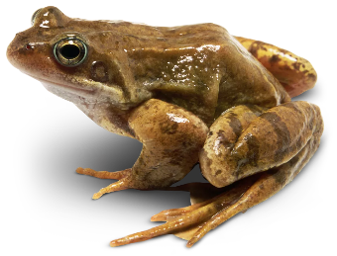
Draw a map of your local area- can you add the park, or the church, or any other landmarks around you? Can you make a key?  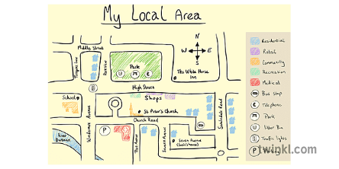 | Keep practising reading and writing our harder to read and spell words. We will send home new ones.  Write sentences using them too.  Said when  all one  there oh | Make a teddy bear at home- draw it, collage it or build one!  What is he/she called? Write about ted in your book.  

I will add work in the home book most weeks now, to get ready for year one. It is a good idea to practise writing and recognising the numbers 1-20 as often as possible, alongside words and sounds. This half term we will have a big push on handwriting and forming letters correctly.

