
St. Peter’s COE Primary School
Reception Summer Term 1 Newsletter
NOTICES
Please ensure your child brings a labelled water bottle to school each day.
Make sure all clothing is clearly labelled with a full name.
Children still require their PE this half term, on Monday.
Children may bring one healthy snack with them to school. Some are bringing too much. However, we have lots of free fruit on offer every day at school. It is easier to have school snack.
Thank you for your continued Tapestry support. It is lovely to see so many of you posting activities from home. Keep up the great work. We are amazed by the children’s progress so far.
Thank you for your attendance at Parents evening. It was heart-warming to hear such lovely comments from you all and show you the work your children have been doing with us. They have come so far in only 6 months!
Keep the junk coming for the art box please, it is used up quickly! We particularly love lids, little pots and small boxes. No big boxes please.
Please remember that the play equipment in the playground is for the children during school hours only. We are not insured after hours and need your help to work together, to keep the children off the equipment.
Finally, we hope you all had a lovely Easter Break and are ready for the Summer term. There’s lots more to learn!
Mrs Harrison
Welcome Back!
We hope you all had a relaxing break and are looking forward to a busy half term full of learning. This half-term our theme is ‘Dinosaurs’ and we will be exploring dinosaurs of the past through the story ‘Gigantosaurus’. We will be reading non-fiction texts too, gaining lots of new vocabulary. The half term will end with poetry about nature.
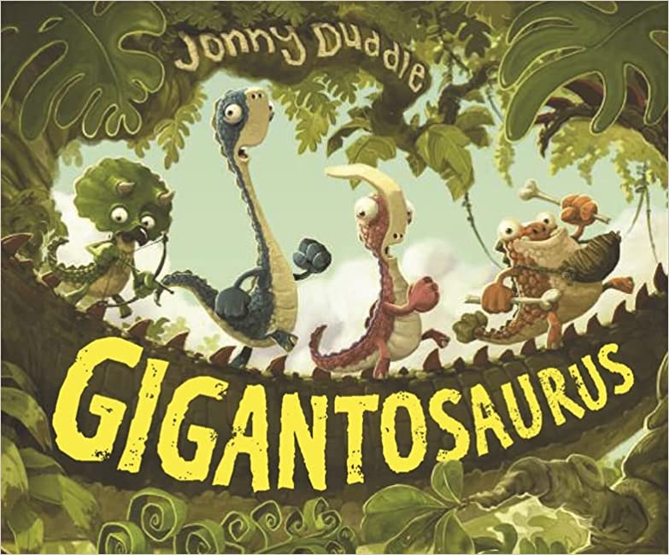
This half term we are going to be scientists, looking at life cycles and food groups, as well as all different animals. We will be historians and explore the journey of the dinosaurs. We will also be geographers and explore maps of the surrounding area, revisiting the use of a compass.
We will be adding small changes, to begin our slow transition to Year One. We will join in with some of the ‘break times’ with Key Stage One outside and will begin using English books to write in, as well as Maths books! We will soon begin ‘4-a-day’ Maths time every morning too! It is so important that children are in school at 8.45am, before the bell so that they can complete their morning maths challenge.

