Home Activities-Summer 1
Complete the activities in any order and add photographs on Tapestry or add the work into your home book. Bring it in on Wednesdays.
Learn about Ascension Day with your grown up.  Draw a picture in your book and write about this important day in the Christian Calendar.   | Can you look for flowers and plants in your garden or the park? What are their names? How do you know? Draw them or take a photo for Tapestry!  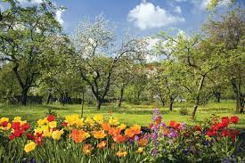 | Explore numbers to 20! Write the number track in your book.  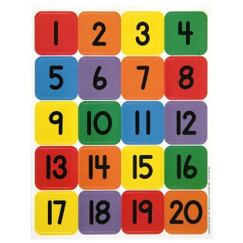
Can you practise taking away using counters?  Try to write the number sentences to show what happened.  8-5=3  5-2=?  10-4= | Look at the map of the UK and where we are in the Northwest of England. Can you find our Capital City, London? What else can you see?  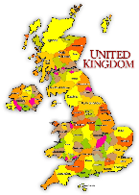 | Can you research an amphibian and write a fact about it in your book!  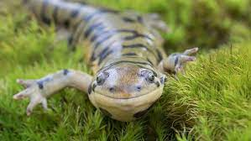
Draw your favourite dinosaur and label it.  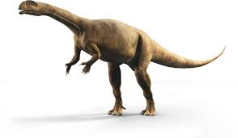 | Practise reading and writing the harder to read and spell words.  Write sentences using them too.  they, love, all, little, children… | Make a dinosaur model at home! Use Lego or junk- anything. Bring it in or take a photo for Tapestry.  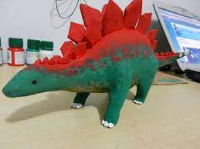

We will also sometimes send phonics or maths activities home. We may add activities in the home book from time to time as we learn new skills and topics. If you do anything in the home book, bring it in on a Wednesday, and we will send it home again on Friday.

