
St Peters CE Primary Summer 1 Term Medium Term Planning ‘Dinosaurs’

Prime Areas

Seven Features of Effective Practice | Areas | LEARNING OBJECTIVE(S)  We will be learning to…
The best for  every child  High quality  Care  The curriculum  what we want  children to learn  Pedagogy  helping children  to learn  Assessment –  checking what  children have  learnt  Self- regulation  and executive  function  Partnership  with parents     | Communication and Language  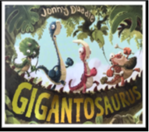 | Listening, Attention and Understanding  - Listen attentively and respond to what they hear with relevant questions, comments and actions when being read to and during whole class discussions and small group interactions  - Make comments about what they have heard and ask questions to clarify their understanding  - Hold conversation when engaged in back-and-forth exchanges with their teacher and peers.  - Understand humour more readily e.g., nonsense rhymes/jokes  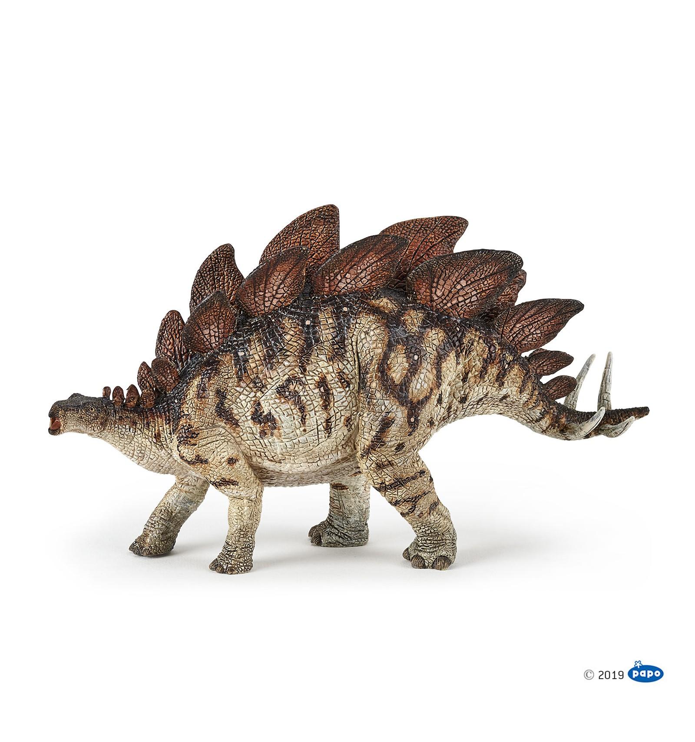  Circle times, carpet sessions, English lessons, worship. Conversation in investigation station.  Speaking  - Participate in small group, class and one-to-one discussions, offering their own ideas, using recently introduced vocabulary.  - Offer explanations for why things might happen, making use of recently introduced vocabulary from stories, non-fiction, rhymes and poems when appropriate.  Express their ideas and feelings about their experiences using full sentences, including use of past, present and future tenses and making use of conjunctions, with modelling and support from their teacher.  Investigation station/conversation corner in class.  Giganotosaurus- new vocabulary linked to Understanding the World.
 | Personal, Social and Emotional Development | Self-Regulation  - Show an understanding of their own feelings and those of others and begin to regulate their behaviour accordingly.  - Set and work towards simple goals, being able to wait for what they want and control their immediate impulses when appropriate  - Give focused attention to what the teacher says, responding appropriately even when engaged in activity, and show an ability to follow instructions involving several ideas or actions.  Use zones of regulation/mood meter. Social stories. Refer back to ‘Going for Goals’ Jigsaw piece. Link to ‘Relationships’ new jigsaw piece. Social skills-Sunshine club interventions with those struggling to express their emotions and be in tune with others.  Link emotions to feature story. Label feelings and look for signs of how others are feeling. Facial expressions.  Managing Self  - Be confident to try new activities and show independence, resilience and perseverance in the face of challenge  - Explain the reasons for rules, know right from wrong and try to behave accordingly  - Manage their own basic hygiene and personal needs, including dressing, going to the toilet and understanding the importance of healthy food choices.  Recap Growth Mindset work- use learning pit in sessions. Refer to jigsaw charter and class charter. Link to traffic lights. Perseverance.  Building Relationships  - Work and play cooperatively and take turns with others  - Form positive attachments to adults and friendships with peers  - Show sensitivity to their own and to others’ needs.  - Continue to see self as a valuable individual  Feeling cross or angry, Regulating emotions. Continue with play buddies.  Discuss talents and address these more in ‘Show and Tell’ time.  Celebrate home/school achievements. Continue with Social skills group- sunshine club.
 | Physical Development | Gross Motor Skills  - Negotiate space and obstacles safely, with consideration for themselves and others  - Demonstrate strength, balance and coordination when playing  - Move energetically, such as running, jumping, dancing, hopping, skipping and climbing.  Use play equipment, balance board, snakes and stilts, bats and balls. Add small hand driven carts.  Summer 1 PE -Dinosaur dance  Fine Motor Skills  - Hold a pencil effectively in preparation for fluent writing – using the tripod grip in almost all cases  - Use a range of small tools, including scissors, paint brushes and cutlery  - Begin to show accuracy and care when drawing.  Provide triangular handwriting pencils for those struggling.  Handwriting intervention to continue. Write well scheme.  Handwriting focus in phonics sessions- sit target group at table.  More detailed, observational drawing opportunities.

Specific Areas

 | Areas | LEARNING OBJECTIVE(S)
Pathways to Write- Summer 1 | Literacy Development  Vocabulary | Reading:  To draw/paint/make an imaginary dinosaur individually or in a small group. To be able to contribute orally to a short story about their dinosaur storyline.  - Continue to develop Phase1 phonological awareness  - Oral blending and segmenting  - Demonstrate an understanding of what has been read to them by retelling stories and narratives using their own words and recently introduced vocabulary …sequence  - Anticipate-where appropriate-key events in stories. Giganotosaurus.  - Use and understand recently introduced vocabulary during discussions about stories, non-fiction, rhymes and poems and during role play.  - Begin to notice some relationships between one text and another- link to previous texts…  - Begin to comment on perceived links with own life experience or other experiences, e.g. films, books  - Say the sound for each letter of the alphabet and for at least 10 digraphs  - Secure P3 phonics…trigraphs and digraphs- continue Phase 4 phonics -ELS  - Read words consistent with their phonic knowledge by sound-blending  - Read aloud simple sentences and books that are consistent with their phonics knowledge, including some common exception words (approximately yellow book band – decodable/instructional level)  - you, they, all, are, my, her, children, love etc - ELS Words (plus see Autumn/Spring words)Continue to assess GPC and HF words at intervals and send home gaps, add gaps to intervention, provision personalised plans.  Writing:  Retell and rewrite the story. Now write in English books, with lines, for Transition to KS1.  - Write recognisable letters (lower case and capital) most of which are formed correctly  - Spell words by identifying the sounds and then writing the sound with letter/s, using taught GPCs  - CVC words  - Write simple phrases and sentences that can be read by others  - Re read what they have written to make sure it makes sense.  - Including: □ oral rehearsal of sentence before writing □ word spacing □ full stop □ capital letter (not required for ELG, but secured for Y1 readiness)  - Begin to sequence 2-3 sentences within purposeful fiction/ non-fiction writing, such as:  - 2-3 part story (e.g. using story map/planner)  - Instructions  - Fact cards  - Letter  Form lower case and capital letters correctly.  Consolidate phase 3 and continue to embed phase 4. New words. ed,er,est endings  Target group consolidate and bridge phase 3 phonic gaps. Sentence writing- hold a sentence.
  beyond  lava flow  herbivore  carnivore  omnivore  graze  beware  lookout  termite  emergency | beast  lurks  enormous  explore  fear  jaws  muffled  survived  shrugged  palaeontologist
 | Mathematics developments  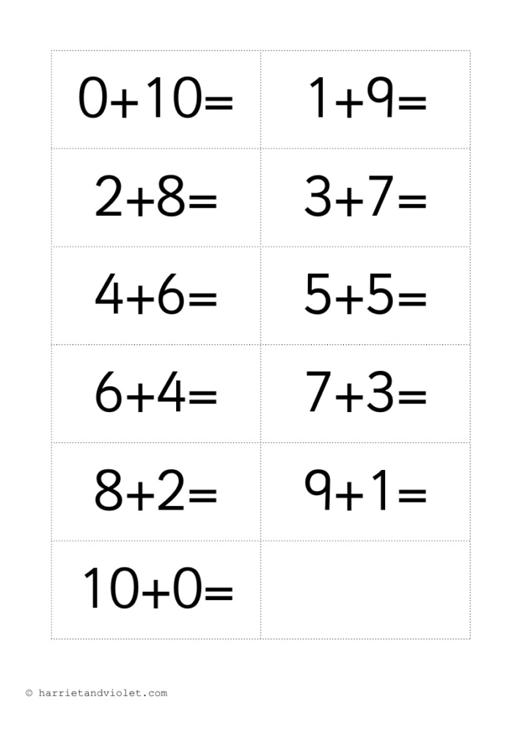 | Numerical Pattern / Number  - Have a deep understanding of numbers to 10, including the composition of each number  - Subitise (recognise quantities without counting) up to 5  - Automatically recall (without reference to rhymes, counting or other aids) number bonds up to 5 (including subtraction facts) and some number bonds to 10, including double facts.  - (Use early number bonds to look within 20)  - Verbally count beyond 20, recognising the pattern of the counting system Build numbers to 20.  - Compare quantities up to 10 in different contexts, recognising when one quantity is greater than, less than or the same as the other quantity Compare numbers within 20.  - Explore and represent patterns within numbers up to 10, including evens and odds, double facts and how quantities can be distributed equally. Look at tens and ones.  Shape, Space & Measure  - Select, rotate and manipulate shapes in order to develop spatial reasoning skills Tangrams  - Compose and decompose shapes within practical activities 2D and 3D shape models  - Continue, copy and create more complex repeating patterns  - Compare length, height, weight and capacity Measure using non-standard and standard measures  - Measure and compare short periods of time stopwatch, sand timers, counting- comparing.  White rose units- Summer 1-To 20 and beyond. How many now? Manipulate, compose and decompose.  Summer 2- Sharing and grouping, Visualise, build and map.
 | Understanding the World  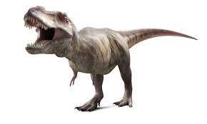 | Past and Present  - Talk about the lives of the people around them and their roles in society  Occupations and jobs- my parents and people in Newton le willows- continue visits to class.  - Know some similarities and differences between things in the past and now, drawing on their experiences and what has been read in class  When did dinosaurs exist? Modern day/dinosaur time- what has changed? What happened to the dinosaurs?  - Understand the past through settings, characters and events encountered in books read in class and storytelling.  Investigate ‘old’ objects- how do we know they are old? Look at artefacts. Compare. Fossils etc  - People, Culture & Communities  - Describe their immediate environment using knowledge from observation, discussion, stories, non-fiction texts and maps  Draw maps for dinosaurs.  Look at local landmarks in newton le willows, around school.  Map of the World.  Volcanoes.  - Know some similarities and differences between different religious and cultural communities in this country, drawing on their experiences and what has been read in class  Different festivals and celebrations.  Places of worship.  - Explain some similarities and differences between life in this country and life in other countries, drawing on knowledge from stories, non-fiction texts and – when appropriate – maps.  - Mini volcanoes. Where did dinosaurs live? Look at globe and revisit oceans/land. Where are we?  Understanding Christianity- What makes a place special/holy? (Places of worship)  Natural World  - Explore the natural world around them, making observations and drawing pictures of animals and plants.  Plant bulbs, beans and seeds. Plant broad beans. Plant our pumpkin seeds, Recap seasonal changes since Autumn…through to Spring.  Parts of a plan, what a plant needs to survive.  Frogspawn- what comes from an egg?  Animal groups- amphibians. (recap over reptiles)  - Know some similarities and differences between the natural world around them and contrasting environments, drawing on their experiences and what has been read in class.  Visit the field. Observations of nature. Observe frogspawn. Learn about amphibians.  Signs of spring.  - Understand some important processes and changes in the natural world around them, including the seasons and changing states of matter.  - Food and animals- food groups- omnivore, carnivore, herbivore.  - Frozen eggs-melting and freezing  - Seasons  - Frogspawn- life cycle of a frog. Change.  - Map of the field.  - Oceans, rivers and lakes- what is the difference? Recap  - Learn about different dinosaurs.
 | Expressive Arts and Design  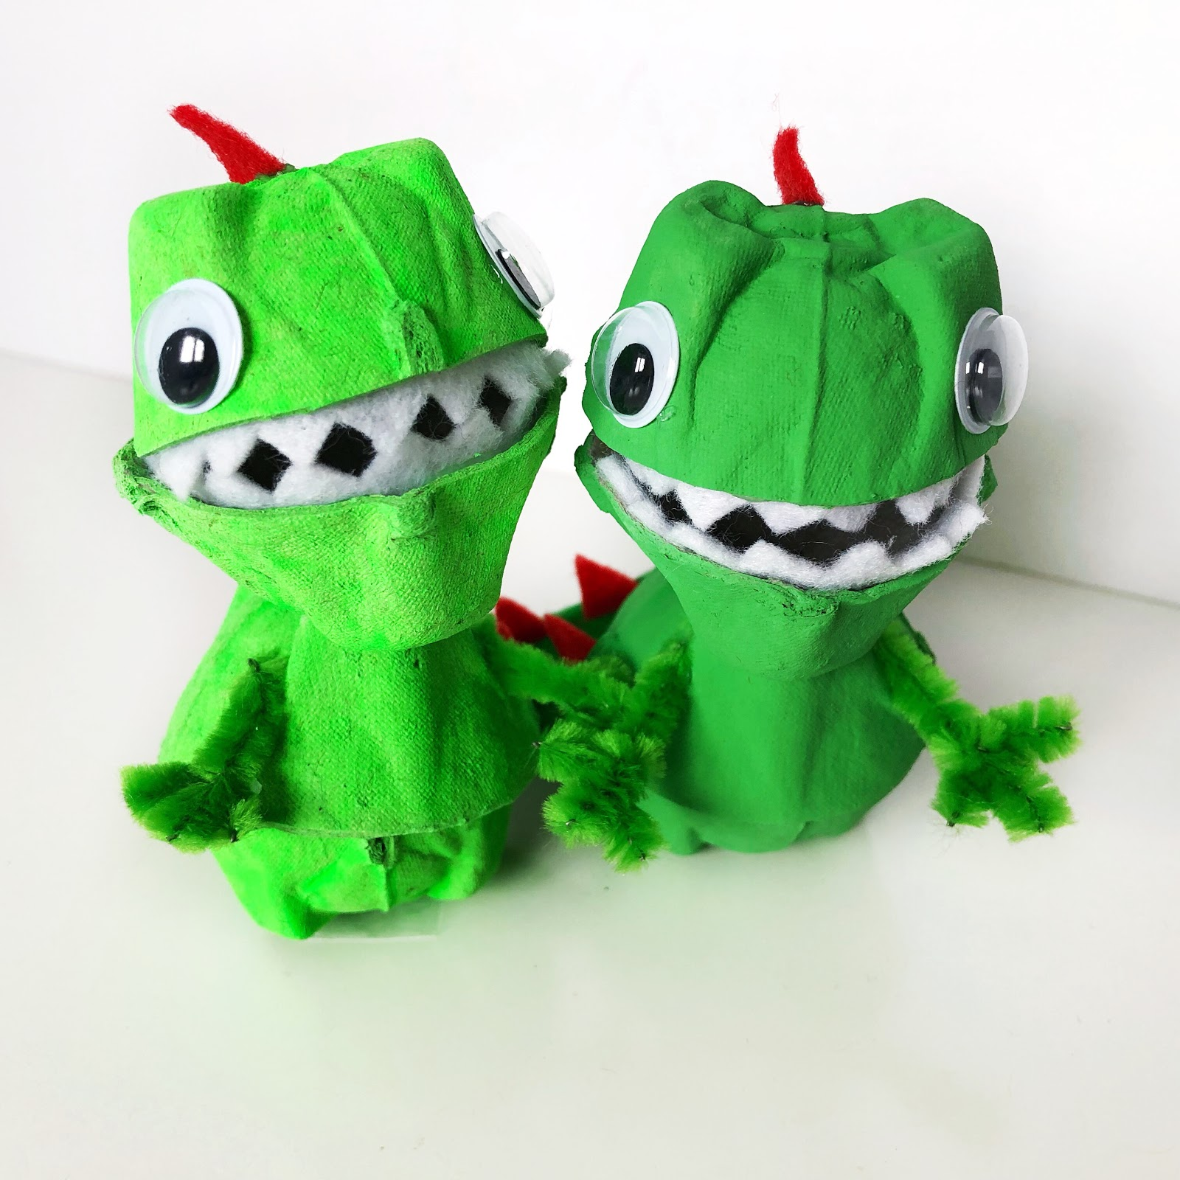 | Creating with Materials  - Safely use and explore a variety of materials, tools and techniques, experimenting with colour, design, texture, form and function  - Share their creations, explaining the process they have used  - Make use of props and materials when role playing characters in narratives and stories.  - Dinosaur models  - Egg box volcanoes  - Create dinosaurs  - Make a safe nest for the eggs  - Make a dinosaur with moving parts.  - Mix paints- paint scenes- ensure colour mixing of primary colours is secure.  Being Imaginative & Expressive  - Invent, adapt and recount narratives and stories with peers and their teacher.  - Sing a range of well-known nursery rhymes and songs.  - Perform songs, rhymes, poems and stories with others, and – when appropriate – try to move in time with music.  - Imagine dinosaur stories and invent new twists etc. Drama.  - Add music to dinosaur sounds/dinosaur clips  - Sing dinosaur rhymes  Flower Threading -DT  Charanga- Big Bear Funk

Characteristics of Effective Learning- Role of the Adult
Playing and Exploring - engagement

Talking aloud helps pupils to think and control what they do. Model self-talk, describing your actions in play.
Model the creative process, showing your thinking about some of the many possible ways forward.
Model the plan-do-review process yourself.
Encourage engagement of all children. Inspire interest in themes and stories.

Active Learning - motivation

Always respect pupils’ efforts and ideas, so they feel safe to take a risk with a new idea.
Give feedback and help pupils to review their own progress and learning. Talk with pupils about what they are doing, how they plan to do it, what worked well and what they would change next time.
Support pupils’ interests over time, reminding them of previous approaches and encouraging them to make connections between their experiences.
Creating and Thinking Critically – thinking

Use the language of thinking and learning: think, know, remember, forget, idea, makes sense, plan, learn, find out, confused, figure out, trying to do.
Model being a thinker, showing that you don’t always know, are curious and sometimes puzzled, and can think and find out.
Encourage open-ended thinking by not settling on the first ideas: What else is possible?
Value questions, talk, and many possible responses, without rushing toward answers too quickly.
Sustained shared thinking helps pupils to explore ideas and make links. Follow pupils’ lead in conversation and think about things together.
Encourage pupils to describe problems they encounter, and to suggest ways to solve the problem.
Show and talk about strategies – how to do things – including problem-solving, thinking and learning.

POSTIVE RELATIONSHIPS  - Events to develop home/school links, with other professionals .... | ENABLING ENVIRONMENTS  - Developing the learning environment, making links with the community ...
Moderation with cluster within EYFS Hub. | Focus on questioning- open ended questions to support shared sustained thinking- and adult interaction within the environment. (EYFS staff)  Planting.  Visit to the library.

TEAM REFLECTION / EVALUATION: (To review part way through half term also)

Possible activities
Personal, Social and Emotional Development
Continue to talk about emotions- themselves and story characters. Feeling sorry. Remorse.
Think about moral of story- telling truth. Continue to develop play social scripts with children. Build relationships.
Self regulation- sensory breaks, kindness box and zones of regulation. What makes a goof friend?
Relationships- Jigsaw
Physical Development
Move in different ways indoors and outdoors. (Make Dinosaur Den)
Use equipment safely.
Scissor control-. Handwriting.
Fine motor activities. Tweeze dinosaurs, dino digs etc
Consolidate Throwing and catching. Parachute games. Running and jumping.
Communication and Language
Talk about our experiences during half term.
Enjoy stories about Spring, Dinosaurs, growing and life cycles.
How do we show we are listening?
Understand how to listen carefully and why listening is important.

Focus on new vocabulary. See list:
Retell simple stories. Articulate ideas.

Giganotosaurus!
Week 1-4
Understanding the World
Describe the natural world around them- Spring changes.
Learn about dinosaurs and their times- Jurassic, Triassic and Cretaceous times.
Food groups.
Maps, compass, maps.- Newton le willows/school.
Look at globe and land/sea. Where are we? Volcanoes.
What comes from an egg? Amphibians.

Literacy Development
Oral rehearsal of sentences.
Write captions and sentences.

Sound out words. Hear rhyme.

Letter formation using rhymes and practise.

Retell story and describe dino. Write story.

Phase 3 secured with ELS. Continue phase 4.

Trips/Visits/Events
Walk on the school field- look at Spring changes.
Planting -seeds etc. Frogspawn/tadpoles in class.

Expressive Art and Design
Safely use and explore a variety of materials and tools-scissors etc
Explore new techniques- printing and rubbing. Sticking, cutting, making books etc, Flower Threading.
Make dinosaurs with clay.
Maths
White rose- To 20 and Beyond.
How many now?
Recognise numerals to 10 and beyond.
Count to 20 forwards and backwards
Spatial resounding- Match , rotate and manipulate. .

Additional Topics:
Computing- Programming beebots
Understanding Christianity- RE- What makes a place holy/special?
Jigsaw- PSHE- Relationships.
Music- Big Bear Funk

Vocabulary
Herbivore
Carnivore
Omnivore

Possible activities
Personal, Social and Emotional Development
Continue to talk about emotions- themselves and story characters. Feeling sorry. Remorse.
Think about moral of story- telling truth. Continue to develop play social scripts with children. Build relationships.
Self regulation- sensory breaks, kindness box and zones of regulation. What makes a good friend?
Relationships- Jigsaw
Physical Development
Move in different ways indoors and outdoors. Dinosaur stomp/Move like a dino.
Use equipment safely.
Scissor control-. Handwriting.
Fine motor activities. Tweeze dinosaurs,
Consolidate Throwing and catching. Parachute games. Running and jumping.
Communication and Language
Enjoy stories about Spring, Dinosaurs, growing and life cycles.
How do we show we are listening?
Understand how to listen carefully and why listening is important.

Focus on new vocabulary. See list:
Retell simple stories. Articulate ideas.
Describe in detail.

Poetry-Behold
Week 5-6
Understanding the World
Describe the natural world around them- changes. What can they see?
Learn about dinosaurs and their times- Jurassic, Triassic and Cretaceous times.
Observe frogspawn over time- frog diaries.
Plan seeds- design seed packets.
Decorate plant pots.
Outline how to care for a plant, how to keep it alive etc.

Literacy Development
Oral rehearsal of sentences.
Write captions and sentences.

Letter formation using rhymes and practise.

Writing describing words/captions.

Phase 3 secured with ELS. Continue phase 4.

Natural vocabulary.

Trips/Visits/Events
Walk on the school field- look at nature to inspire poetry
Planting -seeds etc. Frogspawn in class.

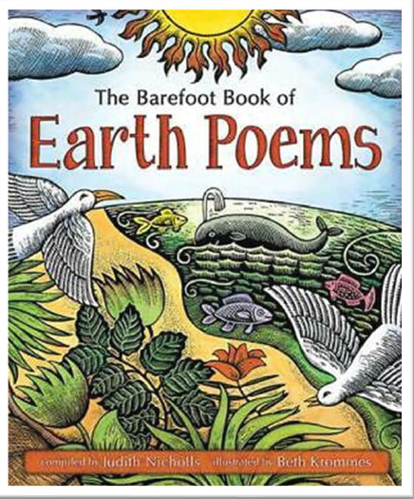
Expressive Art and Design
Safely use and explore a variety of materials and tools-scissors etc
Explore new techniques- printing, mixing etc. Explore materials to make dino skin.
Make dinosaurs. Observe flowers- draw.

Maths

Recognise numerals to 20 and beyond.
Count to 20 forwards and backwards
How many now?
Adding more and taking away.

Additional Topics:
Computing- Programming beebots
Understanding Christianity- RE- What makes a place holy/special?
Jigsaw- PSHE- Relationships.
Music- Big Bear Funk

Vocabulary
Behold
Poem
Beauty

Key Vocabulary
beyond  lava flow  herbivore  carnivore  omnivore  graze  beware  lookout  termite  emergency | beast  lurks  enormous  explore  fear  jaws  muffled  survived  shrugged  palaeontologist

