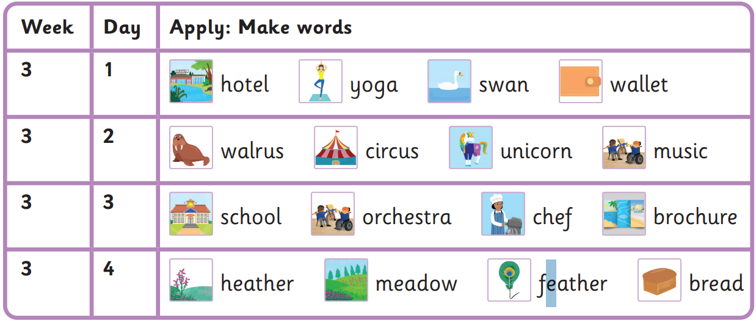
Have you seen the swan in the hotel?
There is a unicorn circus near my house again.
My whole school thanked the chef.
How many feathers do you like in your bread?

Spring 1 Week 3-
o (oa), a (o), u, u (yu), ch (k), ch (sh), ea (e)
Read these sentences
Have whole to many
Again said house people

Harder to read and spell words

