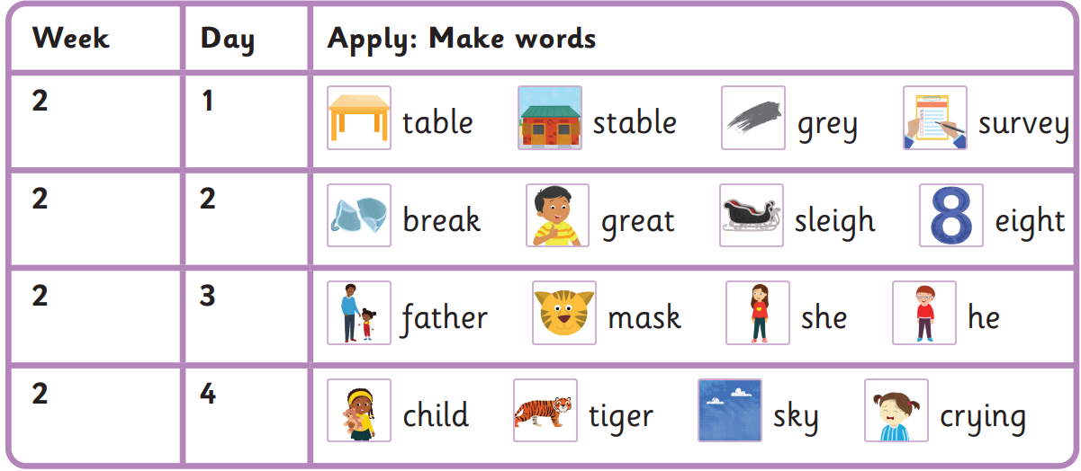
Who wants a grey sleigh?
Will father see a tiger again?
I walked into the table behind the tiger.
I saw the very funny mask he was wearing.
Spring 1 Week 2-
a, ey, ea, eigh, a (ar), e, i, y

Read these sentences
who please want any
again into do very

Harder to read and spell words

