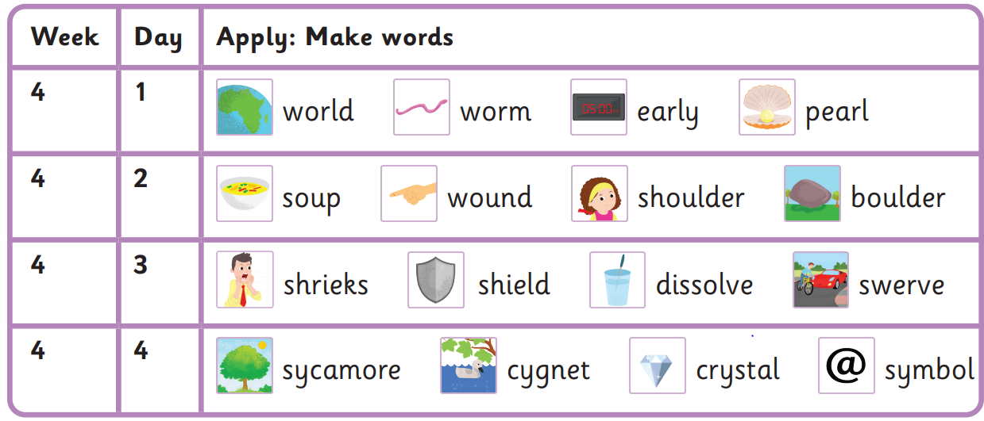
Are you pushing the world?
“I love sugar soup!” shrieked the boy.
The car had to swerve because of a cat in the road.
“Come here, cygnet.” called the girl.

Spring 1 Week 4-
Or (er), ear (er), ou (oo), oul (oa-l), ie (ee), ve (v), y (i),
Read these sentences
Come here sugar are
Because push said love
Harder to read and spell words

