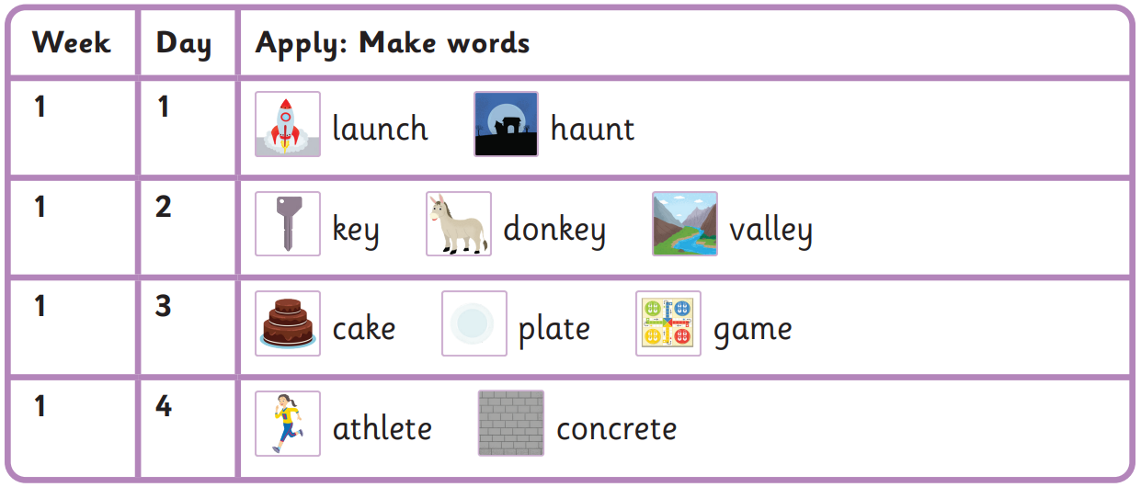
Autumn 2 Week 1-
au, ey, a-e, e-e
Read these sentences
They pressed pause on the launch.
Once the honey was in a valley.
Please eat the cake by the lake.
You need water to make concrete!
house my is water
please was they once

Harder to read and spell words

