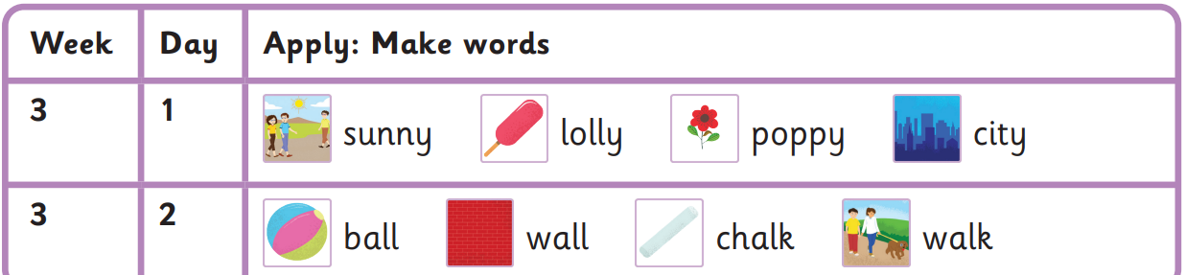
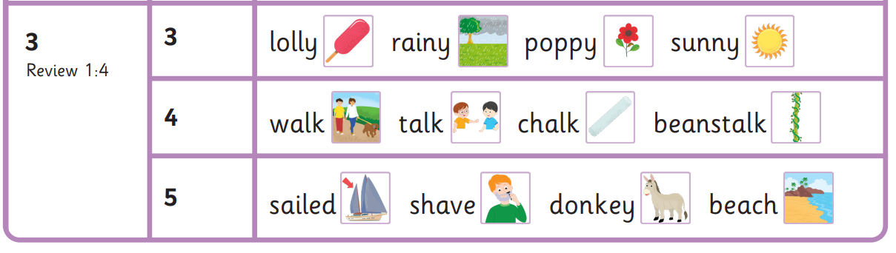
Can children have a lolly on a sunny day?
Please not kick the ball against the wall!
Whose poppy is this?
The boat sailed passed the beach whilst the donkey had a shave.

Autumn 2 Week 3-
Day 1 and 2 y, al Day 3, 4 and 5 Review

Read these sentences
who whose many again
into please do children

Harder to read and spell words

