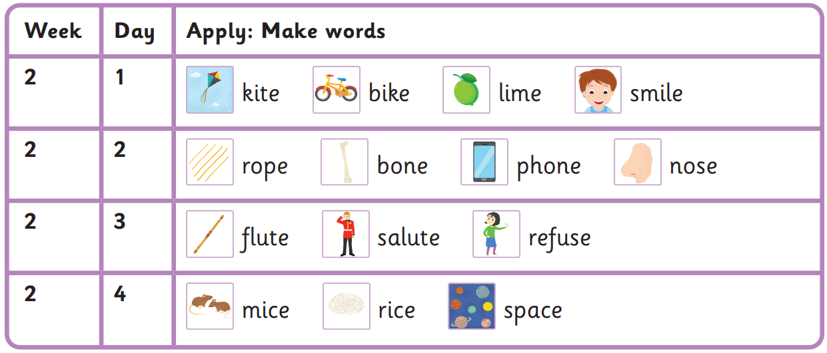
Autumn 2 Week 2-
Split digraphs- i-e, o-e, u-e, c
A split is a vowel digraph that has been split by a consonant.

Read these sentences
Please can I fly your kite? It will make me smile.
Your phone is broke!
Do not refuse to play the flute again.
The little mice went to space to eat rice.
your was please to
many any again little

Harder to read and spell words

