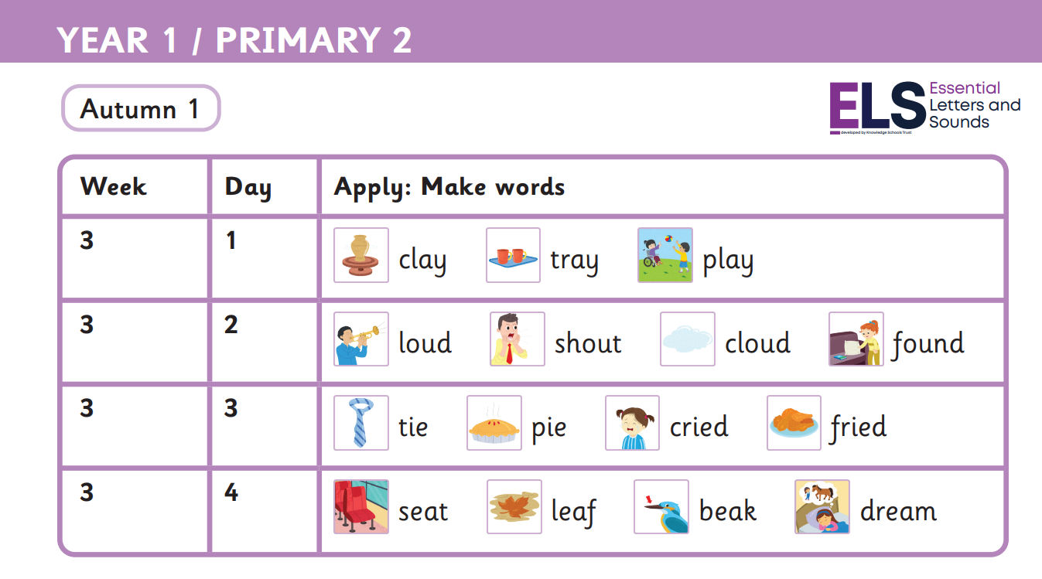
Read these sentences
We play with clay.
They shout at the clouds.
“Let go of the pie!” cried the boy.
I took a seat on a leaf.
we the of go
what they is to
Harder to read and spell words

Autumn 1 Week 3-
Phonemes ay, ou, ie, ea

