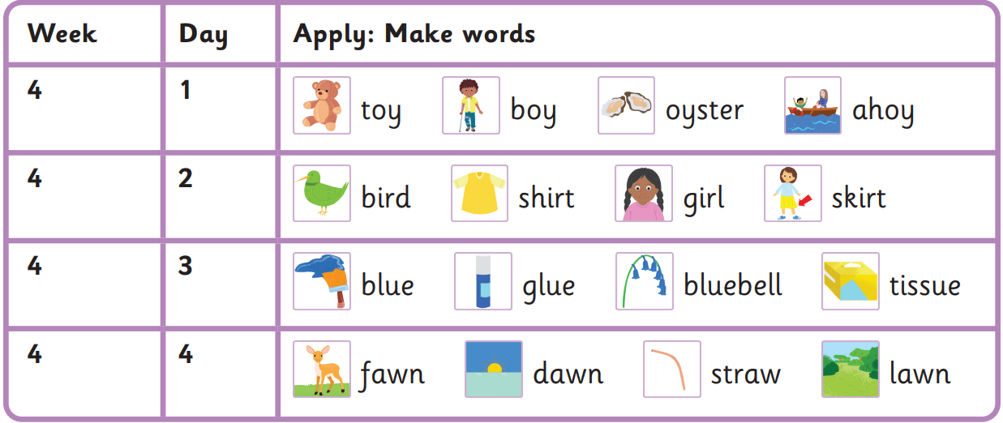
Read these sentences
He shouts ahoy at the boy.
The girl put on a skirt.
My glue is blue.
We have a fawn on the lawn.

was we he your
my of some is
Harder to read and spell words

Autumn 1 Week 4-
oy, ir, ue, aw

