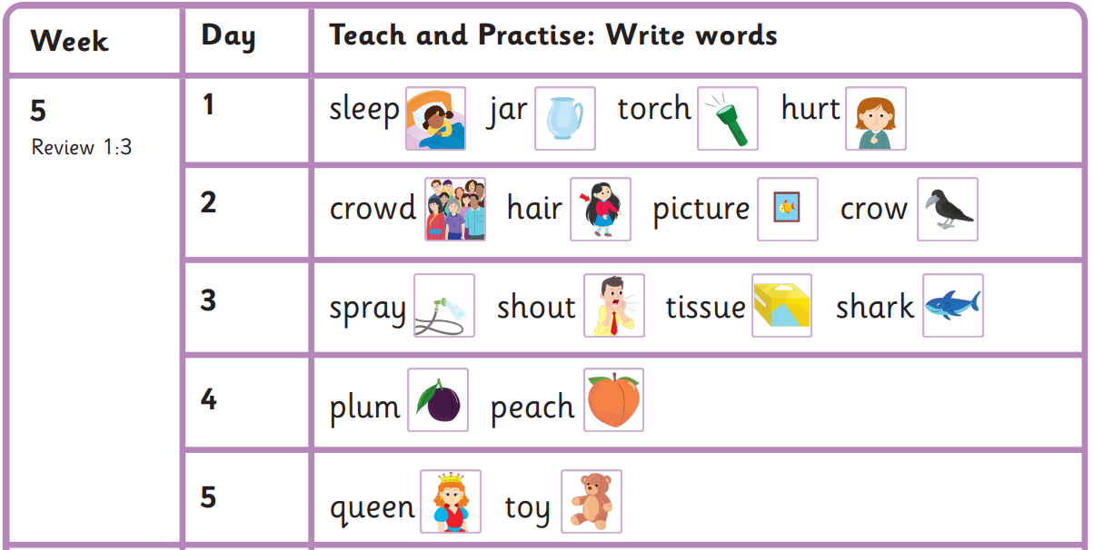
Read these sentences
I hurt my hand with a torch.
Could a crow land on your hair?
If a shark is in the water, shout!
The queen asked for a peach.
you should when asked
water go could is
Harder to read and spell words

Autumn 1 Week 5-
Review week

