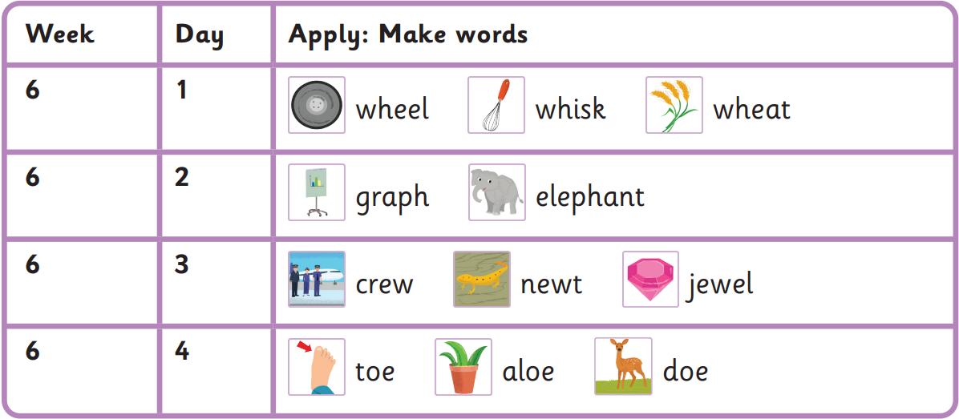
Autumn 1 Week 6-
wh, ph, ew, oe
Read these sentences
Mrs Miller whisked in a wheat field.
The elephant drew their graph.
A crew asked their newt a question.
Oh, the doe stood on my toe!
very people Mrs Mr
house asked oh their

Harder to read and spell words

