Home Activities-Spring 2
Complete the activities in any order and add photographs on Tapestry or add the work into your home book. Bring it in on Wednesdays.
Learn about Easter.  Why is it the most important time in the Christian calendar? What happened at Easter time?  Can you write about Easter in your book?   | Can you hide treasure at home and draw a map to show where it is?  Can you add a compass onto your map?  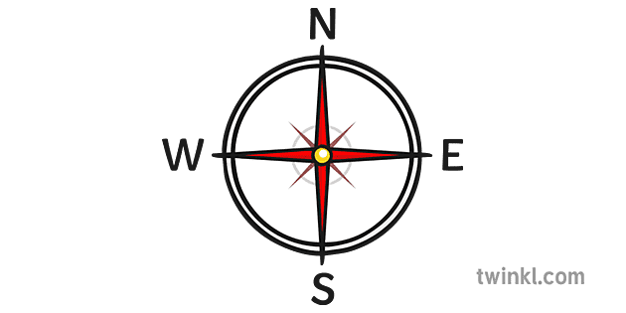 | Draw around your families’ feet and find out who’s is the longest…what can you use to measure them?  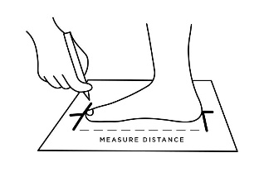
Can you practise making 9 and 10 in different ways? Can you write the fact families in your book?  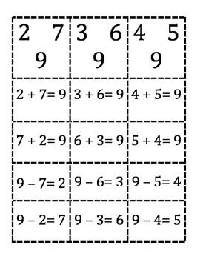 | Explore the world- look at a map or the globe. Think about land and sea. What colour is the land? The sea?  Look at the countries of the World and the different oceans. Where have you been? Where is the UK? What countries are in the UK? Where are we?   | Make a sea creature! Use anything! What did you make? What do you know about it?  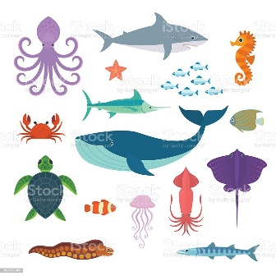
If you could keep one thing safe in a treasure box, what would it be?  What is your treasure?  Draw a picture and write about it.  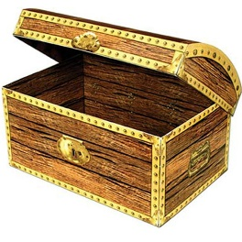 | Practise reading and writing our harder to read and spell words.  he she we me be my you her was buses all they what ball to the no go I what when | Talk about all of the ways that you lead a healthy life. How do you stay healthy and fit?  

We will also sometimes send phonics or maths activities home. We may add activities in the home book from time to time as we learn new skills and topics. If you do anything in the home book, bring it in on a Wednesday, and I will send it home again on Friday.

