
St Peters CE Primary Spring 2 Term Medium Term Planning ‘Land and Sea’

Prime Areas

Seven Features of Effective Practice | Areas |   LEARNING OBJECTIVE(S)  We will be learning to…
The best for  every child  High quality  Care  The curriculum  what we want  children to learn  Pedagogy  helping children  to learn  Assessment –  checking what  children have  learnt  Self- regulation  and executive  function  Partnership  with parents   | Communication and Language  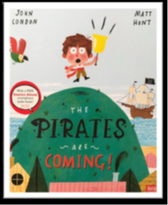 | Listening, Attention and Understanding  - Hold conversation when engaged in back-and-forth exchanges with their teacher and peers.  - Listen carefully to and learn rhymes, poems and songs. Worship songs and nursery rhymes etc  - Listen to and talk about stories to build familiarity and understanding  - Begin to listen to and talk about non-fiction books, developing a familiarity with new knowledge and vocabulary  - Begin to understand humour e.g., nonsense rhymes / jokes  Speaking  - Use new vocabulary in different contexts- see vocabulary list  - Ask questions to find out more and to check they understand what has been said to them  - Articulate their ideas & thoughts in well-formed sentence  - Connect one idea or action to another using a range of connectives- relate to feature story. Hot seating etc  - Describe events in some detail Retell stories, using story maps and illustrations. Describe what happens…  - Develop and use social phrases with confidence ‘Come and play with me’ ‘Can I play here?’ ‘Do you want a turn?’  - Retell a simple story, once they have developed a deep familiarity with the text; some as exact repetition and some in their own words  - Use talk to help work out problems, organise thinking & activities explain how things work/why things happen  Share thinking, reasoning, sharing opinions and thoughts.
 | Personal, Social and Emotional Development  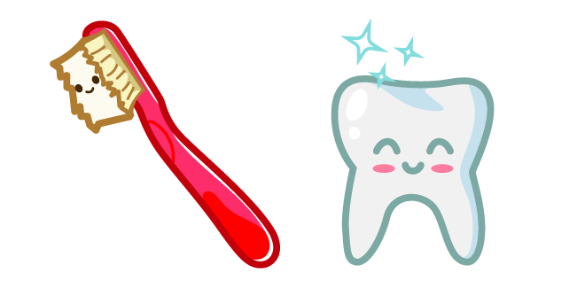 | Self-Regulation  - Express feelings and consider the feelings of others  - Set own goals and show resilience and perseverance in the face of challenge-  - Identify and moderate own feelings socially and emotionally  - Think about the perspectives of others- how do they feel? How do you think you would feel? Hot seating- PIRATES  - Identify and moderate own feelings socially and emotionally  - Focus on □ keeping calm □ being patient □ waiting for a turn □ sharing □ tidying up after themselves  Managing Self  - Manage own self-care needs  - Know and talk about the different factors that support their overall health and wellbeing: □ sensible amounts of ‘screen time’ □ having a good sleep routine □ being a safe pedestrian (recap road safety officer visit)  - Toothbrushing – importance and how … clean, decay – Information from Local Authority sent over. Toothbrushes already given by parent.  - Talk about importance of daily exercise and healthy eating … exercise, healthy / unhealthy, heartbeat, fit – make a healthy fruit salad for the pirates. (Healthy me- PSHE Jigsaw)  Building Relationships  - See self as a valuable individual – follow on from dreams and goals. I am good at….I have learnt to…..  - Build constructive and respectful relationships – use social scripts from social interventions.  - Helping others- friendship-make a friendship display to consolidate RE.  - Reactions and emotions- regulating- discuss own feelings- social stories  - Feeling lonely- read stories and discuss experiences.  - Collaborative sharing-taking turns- my turn, your turn,
 | Physical Development | Gross Motor Skills  - Use different sizes / types of balls – in pairs (throwing and catching)  - Continue to refine the fundamental movement skills they have already acquired: - rolling - crawling - walking - jumping - running - hopping - skipping – climbing- in PE warm ups  - Begin to progress towards a more fluent style of moving, with developing control and grace  - Develop overall body-strength, balance, co-ordination and agility.  - Use their core muscle strength to achieve a good posture when sitting at a table or sitting on the floor  - Combine different movements with ease and fluency  - Confidently and safely use a range of large and small apparatus indoors and outside, alone and in a group  - Further develop and refine a range of ball skills including passing, batting and aiming  Fine Motor Skills  - Develop small motor skills so that they can use a range of tools competently, safely and confidently; pencils for drawing and writing, paintbrushes, scissors, knives, forks and spoons- digging for treasure etc.  - Begin to develop the foundations of handwriting style, which is fast, accurate and efficient, consolidating:  effective pencil grip/Consolidate tripod grip.  - Correct letter formation (see Writing) Use Essential letters and sounds letter formation rhymes and begin to use handwriting lines.  Use write well scheme to consolidate correct formation of letters.  Spring 2- Throwing and catching, using a ball-–PE scheme

Specific Areas

 | Areas | LEARNING OBJECTIVE(S)
Pathways to Write- Spring 2 | Literacy Development | Reading: Comprehension / Word Reading  To create a pirate ship and interact with their peers to role play parts of the story. This may involve relevant mark making.  - Begin to use and understand some recently introduced vocabulary during discussions about stories, non-fiction, rhymes and poems and during role play…fiction, non-fiction, set  - Retell story in small world / role play (in correct sequence) …beginning, middle, end, set  - Take on role of character using some story language  - Talk about likes and dislikes of texts, rhymes and poems  - Choose a book and begin to explain why …because  - Begin to anticipate - where appropriate - some key events in stories …predict / prediction  - Re-read books to build up their confidence in word reading, their fluency and their understanding and enjoyment  - Continue to develop P1 phonological awareness for those who are below ARE , focusing on Oral blending and segmenting in intervention.  - Say the sound for: each letter of the alphabet  - Secure phase 3 □ CVC words and using phase 3 digraphs/trigraphs  - Read some common exception words matched to ELS- he she we me be my was you my they all etc  - Read simple phrases / sentences  - Learn new sounds and apply to reading- trigraphs and digraphs- Read red guided reading books (decodable) aligned to phonic knowledge.  Writing:  To write from the point of view of Tom, describing what he has learned about pirate ships.  - Form most lower-case and capital letter correctly- continue handwriting practise.  - Spell words by identifying the sounds and then writing the sound with letter/s, using taught GPCs - CVC words- Interventions for those not yet securely segmenting and writing cvc word using clusters.  - Write captions/phrases and begin to write simple sentences using known GPCs …sentence, full stop, capital letter  - Include word spacing- finger spaces.  - Orally rehearse caption or sentence before writing. Focus on this in phonics-the apply section of session.  - Re-read what they have written to make sure it makes sense. Check writing- leading to self-correction.  - Begin to write a variety of □ fiction and non-fiction sentences / captions  - Apply phase 3 digraphs and trigraphs/letter clusters into writing.
 | Mathematics developments  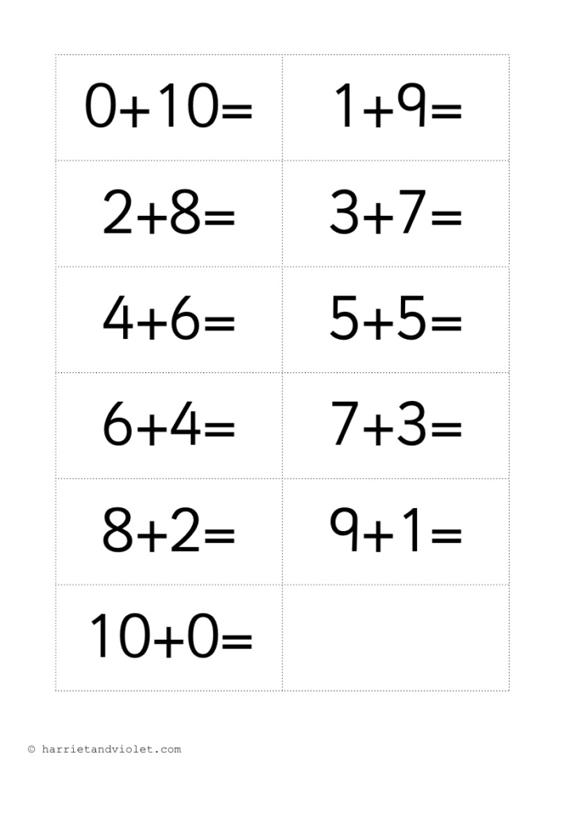 | Numerical Pattern / Number  - Recite numbers to 20- orally  - Backward from 10 and begin to recite backwards from 15  - Break counting chain (not always starting from 1 forward or 10 backwards)  - Talk about position up to 5 and begin to talk about position up to 10  - Count objects, actions and sounds  - Up to 10, in context of □ daily routine □ sharing □ turn taking  - Count objects in an irregular arrangement  - Begin to estimate number of objects up to 10 then check by counting  - Subitise 5 objects (quick recall without counting)  - Link the number symbol (numeral) with its cardinal number value to 10  - Use stem sentence … six is one more than five….one more than five is six  - Begin to explore the composition of numbers to 10- part/whole  - Recall number bonds to 5 – what can you see?  - Find the total number of items (up to 10) in two groups by counting all of them together, using a range of manipulatives … altogether, more/now  - Find the total number of items (up to 10) in a group by take away/subtraction, using a range of manipulatives … left  Shape, Space & Measure  - Select, rotate and manipulate shapes in order to develop spatial reasoning skills  - Begin to compose and decompose shapes within practical activities  - Continue, copy and create repeating pattern  - Compare length, height, weight and capacity Heavier, lighter, mass, longer, shorter etc  - Order 2-3 items by capacity and height  - Begin to order and sequence familiar events  Become familiar with a clock face and hands- in provision  Measure short periods of time- using sand timers, stop watches etc  White rose units- Length, height and time/ Building 9 and 10.  Number bonds to 10. Continue to record in Maths book.
 | Understanding the World  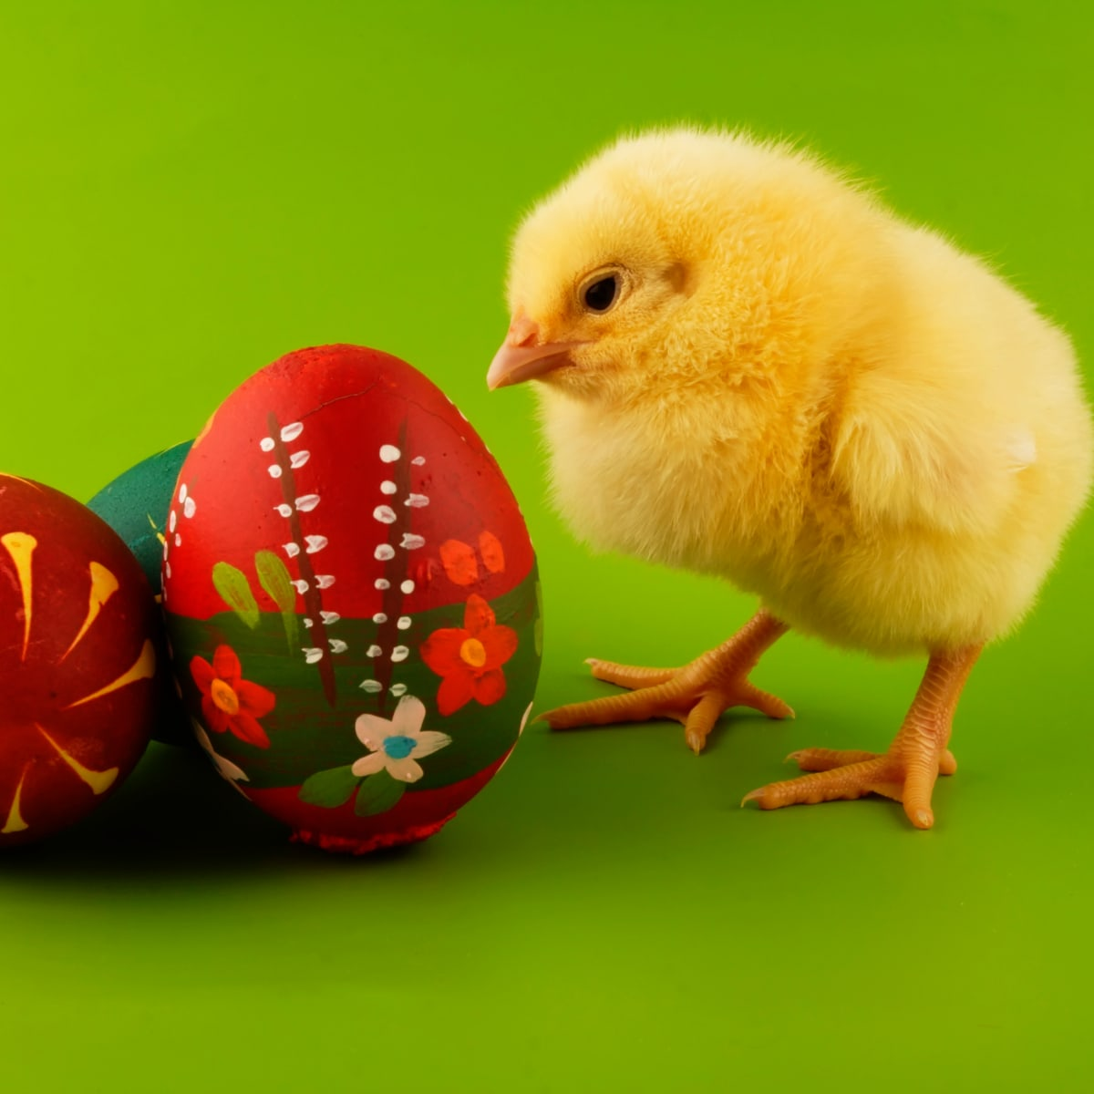 | Past and Present  - Comment on images of familiar situations in the past  - What is a pirate? History of Pirates and settling/voyagers etc…  - How has transport changed over time? (look at buses and public transport) How are new cars different to those in the past?  - People who help us- what is your parents’ occupation? Continue visits from parents to talk about jobs.  - How has communication changed over time? How would you send a message on a ship as a pirate? How can you send a message now? Look at telephones over time and different ways to communicate.  - People, Culture & Communities  - Talk about members of their immediate family and community  - Name and describe people who are familiar to them  - Understand that some places are special to members of their community- look at places of worship  - Recognise that people have different beliefs and celebrate special times in different ways- e.g. Mardi gras, Easter  - Recognise some similarities and differences between life in this country and other countries  - Special journeys  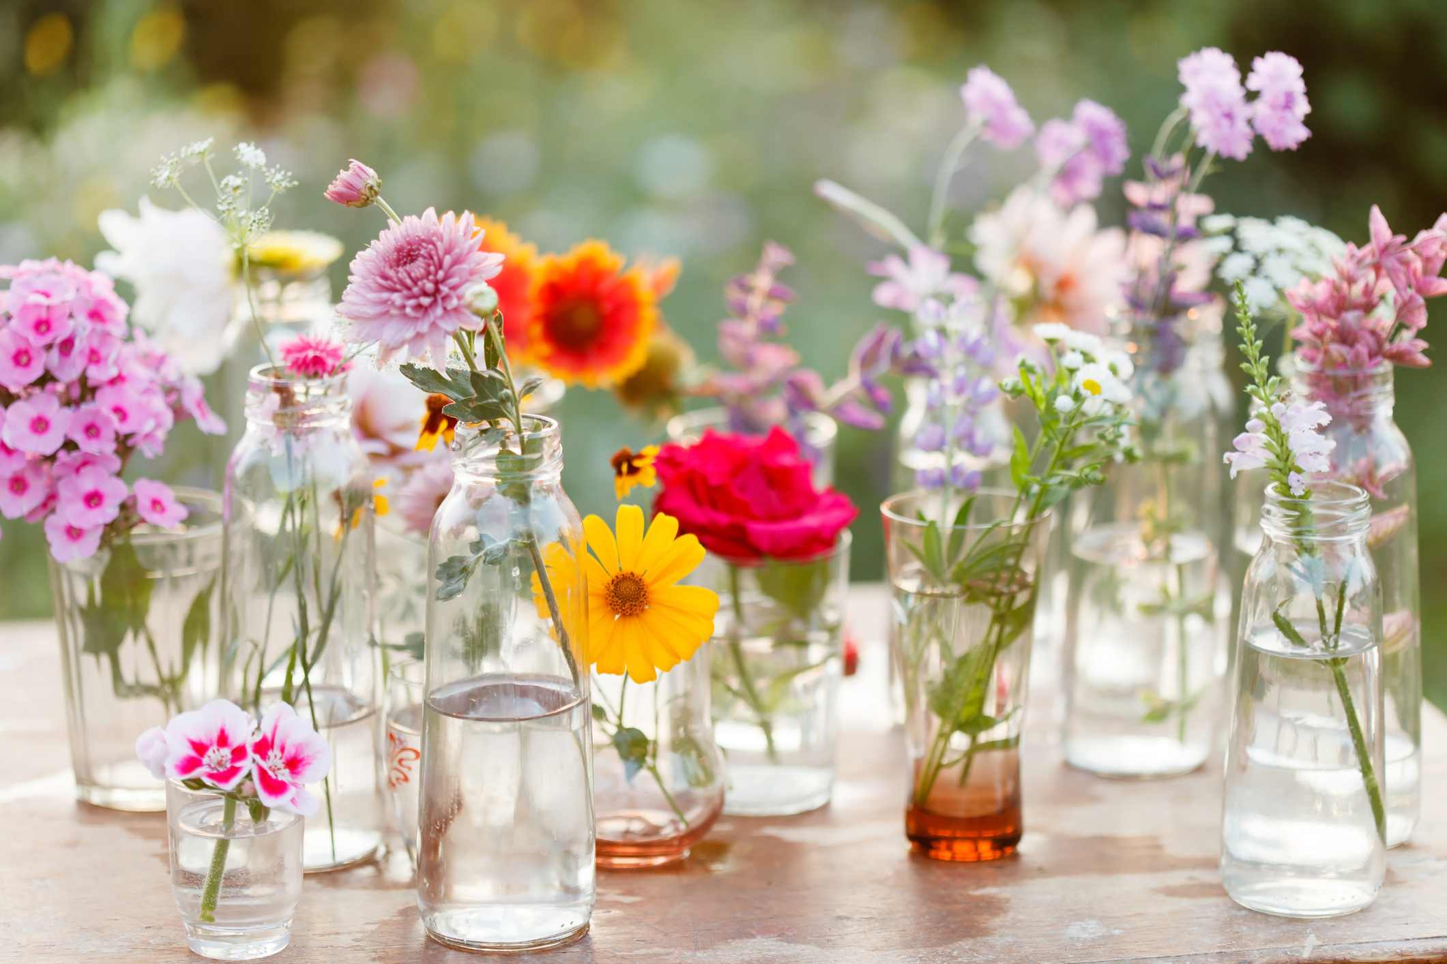  - Faith Journeys and places of worship. Mosque, temple, church…  - Holidays- where have you been in the world?  - Maps and compass- treasure maps and hunts  Understanding Christianity- Easter  Natural World  - Understand the key features of the life cycle of a plant and an animal. Frogspawn in class, plant seeds…  - Begin to understand the need to respect and care for the natural environment and all living things.  - Explore the natural world around them- Spring walk  - Describe what they see, hear and feel whilst outside  - Understand the effect of changing seasons on the natural world around them – changes outside…  - Transport- similarities and differences-land and sea vehicles.  - Animals- similarities and differences- under the sea, dry on land  - Describe and identify materials- treasure hunts- magnetic investigation.  - Signs of Spring  - Rockpool -what would you find in a UK rockpool? Aqualease visit.
 | Expressive Arts and Design  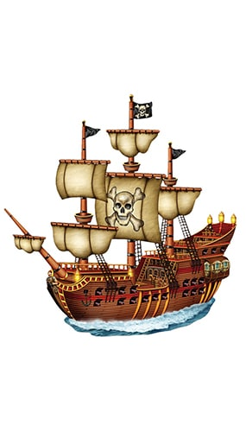 | Creating with Materials  - Explore and use a variety of artistic effects to express their ideas and feelings.  - Return to and build on their previous learning, refining ideas and developing their ability to represent them.  - Create collaboratively sharing ideas, resources and skills.  - Crayon rubbing- natural objects  - Seasonal work- Spring scenes, flowers etc  - Printing- make sea life creatures.  - Messy play/textures- How does it feel? What does it feel like?  - Make a vehicle- on land or sea  - Easter art  - Van Gogh- Sunflowers  Being Imaginative & Expressive  - Listen attentively, move to and talk about music, expressing their feelings and responses.  - Watch and talk about dance and performance art, expressing their feelings and responses- link to sea animals and pirates.  - Sing in a group or on their own, increasingly matching the pitch and following the melody.  - Explore and engage in music making and dance, performing solo or in groups.  - Develop storylines in their pretend play.  - Moving in different ways- link to vehicles and animals  - Adding music to a story  - Moving like the sea- expressing ourselves with music

Characteristics of Effective Learning
Playing and Exploring - engagement

Showing curiosity about objects, events and people.
Pretending objects are things from their experience.
Representing their experiences in play.
Acting out experiences with other people.
Showing a ‘can do’ attitude. Growth mindset.
Active Learning - motivation

Persisting with an activity.
Showing high levels of energy, fascination.
Maintaining focus on their activity for a period of time.

Creating and Thinking Critically – thinking

Making links and noticing patterns in their experience.
Changing strategy as needed.

POSTIVE RELATIONSHIPS  - Events to develop home/school links, with other professionals .... | ENABLING ENVIRONMENTS  - Developing the learning environment, making links with the community ...
EYFS – Parent teacher meetings  Moderation with cluster within EYFS Hub. | Focus on questioning and adult interaction within the environment.  Local area walk- Spring walk end of March.  Aqualease visit- classroom rockpool experience

TEAM REFLECTION / EVALUATION: (To review part way through half term also)

Possible activities
Personal, Social and Emotional Development
Continue to talk about emotions- themselves and story characters. Feeling lonely.
Think about moral of story- telling truth.
Continue to develop play social scripts with children. Build relationships.
Self regulation- sensory breaks, kindness box and five point scale- anxiety. What is important to you- your treasure?
Oral health/healthy eating.
Physical Development
Move in different ways indoors and outdoors. (Make pirate ship etc)
Use equipment safely. (Walk the plank)
Scissor control
Fine motor activities- treasure etc
Consolidate pencil grip- tripod.
Throwing and catching. Parachute games.
Communication and Language
Talk about our experiences during half term.
Enjoy stories about Spring, Sea and land animals and pirates!
How do we show we are listening?
Understand how to listen carefully and why listening is important.

Focus on new vocabulary. See list:
Retell simple stories.

The Pirates are Coming!
Week 1-4
Understanding the World
Describe the natural world around them- Spring changes.
Collect and sort/describe leaves- tree species- recap new vocabulary.
Maps, compass, treasure maps. X marks the spot. Look at globe and land/sea. What is an island?
Sending messages- communication over time.
Describe the differences between transport over time and now. (ships/boats) Boats- Floating and sinking.
Take phots of different vehicles to compare. People who help us.

Literacy Development
Oral rehearsal of sentences.
Write captions and sentences.

Sound out words and write in order.

Letter formation using rhymes and practise. Send messages- in bottle tec.

Retell story and describe pirates/ sea vessels. Write story from Tom’s view.

Phase 3 secured with ELS. Consolidate phoneme gaps. Begin phase 4.

Trips/Visits/Events
Walk on the school field- look at Spring changes. Aqualease.
Planting -seeds etc. Library visit.

Additional Topics:
Computing- Programmable toys
Understanding Christianity- RE- Easter
Jigsaw- PSHE- Healthy Me
Music- Our world.

Expressive Art and Design
Safely use and explore a variety of materials and tools-scissors etc
Explore new techniques- printing and rubbing. Follow trails. Make journey sticks- Spring walk. Leaf rubbing etc.
Make boats. Design pirate flags.
Maths
White rose- length, height and time.
Building 9 and 10
Count to 20 forwards and backwards. (walk the plank)
Composing 9,10.
Ordering numerals to 10.
Introduce money in play- treasure coins.

Vocabulary
Land/Sea
Island Pirate

Possible activities
Personal, Social and Emotional Development
Continue to read stories about emotions- identify and express different emotions.
Discuss healthy eating. Make healthy food plates and design own fruit salad.
Continue to develop play social scripts with children.
Physical Development
Move in different ways indoors and outdoors.
Use equipment safely.
Scissor control-cut out fish etc.
Threading around vehicles.
Throwing and catching.
Pencil grip and link to handwriting write well.
Communication and Language
Talk about our experiences during bus journeys or public transport/ boats etc.
Enjoy stories about People who help us and journeys.
Understand how to listen carefully and why listening is important.

Focus on new vocabulary.
Learn new sea life name and vocabulary.

Commotion in the Ocean
Week 5
Understanding the World
Explore a Mosque and compare to a church. Other places of worship.
Other Faith celebrations- Easter.
Looking at Sea and Land creatures- how are they different?
Introduce frogspawn at end of half term. Discuss and explore growth and change.

Literacy Development
Oral rehearsal of sentences.
Write captions and sentences.
Label sea life.
Rhymes- children generate rhymes.
Describe a sea creature and write about it.
Sound out words and write in order.

Letter formation using rhymes and practise.

Phase 4 with ELS.

Vocabulary
Commotion
Ocean
Sea life
Trips/Visits/Events
‘Children have a creature and verse about it- read to year six buddies’

Maths
White rose- Building 9 and 10
Counting back, comparing numbers.
Making ten.
3D shapes.
Pattern.

Additional Topics:
Computing- Programmable toys
Understanding Christianity- RE- Easter
Jigsaw- PSHE- Healthy Me
Music- Our world.

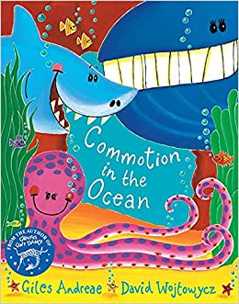
Expressive Art and Design
Safely use and explore a variety of materials and tools-scissors etc
Explore new techniques- make patterned fish and sea creatures.
Make an underwater scene- compare land and sea.
African music.

Key Vocabulary
false alarm  warnings  pelican  attic  barrel  bobbing  villager  rusty  special  trudged  yelled | silently  harbour  gangplank  captain  crew  ashore  narrow  marched  growled  welcome  skull and crossbones

