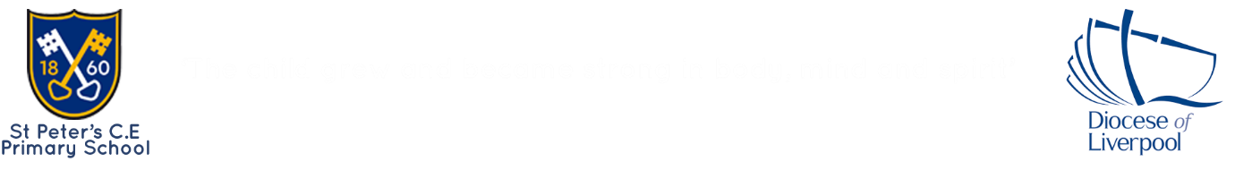
St. Peter’s COE Primary School
Reception Spring Term 1 Newsletter-Mrs Harrison
NOTICES
Please ensure your child brings a labelled water bottle to school each day.
Children will still be using the hall for PE on Mondays, keeping warm. This half term is dance.
Large animals- if you have any unwanted large jungle animals at home for our outdoor area, we would love them! (No cuddly toys please)
We are still collecting kitchenware for our sand kitchen and home corner. Any unwanted, clean appliances, utensils or teapots etc will be gratefully received.
Thank you for your continued Tapestry support. It is lovely to see so many of you posting activities from home. Keep up the great work. We are amazed by the children’s progress so far and excited for 2026!
As part of our dreams and goals topic in Jigsaw PSHE, we are wanting to learn about different jobs in and around Newton. What is your occupation? Perhaps you could come and talk to the children about your job and what you do. You could bring some things to show or some photos and talk about your day at work. Just a 10-minute chat. No pressure!
Speak to Mrs Harrison if you are interested and we will look at the diary!
If you missed any of the workshops and need a catch up, let me know and I can give you a quick run through or have a chat.
Welcome Back
Welcome back and Happy New Year! I hope you all had a relaxing break and are looking forward to a busy half term full of learning. Our new theme is ‘A Special Journey’ and we will be exploring the story ‘Let’s All Creep Through Crocodile Creek’ and the African story ‘All Aboard for the Bobo Road.’ We will be using the texts to explore different travel, animals and the wider world.

To end the half term, we will look at poetry and enjoy reciting rhymes!
This half term, we will be learning the meaning of lots of new words: hibernate, camouflage, creek, reptile, journey, occupation…don’t forget to ask your child about the word/s of the week!

English
We will read the feature text, talking about the emotions of fright and worry. We will retell the story and make story maps. We will continue phase three phonics, learning that two letters make one sound in many words.
Maths
We will consolidate all the different ways to build 5 and then move onto numbers 6, 7 and 8. We will represent the numbers in different ways. We are also going to learn about capacity and measure.
Religious Education
Our RE topic is all about the Bible and stories Jesus heard. We will hear well-known Bible stories and parables.
Understanding of the World
We will learn about different occupations, understanding that many jobs are different. We will look at jobs in the community, our parents’ jobs, jobs in our school and different places of work. We will look at different emergency vehicles. We will make maps and look at the map of the UK and explore where Africa is on the world map. We will learn about animals and in particular, crocodiles! We will explore winter and the seasonal changes.
Outdoor learning
We will explore ‘big write’ outside with water, chalk and ribbon sticks. We will set up a crocodile creek and follow the children’s requests and ideas. This may involve a puppet show shed! We will make a bus stop for the Bobo Road. We will investigate numbers to ten outside, using large tens frames and natural counters, in our ‘messy maths’ area.
Expressive Arts
We will use different materials to explore collage this half term and make vehicles and models using junk materials. We will mix colours and make camouflage art. In music we are learning about beat and rhythm.
PSHE
We are learning about dreams and goals. We will choose our own goals to achieve and discuss how we learn from mistakes. We will become resilient learners! Oh yes, we will!

Please look at the reception class page to read the detailed medium-term plans, whole year Curriculum overviews and a copy of this newsletter.
Contact me on Tapestry or using the class email:
StPetersReception-Y1@sthelens.org.uk

Happy New Year! Mrs Harrison and the EYFS Team.

