
St Peters CE Primary Spring 1 Term Medium Term Planning ‘A special Journey’

Prime Areas

Seven Features of Effective Practice | Areas | LEARNING OBJECTIVE(S)  We will be learning to…
The best for  every child  High quality  Care  The curriculum  what we want  children to learn  Pedagogy  helping children  to learn  Assessment –  checking what  children have  learnt  Self- regulation  and executive  function  Partnership  with parents   | Communication and Language  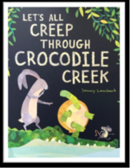 |   Listening, Attention and Understanding  - Hold conversation when engaged in back-and-forth exchanges with their teacher and peers.  - Listen carefully to and learn rhymes, poems and songs.  - Listen to and talk about stories to build familiarity and understanding  - Begin to listen to and talk about non-fiction books, developing a familiarity with new knowledge and vocabulary  Speaking  - Use new vocabulary in different contexts- see vocabulary list  - Ask questions to find out more and to check they understand what has been said to them  - Articulate their ideas & thoughts in well-formed sentences  - Connect one idea or action to another using a range of connectives- relate to our feature story.  - Describe events in some detail  - Develop and use social phrases with confidence  - Retell a simple story, once they have developed a deep familiarity with the text; some as exact repetition and some in their own words  EarlyTalk boost to be completed with group and end assessments done in week.  SALT plans- follow key recommendations and objectives. Incorporate into whole group time, as well as short 1:1 sessions. Begin to use colourful semantics. Continue THINK EQUAL sunshine club.
 | Personal, Social and Emotional Development | Self-Regulation  - Express feelings and consider the feelings of others. Use feelings wall.  - Set own goals and show resilience and perseverance in the face of challenge- link to dreams and goals PSHE/Jigsaw  - Identify and moderate own feelings socially and emotionally  - Think about the perspectives of others- how do they feel? How do you think you would feel? Hot seating.  - Focus on □ keeping calm □ being patient □ waiting for a turn □ sharing □ tidying up after themselves  - Continue sunshine club- using social scripts and expressing emotion.  Managing Self  - Manage own self-care needs  - Know and talk about the different factors that support their overall health and wellbeing: □ sensible amounts of ‘screen time’ □ having a good sleep routine □ being a safe pedestrian- link to role play  - Toothbrushing – importance and how … clean, decay (involve nurse and oral health team)  - Talk about importance of daily exercise and healthy eating … exercise, healthy / unhealthy, heartbeat, fit (use PE lessons and lead into ‘healthy me’ jigsaw piece PSHE spring 2)  Building Relationships  - See self as a valuable individual -What are you good at? Why are you a good friend? Link to ‘dreams and goals’  - Build constructive and respectful relationships  - Helping others- friendship-make a friendship display  - Reactions and emotions- regulating- discuss own feelings  - Feeling lonely- read stories and discuss experiences.  - Collaborative sharing-taking turns- using social scripts and role models.  Continue Think Equal Sunshine Club
 | Physical Development | Gross Motor Skills  - Use different sizes / types of balls – in pairs  - Continue to refine the fundamental movement skills they have already acquired: - rolling - crawling - walking - jumping - running - hopping - skipping – climbing  - Begin to progress towards a more fluent style of moving, with developing control and grace  - Develop overall body-strength, balance, co-ordination and agility.  - Use their core muscle strength to achieve a good posture when sitting at a table or sitting on the floor  - Combine different movements with ease and fluency- link to dance PE  - Confidently and safely use a range of large and small apparatus indoors and outside, alone and in a group  - Digging- use wet sand outside-new sand kitchen  Fine Motor Skills  - Develop small motor skills so that they can use a range of tools competently, safely and confidently; pencils for drawing and writing, paintbrushes, scissors, knives, forks and spoons  - Begin to develop the foundations of handwriting style, which is fast, accurate and efficient, consolidating:  Effective pencil grip-Consolidate tripod grip.  Correct letter formation (see Writing)  Use Essential letters and sounds letter formation rhymes and use handwriting lines.  Use write well scheme to consolidate correct formation of letters with targeted children. See plans.  Spring 1- Dance, response to music and body movement – Jungle Dance- PE scheme- Link to EAD

Specific Areas

 | Areas | LEARNING OBJECTIVE(S)
Pathways to Write- Spring 1 | Literacy Development | Reading: Comprehension / Word Reading  To draw/make a crocodile and be able to describe some of its features to a familiar adult  - Begin to use and understand some recently introduced vocabulary during discussions about stories, non-fiction, rhymes and poems and during role play…fiction, non-fiction, set (see vocabulary list)  - Retell story in small world / role play (in correct sequence) …beginning, middle, end,  - Take on role of character using some story language  - Talk about likes and dislikes of texts- Choose a book and begin to explain why …because  - Begin to anticipate - where appropriate - some key events in stories …predict / prediction- Link to guided read.  - Re-read books to build up their confidence in word reading, their fluency and their understanding and enjoyment  - Continue to develop P1 phonological awareness for those who are below ARE , focusing on Oral blending and segmenting- see plans.  - Say the sound for: each letter of the alphabet  - Mid PHASE 3 □ CVC words and using phase 3 digraphs  - Read some common exception words matched to ELS- he she we me be my was you etc (see list) All words sent home.  - Read simple phrases / sentences independently, using phonic knowledge.  - Learn new sounds and apply to reading- trigraphs and digraphs  - Read red band books by end of spring 1.  Library loans- animals stories, crocodiles, transport.  Writing:  - Form most lower-case and capital letter correctly- continue handwriting practise with write well group.  - Spell words by identifying the sounds and then writing the sound with letter/s, using taught GPCs - CVC words moving to cvcc ccvc  - Write captions/phrases and begin to write simple sentences using known GPCs …sentence, full stop, capital letter  - Include word spacing- finger spaces.  - Orally rehearse caption or sentence before writing. Focus on this in phonics, apply ELS session.  - Re-read what they have written to make sure it makes sense.  - Begin to write a variety of □ fiction and non-fiction sentences / captions
  To create a story map of the journey and write labels/captions/ sentences describing the crocodiles.
Pathways to Write- Spring 1 | Mathematics development  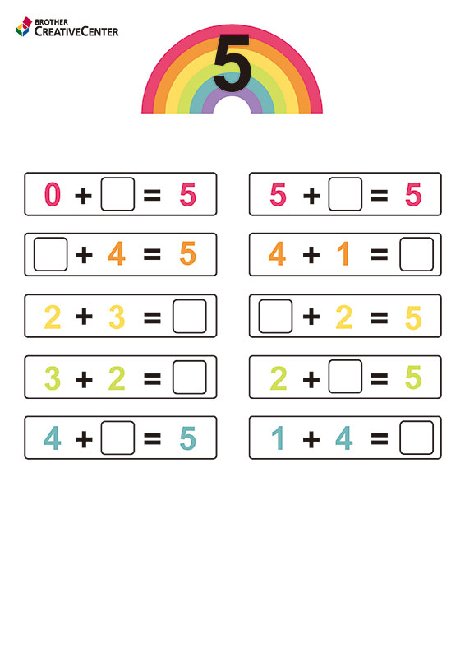 | Numerical Pattern / Number  - Recite numbers to 20- orally  - Backward from 10 and begin to recite backwards from 15  - Break counting chain (not always starting from 1 forward or 10 backwards)  - Talk about position up to 5 and begin to talk about position up to 10  - Count objects, actions and sounds  - Up to 10, in context of □ daily routine □ sharing □ turn taking  - Count objects in an irregular arrangement- order irrelevance.  - Begin to estimate number of objects up to 10 then check by counting.  - Subitise 5 objects (quick recall without counting)  - Link the number symbol (numeral) with its cardinal number value to 10  - Use stem sentence … six is one more than five, one more than five is six…  - Begin to explore the composition of numbers to 10- no recall needed as yet.  - Recall number bonds to 5 and up to 5.  - Find the total number of items (up to 10) in two groups by counting all of them together, using a range of manipulatives … altogether, more- first then now  - Find the total number of items (up to 10) in a group by take away/subtraction, using a range of manipulatives … left, take away, less  Shape, Space & Measure  - Select, rotate and manipulate shapes in order to develop spatial reasoning skills  - Begin to compose and decompose shapes within practical activities  - Continue, copy and create repeating patterns  - Compare length, height, weight and capacity  - Order 2-3 items by capacity and height  White rose units- Alive in 5, Mass and Capacity, Growing 6,7,8
Pathways to Write- Spring 1 | Understanding the World    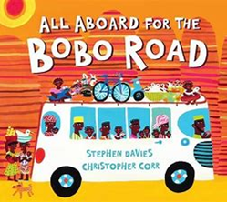 | Past and Present  - Comment on images of familiar situations in the past  - How has transport changed over time? (look at buses and public transport)  - People who help us- begin to ask parents in to talk about their jobs in the community. Occupations.  - People, Culture & Communities  - Talk about members of their immediate family and community  - Name and describe people who are familiar to them  - Understand that some places are special to members of their community- look at places of worship- Revisit a Temple and church. Look at Mosque.  - Recognise that people have different beliefs and celebrate special times in different ways- e.g. Chinese New Year, Eid etc  - Recognise some similarities and differences between life in this country and other countries- African countries school life etc Hot and cold…  - Special journeys  - Faith Journeys  - Holidays  - Maps and compass- Where is Africa? Where are we? UK and around the world.  Understanding Christianity- Friendship  Natural World  - Understand the key features of the life cycle of a plant and an animal- begin to look at animals- crocodile etc  - Begin to understand the need to respect and care for the natural environment and all living things.  - Explore the natural world around them- look at the tree changes, wildlife- use the new Eco Hunt- winter hunt. Hibernation boxes etc.  - Describe what they see, hear and feel whilst outside- winter welly walk.  - Understand the effect of changing seasons on the natural world around them  - Transport- similarities and differences  - Animals- similarities and differences  - Describe and identify materials- revisit these.  - Camouflage  - Investigate hibernation  - How is Africa different to the UK?
 | Expressive Arts and Design | Creating with Materials  - Explore and use a variety of artistic effects to express their ideas and feelings.  - Return to and build on their previous learning, refining ideas and developing their ability to represent them.  - Create collaboratively sharing ideas, resources and skills.  - Crayon rubbing- natural objects  - Seasonal work- winter scenes and snowflakes  - Printing- making animal trails  - Messy play/textures- How does it feel? What does it feel like?  - Make a vehicle- design and make  - Burkina Faso Flags  Being Imaginative & Expressive  - Listen attentively, move to and talk about music, expressing their feelings and responses. Link to PE dance.  - Watch and talk about dance and performance art, expressing their feelings and responses- link to PE- Dance  - Sing in a group or on their own, increasingly matching the pitch and following the melody.  - Explore and engage in music making and dance, performing solo or in groups. Use stage outdoors.  - Develop storylines in their pretend play.  - Moving in different ways- link to vehicles and animals  - Adding music to a story  - Moving like the sea- expressing ourselves with music  - African dances- tribal dance  - Junge dance- PE

Characteristics of Effective Learning
Playing and Exploring - engagement

Showing curiosity about objects, events and people.
Pretending objects are things from their experience.
Representing their experiences in play.
Acting out experiences with other people.
Showing a ‘can do’ attitude. Growth mindset.

Active Learning - motivation

Persisting with an activity.
Showing high levels of energy, fascination.
Maintaining focus on their activity for a period of time.

Creating and Thinking Critically – thinking

Making links and noticing patterns in their experience.
Changing strategy as needed.

POSTIVE RELATIONSHIPS  - Events to develop home/school links, with other professionals .... | ENABLING ENVIRONMENTS  - Developing the learning environment, making links with the community ...
EYFS workshops for parents-mop ups of any parent who needs additional support.  Moderation with EYFS hub. | Focus on questioning and adult interaction within the environment.  SHREC approach. Team training.  VISIT to the library

TEAM REFLECTION / EVALUATION: (To review part way through half term also)

Personal, Social and Emotional Development
Continue to read stories about emotions- identify and express different emotions. Think about the other point of view. Focus on scared and worried.
Continue to develop play social scripts with children.
Talk about celebrations and experiences.
Physical Development
Move in different ways indoors and outdoors. Dance- move to music.
Use equipment safely.
Scissor control
Fine motor threading activities.
Consolidate pencil grip- tripod.
Cutting snowflakes.
Communication and Language
Talk about our experiences during Christmas and holidays.
Enjoy stories about Winter, hibernation, and animals.
How do we show we are listening?
Understand how to listen carefully and why listening is important.

Focus on new vocabulary.

Into the pond!
Week 6
Understanding the World
Describe the natural world around them- Winter changes. Plants.
Collect and sort/describe leaves- tree species- recap new vocabulary. Leaf prints and rubbing. Texture work.
Where do you go on a special journey?
How did you celebrate Christmas?

Literacy Development
Oral rehearsal of sentences.
Write captions and sentences.
Label animals.

Sound out words and write in order.

Letter formation using rhymes and practise.

Retell story and describe animals.

Phase 3 continued with ELS.

Trips/Visits/Events

Visit the field- winter walk..

Maths
White rose- Alive in 5!
Sing number rhymes.
Recognise numerals to 5, 6,7,8.
Count to 20 forwards and backwards.

Additional Topics:
Computing- The computer
Understanding Christianity- RE- Stories Jesus Heard
Jigsaw- PSHE- Dreams and Goals
Music- Everyone!


Expressive Art and Design
Winter art
Safely use and explore a variety of materials and tools-scissors etc
Explore new techniques- printing and rubbing. Follow trails.


Vocabulary
Pond
Drake
Merry

Personal, Social and Emotional Development
Continue to read stories about emotions- identify and express different emotions. Think about the other point of view. Focus on scared and worried.

Continue to develop play social scripts with children.
Physical Development
Move in different ways indoors and outdoors. Dance- move to music.
Use equipment safely.
Scissor control
Pick thorns out of play dough. (sticks)
Fine motor threading activities.
Consolidate pencil grip- tripod.
Communication and Language
Talk about our experiences during Christmas and holidays.
Enjoy stories about Winter, hibernation, and animals.
How do we show we are listening?
Understand how to listen carefully and why listening is important.

Focus on new vocabulary.

Let’s all creep through Crocodile Creek
Week 1-4
Understanding the World
Describe the natural world around them- Winter changes. Plants.
Collect and sort/describe leaves- tree species- recap new vocabulary. Leaf prints and rubbing. Texture work.
Learn about a crocodile.
Other Faith celebrations. Chinese new year.
Where do you go on a special journey?
Camouflage.
How has transport changed?

Literacy Development
Oral rehearsal of sentences.
Write captions and sentences.
Label animals.

Sound out words and write in order.

Letter formation using rhymes and practise.

Retell story and describe animals.

Phase 3 continued with ELS.

Trips/Visits/Events
Visit the library- storytelling session.
Planting -winter plants and bulbs.

Maths
White rose- Alive in 5!
Sing number rhymes.
Recognise numerals to 5, 6,7,8.
Count to 20 forwards and backwards.
Capacity and weight. Weigh animals.

Additional Topics:
Computing- The computer
Understanding Christianity- RE- Stories Jesus Heard
Jigsaw- PSHE- Dreams and Goals
Music- Everyone!

Expressive Art and Design
Camouflage art.
Safely use and explore a variety of materials and tools-scissors etc
Explore new techniques- printing and rubbing. Follow trails. Make journey sticks.

Vocabulary
Creek
Creep
Camouflage

Personal, Social and Emotional Development
Continue to read stories about emotions- identify and express different emotions. Think about the other point of view. Focus on scared and worried.
Discuss healthy eating. Make healthy food plates and design own fruit salad- explore unusual fruits and their origins,
Continue to develop play social scripts with children.
Physical Development
Move in different ways indoors and outdoors. Dance- move to music.
Use equipment safely.
Scissor control
Threading around vehicles.
Fine motor- colouring etc.
Consolidate pencil grip.
Communication and Language
Talk about our experiences during bus journeys or public transport.
Enjoy stories about People who help us and journeys.
Understand how to listen carefully and why listening is important.

Focus on new vocabulary.
Learn new country names/continents and vehicle names etc.

All Aboard for the Bobo Road
Week 5
Understanding the World
Describe the differences between transport over time and now.
Take phots of different vehicles to compare. People who help us.
Explore a Mosque and compare to a church.
Other Faith celebrations- Who prayers in a Mosque?
Looking at Africa and the Map of the World. Link to text.

How has transport changed?

Literacy Development
Oral rehearsal of sentences.
Write captions and sentences.
Label vehicles and people who help us.

Sound out words and write in order.

Letter formation using rhymes and practise.

Retell story and describe Africa.

Phase 3 continued with ELS.

Maths
White rose- Growing 6,7,8.
One more and one less. Adding more.
Recognise numerals to 5, 6,7,8.
Count to 20 forwards and backwards.
Length, height and Time.

Expressive Art and Design
Safely use and explore a variety of materials and tools-scissors etc
Explore new techniques- make food art.
Tate African food and compare.
African music.
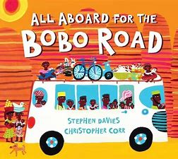

Additional Topics:
Computing- The computer
Understanding Christianity- RE- Stories Jesus Heard
Jigsaw- PSHE- Dreams and Goals
Music- Everyone

Vocabulary
Africa
Bus
Vehicle

Trips/Visits/Events Visit from parent/staff/pupil- to talk about faith (Islam)
‘African’ food day at school-try food from the book

