Home Activities-Spring 1
Complete the activities in any order and add photographs on Tapestry or add the work into your home book. Bring it in on Wednesdays.
We are learning about dreams and goals in Jigsaw PSHE lessons.  What are you dreams? Do you want to achieve something or get better at doing something?  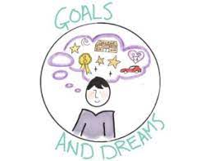 | Find out about a crocodile…can you write a fact and draw a picture?  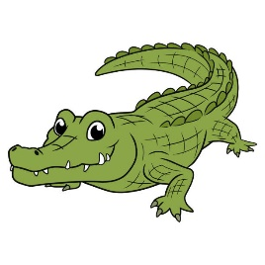 | Choose two objects from home and think about which is heavy and which is light…what is heavier than it? What is lighter? Can you order objects from the heaviest to the lightest?  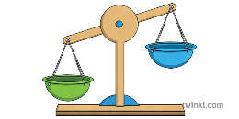
Can you practise making 6,7,8 in different ways? Can you write them in your book?  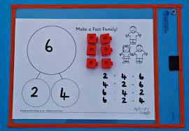 | 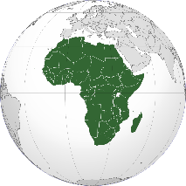  Where is Africa? What can you find out about Africa? Can you see it on a map? Is it close to us or far away? Can you find the UK, where we are? | Make a crocodile! Can you make one out of egg cartons or even Lego? Take a pic for Tapestry!  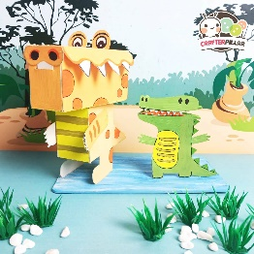
If you could go on a special Journey, where would you go? Perhaps you have been somewhere special? Draw a picture and write about it.   | Practise reading and writing our ‘harder to read and spell’ words.  he she we me be my you her was they all are ball etc  Let me know if you need new ones. | Learn about Chinese New Year.  Can you make a decoration for the festival taking place in February half term?  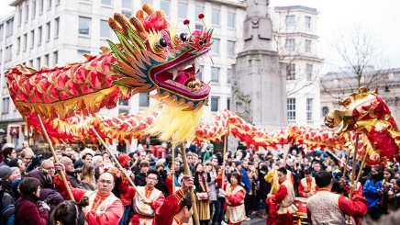

We will also sometimes send phonics or maths activities home. We may add activities in the home book from time to time as we learn new skills and topics. If you do anything in the home book, bring it in on a Wednesday, and the teacher will send it home again on Friday after having a look and celebrating the work.

