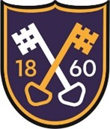
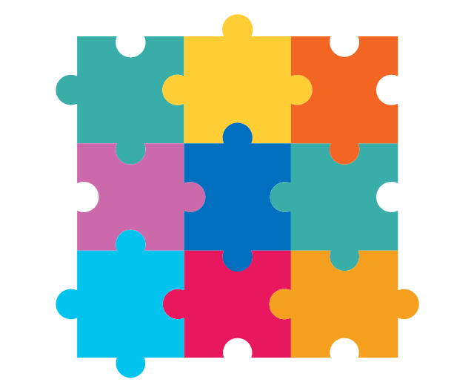
History
This half term we will be looking
at George Stephenson and the ‘Rocket’. We will be looking at changes over time and it’s impact on our local area.

Design and technology
This half term we will be looking at puppets and making our own Christmas themed puppets.
Science
This half term we will be looking at different everyday materials and their properties with links to our local area and glass making.
English
This half term will be looking at the wonderful story ‘Nibbles the book monster’. Nibbles causes mischief and mayhem.
Science Year 2
This half term will be looking at materials, their properties and how these can be applied to real life situations.
Computing
This half term we will be learning
how to use basic
computer programs .
Autumn Term 2 Year 1 Newsletter
Literacy
This half term we will be
reading ‘Lost and Found’. We will write our own version of the story with our newly created characters.

R.E
This half term will be learning about God and creation moving on to Christmas and the symbolism behind gift giving.
PSHE/ Jigsaw
We are unit this half term is ‘Celebrating Differences’. We will look at our differences and what makes us unique.
P.E
This half term will be gymnastics. We will be looking at basic positions, movements and balance.

Maths
This half term, we will
be looking at addition
and subtraction before moving on to 2D and 3D shapes.

