
St Peters CE Primary Autumn 2 Term Medium Term Planning ‘Tell Me a Story’

Prime Areas

Seven Features of Effective Practice | Areas | LEARNING OBJECTIVE(S)  We will be learning to…
The best for  every child  High quality  Care  The curriculum  what we want  children to learn  Pedagogy  helping children  to learn  Assessment –  checking what  children have  learnt  Self- regulation  and executive  function  Partnership  with parents  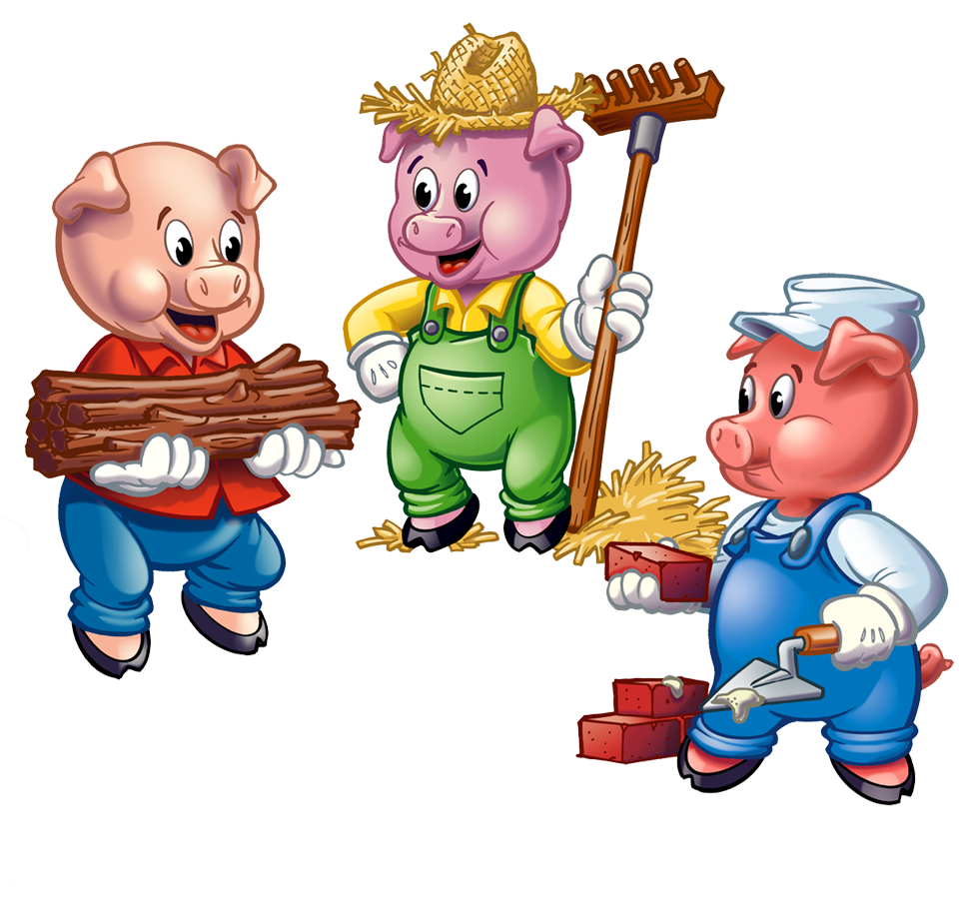 | Communication and Language  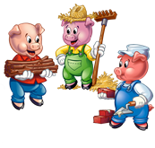 | Listening, Attention and Understanding  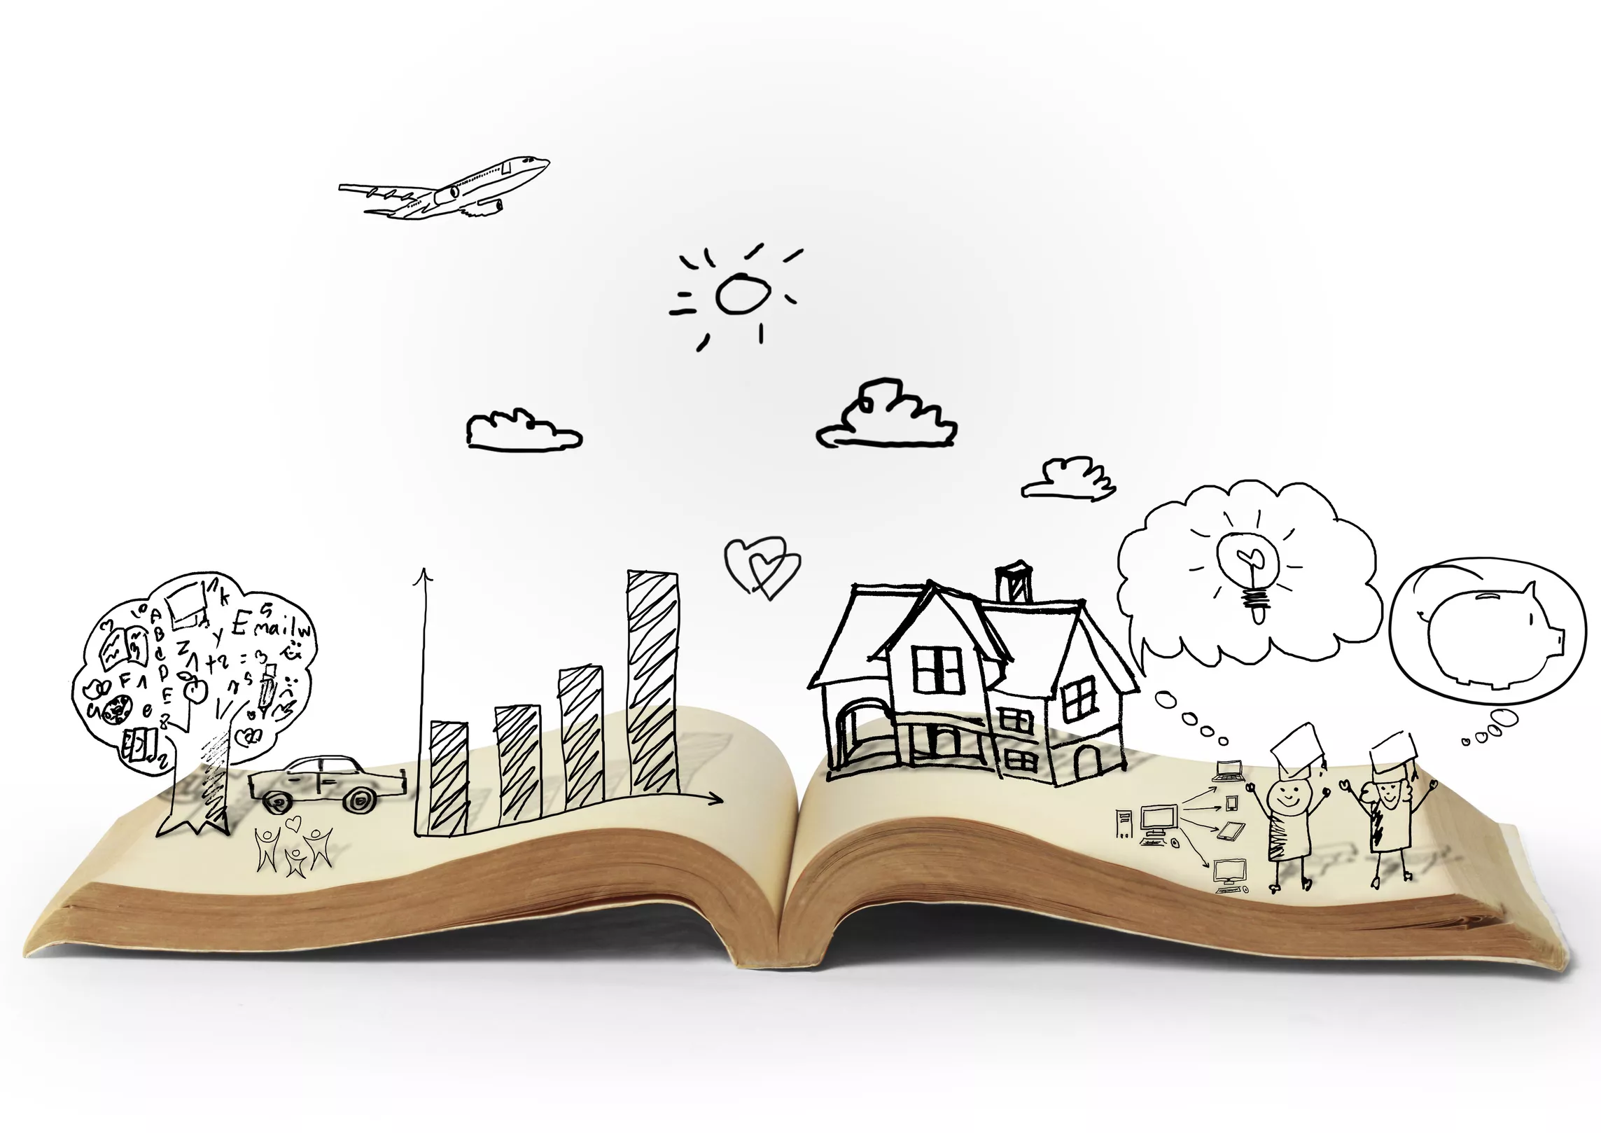  - Understand a question or instruction that has two parts  - Understand ‘why’ questions  - Understand how to listen carefully and why listening is important  - Learn new vocabulary linked to daily routine / theme  - Begin to engage in story time -repeated refrains  - Join in with repeated refrains / fill in rhyming words  - Listen to and begin to talk about stories to build familiarity and understanding  - Discuss characters, events, setting … character, what happened, first, next, then  - Listen carefully to rhymes and songs and begin to pay attention to how they sound  - Learn rhymes, songs & poems  - Anticipate words, begin to adapt phrases (with support)  Speaking  - Use new vocabulary throughout the day  - Begin to ask questions to find out more and to check they understand what has been said to them  - Begin to articulate their ideas and thoughts in well-formed sentence  - Begin to connect one idea or action to another using a range of connectives… because, although, but...  - Begin to describe events in some detail -news time, story time, retell etc  - Develop social phrases - use scripts  - Focused & linked texts – within small world / role play  - Begin to retell a simple story, once they have developed a deep familiarity with the text; some as exact repetition and some in their own words  - Develop social phrases  - Routines of the day … greetings- hi, how are you? Can I play? That looks fun.  - Friendship … Would you like to…? Can I have a turn please? Do you want to play? Sunshine club
 | Personal, Social and Emotional Development | Self-Regulation  - Begin to express feelings and consider the feelings of others  - Identify and name emotions … emotion, lonely, sad/happy, confident, pleased, frightened, angry, confused, disappointed, nervous/worried, excited (try to add more than happy and sad)  - Link book character’s emotion to own experiences … expression, mood, feeling/emotion  - Begin to set own goals and show resilience and perseverance in the face of challenge  - Begin to identify and moderate own feelings socially and emotionally  - Focus on □ keeping calm □ being patient □ waiting for a turn □ sharing □ tidying up after themselves  Managing Self  - Manage own self-care needs … fasten coat  - Develop confidence to try new activities and show independence  - Access all types of enhancements (indoors & outdoors)  - Toothbrushing – importance and how … clean, decay  - Talk about importance of daily exercise and healthy eating … exercise, healthy / unhealthy, heartbeat, fit  Building Relationships  - Begin to see self as a valuable individual  - Describe self, positively … proud, special, love (use books: ‘Its good to be me) Use feelings books,  - Begin to build constructive and respectful relationships
 | Physical Development | Gross Motor Skills  - Revise and refine the fundamental movement skills they have already acquired: - rolling - crawling - walking - jumping - running - hopping - skipping – climbing  - Engage in and develop confidence in actions  - Begin to develop overall body-strength, balance, co-ordination and agility.  - Use above actions, within obstacle courses … balance, obstacle, spatial, prepositions (LA support on SALT plans)  - Set own physical challenge … challenge, goal  - Begin to use their core muscle strength to achieve a good posture when sitting at a table or sitting on the floor … straight, upright, flat  - Change movements / directions quickly  - Begin to confidently and safely use a range of large and small apparatus indoors and outside, alone and in a group  - Further develop and refine a range of ball skills including throwing, catching, kicking –  - Use different sizes / types of balls – in pairs- follow on from PE lesson. Add more balls to outdoor trolley.  Fine Motor Skills  - Use a comfortable grip with good control when holding pens and pencils  - Consolidate tripod grip  - Continue to develop small motor skills so that they can use a range of tools competently, safely and confidently. Add pics and vocab to the dough wall.  - Ensure regular engagement and develop confidence in use of tools… grip, steady, snip, twist, curve, straight  Autumn 2- use of equipment and spatial awareness- body movement – Multi skills- PE scheme

Specific Areas

 | Areas | LEARNING OBJECTIVE(S)
Pathways to Write- Autumn 2  Mother Goose rhymes  Three Little Pigs  Letter to Santa | Literacy Development | Reading: Comprehension / Word Reading  - Begin to retell simple stories and narratives using their own words and some recently introduced vocabulary.  - Recall key events … event  - Talk about main characters… character, beginning, middle, end  - Begin to re-read books to build up their confidence in word reading, their fluency and their understanding and enjoyment  - Understand the five key concepts about print, with a focus on -Left to right /1-1 correspondence … word, letter, first / last  Continue to develop P1 phonological awareness, focusing on;  - Rhythm & rhyme; alliteration (initial sounds); oral blending and segmenting … blending, segmenting  - Read individual letters by saying the sounds for them  - Blend sounds into words, so that they can read short words made up of known GPCs  - Begin to read a few common exception words -I, go, to, the, no, into … harder to read and spell words.  - Secure P2 phonics … phoneme, grapheme, alphabet letter names. Digraphs -begin.  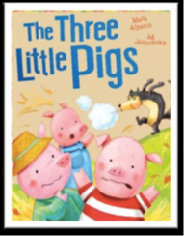  - Blend sounds into words, so that they can read short words made up of known GPCs  - P2 □ VC words □ CVC words  - P3 Begin straight away, supporting those not fully secure phase 2 with additional 1:1/groups, in class support.  Writing:  - Write name correctly  - Use some of their print and letter knowledge in their early writing  - Begin to form lower-case letters correctly  - Begin to spell words by identifying the sounds and then writing the sound with letter/s, using known GPCs … spell  - Use □ initial sounds □ VC □ CVC words Begin to write captions.  - Write labels  - Oral rehearsal / vocabulary  - Begin to write lists & captions, focusing on …label, caption, space  - Oral rehearsal / new and pre taught vocabulary  - Begin to reread what they have written
 |   Mathematics developments | Number  - Recite numbers to 10  - Forward & backward  - Break counting chain (not always starting from 1)  - Talk about position … before, after – check use of language  - Count objects, actions and sounds ,Up to 5  - Count objects in an irregular arrangement  - Subitise 3 / 4 objects (quick recall without counting) Daily maths sessions.  - Matching children to images in workshop areas  - Fast recognition of dice patterns  - Link the number symbol (numeral) with its cardinal number value to 5  - Compare quantities up to 5 … more than, less than, fewer, who has one more / less  - Understand ‘one more/less than’ to 5  - Use sentence with support … Three is one more than two , focus on oracy and stem sentences.  - Using variety of resources … more, less, makes, equals, altogether  - Use a range of resources  Shape, Space & Measure /Numerical Pattern  - Select, rotate and manipulate shapes in order to develop spatial reasoning skills  - Create shape picture …consolidate …2D shape names – triangles and circles. Shapes with 4 sides.  - Put shapes together to make new shape … fit, turn  - Continue, copy and create repeating patterns RECAP  - Begin to compare length, weight and capacity  - Order 2-3 items by length / weight … heavier/est, lighter/est, longer/est, shorter/est RECAP
 | Understanding the World | Past and Present  - Begin to make sense of their own life-story and family’s history  - Begin to comment on images of familiar situations in the past  - When Mum and Dad were little … past, history, long ago  - Stories from my parents’ childhood.  - Discuss how we have changed and grown. Recap baby pics.  - How has house building changed over time? (Construction)  - People, Culture & Communities  - Talk about members of their immediate family and community  - Describe family members … grandparent, older, younger  - Understand that there are many different types of families …parent, stepsister / brother / mum / dad, similar, different  - Name and describe people who are familiar to them -People in their local / school community… site manager, office manager, lolly pop person, teacher, head teacher  - Begin to understand that some places are special to members of their community  - Talk about special places they go with their family… places of worship visited by children – different between church and Temple  - Understand how different people celebrate birthdays- share memories and accounts of birthdays.  - Develop a knowledge and awareness of other festivals … Harvest, Diwali, Christmas  Natural World  - Explore the natural world around them  - Leaves □ sort by shape/size – visit the field and learn about tree species. Follow on from autumn walk…  - Describe what they see, hear and feel whilst outside  - Leaf shape, size & colour… shape and colours words e.g. long, spiky, gold, rust, orange (Vocabulary)  - Understand the effect of changing seasons on the natural world around them – Autumn into Winter  - Observe / talk about changing seasons  - seasons … season, summer, autumn, winter -changes in autumn … temperature, change, hibernation, darker, weather, wind  - (Name animals and their babies .Farm animals.  - Investigate wind, blowing and how objects can blow away or stay standing. Look at materials  - Plant seeds and care for growing plants outside in the planter. (Plant winter plants)  - Begin to understand the key features of the life cycle of a plant and an animal. (return in spring to this) Farm animals.  - Begin to understand the need to respect and care for the natural environment and all living things. Hibernation houses. DT link.
 | Expressive Arts and Design | Creating with Materials  - Draw with increasing complexity and detail, such as representing a face with a circle and including details  - Show different emotions in drawings and paintings  - Safely use and explore a variety of materials and tools  - Explore new techniques  - Talk about new creations  - Begin to return to and build upon previous learning  - Mixing cement- using different materials, sorting and building with materials. Explore new sand kitchen and pump.  - Observational drawings  - Design a trap for the wolf. Hibernation house in eco hub.  - Clay Diwa lamps  - Junk model- the three pigs houses.  - Christmas crafts  Being Imaginative & Expressive  - Take part in simple pretend play - role, pretend, imagine  - Begin to develop complex stories using small world equipment  - Begin to develop storylines in their pretend play – including those linked to focus text … story language, character, beginning, middle, end – Three Little Pigs  - Begin to listen attentively, move to and talk about music, expressing their feelings and responses  - How does the music make me feel? … emotions vocabulary (see PSE- emotions on feelings wall)  - Sing in a group or on their own  - Engage in circle and partner songs  - Begin to explore and engage in music making and dance – use music area and stage/music lessons  - Invent and dance / play music to show different emotions … emotions vocabulary (see PSE)

Characteristics of Effective Learning
Playing and Exploring - engagement

Showing curiosity about objects, events and people.
Pretending objects are things from their experience.
Representing their experiences in play.
Acting out experiences with other people.
Showing a ‘can do’ attitude. Growth mindset.

Active Learning - motivation

Persisting with an activity.
Showing high levels of energy, fascination.
Maintaining focus on their activity for a period of time.

Creating and Thinking Critically – thinking

Making links and noticing patterns in their experience.
Changing strategy as needed.

POSTIVE RELATIONSHIPS  - Events to develop home/school links, with other professionals .... | ENABLING ENVIRONMENTS  - Developing the learning environment, making links with the community ...
EYFS workshop for parents- Maths- early number skills  Moderation with cluster within EYFS Hub.  Lyme and ST Marys moderation? Get cluster back together. | Local area walk- Welly walk- Further Autumnal changes- leaf collection and identification.  Croxteth Farm school trip- November.13th

TEAM REFLECTION / EVALUATION: (To review part way through half term also)

Communication and Language
Talk about families, events in lives.
Enjoy stories about animals.
Speaking and listening circle times. Hot seating.
Understand how to listen carefully and why listening is important.

Learn new vocabulary linked to the next and materials etc.

Encourage collaboration and working together in role play areas. Talking to peers.

Physical Development
Move in different ways indoors and outdoors- act out the 3 pigs/wolf’s movements.
Finger frenzy- pick up piggy tails in mud (pasta), build as house with cards, cut out shapes to make a house.
Make a wolf den outside.
Begin to use equipment safely- cut out characters.
Draw story on large paper.
Complete finger gym activities- threading etc.
Personal, Social and Emotional Development
Discuss The characters’ feelings throughout the story.
Talk about how you would feel if you were a pig or the wolf.
Link emotions to characters.
Set up home corner as ‘The three Pigs story.’

Understanding the World
Investigate wind and what materials are easy to blow down. Good materials to build with. (predict and test)
Compare houses in community and materials.
Name the materials from the three houses. Describe properties- vocabulary.
Name farm animals’ friends for the pigs.
Baby animals and adult.

Three Little Pigs
Week 2-5
Literacy Development
Oral retelling of story- thread the story in reading area.
Use props to retell story and make story sack/book.
Draw images and write labels to represent story.
Label characters.
Label a plan and write a simple caption.
Read and write CVC labels with support.
Write captions and words to retell the story.

Expressive Art and Design
Make wooden spoon pigs for story telling.
Builders tray to sort and build.
3D house using pasta and marshmallows.
Print with blocks and straw. Sing farm songs. Diwa lamp.

Maths
1,2,3,4,5
Sort animals from the book- count how many in each group.
2D shape houses and pigs.
Count within 5. 1,2,3,One more/less.
Shapes with 4 sides

Additional Topics:
Computing- using a PC
Understanding Christianity- RE- Special places/Christmas.
Jigsaw- PSHE- Celebrating difference.
Music- My stories!

Vocabulary
See list…
Wood, sticks, bricks, construct.
Construct
Trips/Visits/Events
Local area walk- look at houses.
Visit from construction?

Communication and Language
Talk about the rhymes we know.
Daily routines e.g., tidy up time, challenges, listening rules.
Enjoy different rhymes.
Speaking and listening circle times.
Understand how to listen carefully and why listening is important.

Learn new vocabulary linked to rhymes.

Physical Development
Finger frenzy- threading rhyme characters.
Begin to use equipment safely- scissor control and pencil grip.
Use gross motor skills to build nursery rhyme scenes.
Make a grandfather clock outside.
Dance to music.

Personal, Social and Emotional Development
What is special about your home?
Independence- what goals can you set for yourself?
Rules and routines at home and school.
Working together to perform a rhyme with instruments.



‘Mother Goose’ Rhymes
Week 1
Understanding the World
Think about Jesus Birthday and how we celebrate. How do other communities and faiths celebrate birthdays?
What other buildings are special in our community?
Christmas- how do we celebrate? What other celebrations are important to others?

Literacy Development.
Concepts about print/reading behaviours.

Draw images and write labels.
Hear and say rhymes and alliteration.

Read and write CVC labels with support.
Write caption and words – to complete rhymes.
Write their own rhyme/part of rhyme.
Phase 3 phonics.

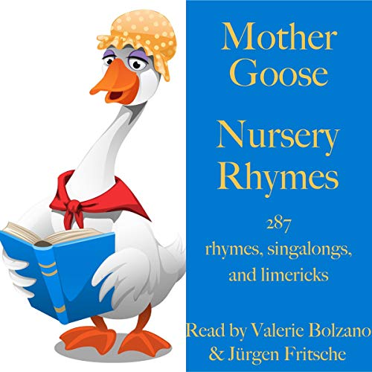
Expressive Art and Design
Paint nursery rhyme characters.
Junk modelling- props from rhymes. Show time- on stage- rhymes.
Make rhyme cards.
Maths

Subitise numerals to 5/representations.
Circles and triangles.

Subitising 12,3,4,5

Additional Topics:
Computing- Rigby star- internet.
Understanding Christianity- RE- Special places/Christmas.
Jigsaw- PSHE- Celebrating difference.
Music- My stories!

Vocabulary
nimble
candlestick
fiddle curds whey
sport
tuffet
curds and whey

Trips/Visits/Events
Trip to the farm.

Physical Development
Finger frenzy- Snowball- - tweezer pom poms into a winter scene.
Begin to use equipment safely- cut out pumpkins to decorate. Make decorations for home corner- Christmas.
Small world- have Nativity scene.
Build Santa’s sleigh. Role play.

Personal, Social and Emotional Development
How can we show our feelings?
What is special about Christmas time?
Independence- can you do your own zip? Put on your own coat?
Rules and routines.
Communication and Language
Use new vocabulary to describe Winter scenes and Christmas.
Daily routines e.g., tidy up time, challenges, listening rules. Visual timetable. Introduce challenge cards.
Enjoy stories about Christmas.
Speaking and listening circle times.
Conversation modelling and time to talk.

‘Letter to Santa’
Week 6-7
Understanding the World
Explore the Christmas Story and think about other festivals in other faiths.
Winter walk- begin to look for signs of Winter for next term…

Literacy Development
Retell the story as a group.

Wish list.

Read simple captions and words, in letter.

Write own letter to Santa

Phase 3 phonics.

Trips/Visits/Events
Post letter.
Signs of Winter/Seasons.

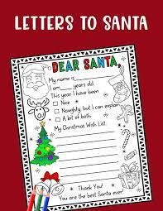
Expressive Art and Design
Christmas crafts, cards, calendars.
Maths
1,2,3,4,5
Recap numbers to 5.
Subitising
Building numbers to 5.
Alive in 5.

Additional Topics:
Computing- Investigating technological toys.
Understanding Christianity- RE- I am Special.
Jigsaw- PSHE- Being in my World
Music- Hey Me!

Vocabulary
Winter
Letter
Nativity

