Home Activities-Autumn 2
Complete the activities in any order and add photographs on Tapestry or add the work into your home book. Bring it in on Wednesdays.
Why do Christians celebrate Christmas?  Make a poster about Christmas day!  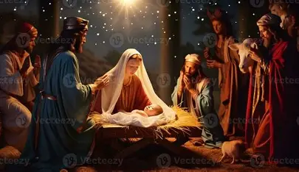 | Find out about a farm animal…can you write a fact and draw a picture?  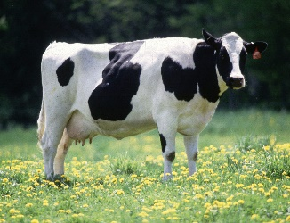 | Go on a shape hunt at home and find triangle and circles. Take pics for Tapestry! Can you describe the shapes?
Can you practise making 3 in different ways. Can you write it in your book? What about 4 and 5?  e.g. 2+ 1= 3  1+2= 3 0+3=3 | Can you find objects around the house and learn what they are made from? Perhaps paper, plastic, metal? What did you find?  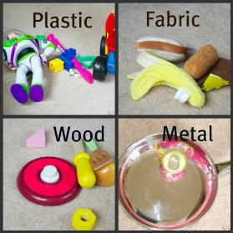 | Make a house for the three little pigs! It could be made from Lego, blocks, junk modelling- anything you like! Do you think the wolf could blow it down?  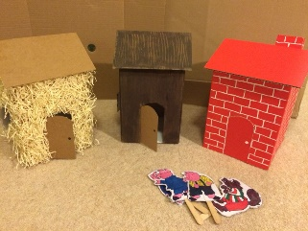
Practise writing your tricky harder to read and spell words in your book.  I to the no go  into pull his is | In Jigsaw lessons we are ‘Celebrating Difference’. How are you different to your friends? How are you similar?   | Leave this until a little later!  Get ready to write that letter or list to Santa!  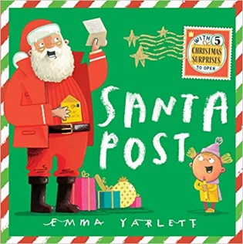

We will also sometimes send phonics or maths activities home. We may add activities in the home book from time to time as we learn new skills and topics. If you do anything in the home book, bring it in on a Wednesday, and I will send it home again on Friday. Thanks!

