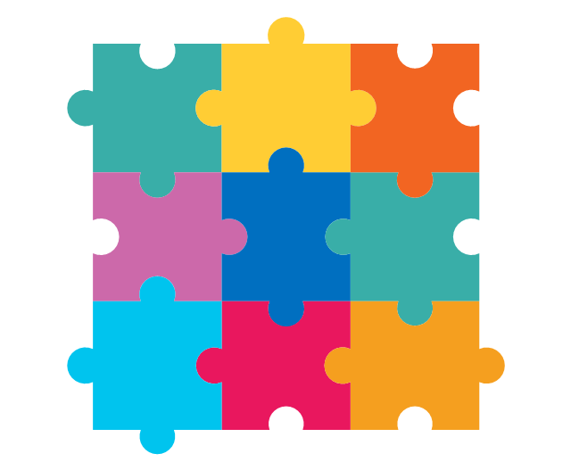`

**PSHE/ Jigsaw**

**We are unit this half term is ‘Being me’. We will discuss what makes us special and what makes our friends special too.**

**Autumn Term 1 Year 1 Newsletter**

**P.E**

**This half term will be looking at ball skills including catching and throwing. Our lessons will be on a Wednesday. The first session will be 10/9/25**

**Computing**

**This half term we will be learning**

**how to log on and use a mouse with control.**

**Science**

**This half term we will be looking at the seasonal changes as we enter into Autumn.**

**R.E**

**This half term will be learning about Harvest celebrations and**

**how this differs in different religions.**

**Geography**

**This half term we will be looking**

**at our local area and key features**

**and landmarks within it.**

**Maths**

**This half term, we will**

**be place value focusing on tens and ones as well as comparing number.**

**Literacy**

**This half term we will be**

**reading ‘Lost and Found’. We will write our own version of the story with our newly created characters.**