Home Activities-Autumn 1-All About Me/My School
Please complete the activities in any order over the half term and add photographs on Tapestry or add the work into your home activity book. You can bring your book in to show me on Wednesdays and I will collect it in to look at and send it back home on a Friday, ready for the weekend.
Draw a picture of your family. Can you name them? Write labels.  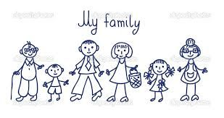 | What can you do? What are you good at? Draw a picture or take a photograph of something that you have learnt to do recently.   | Practise writing your numbers to 5. Find objects around the house and count them.  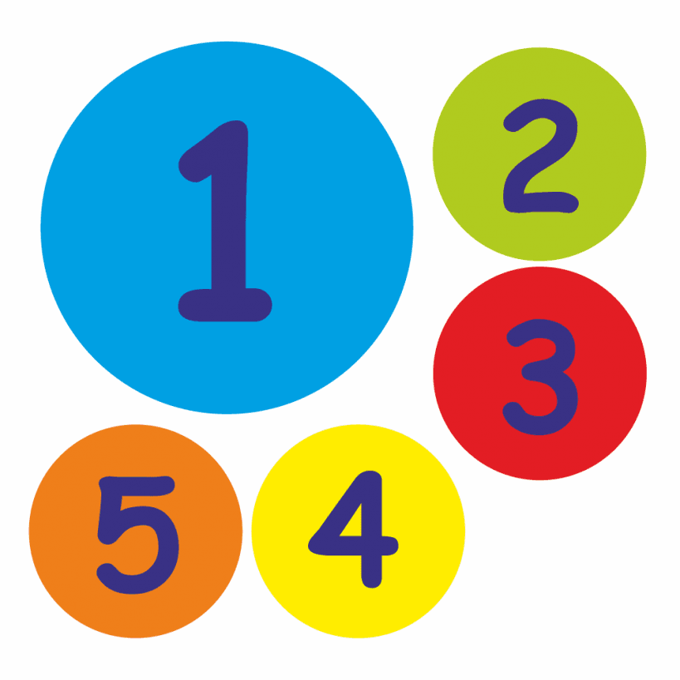
Look for numbers in the environment. Can you find numbers on doors, signs etc?  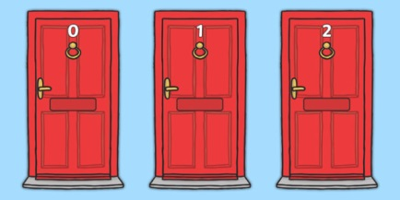 | Leave this activity until a little later.  Think about Mr Bear. What was keeping him awake all night? Draw the things he heard, in your book.  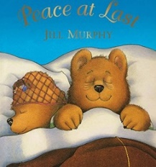 | Bring in a copy of a photograph of you as a baby. (We keep this at school) Talk about how you have grown and changed. 
  Can you make a healthy meal with your family? Why is it healthy? Put a photo on Tapestry. Write the recipe together in your book! | Practise writing your name in your book. Can you use a capital letter to begin and lower case letters for the rest?  Mrs Harrison |   Can you draw your house and learn your address? Where you do you live? What number?
We will also send some phonics or number activities home at times. We may add activities in the home book from time to time as we learn new skills and topics. Home activities should always be fun and children can practise their skills and show you what they can do and what they have been learning. If time is an issue, reading is the best activity you can do.

