Autumn 1
Guided Reading: Fairytales from Land of Stories and Fearless Fairytales
Week 1 | Week 2 | Week 3 | Week 4 | Week 5 | Week 6 |  | Week 7 | Week 8
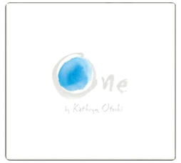 | 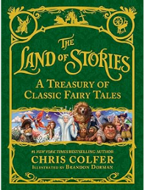  Gingerbread Man |  |  | 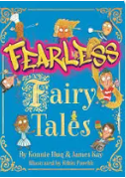  Gingerbread Kid |  |  | https://www.jamieoliver.com/recipes/eggs/home-sweet-home-gingerbread-house/
Sentence level | Narrative retell: Fronted adverbials (time), punctuated speech, noun phrases |  |  | Diary entry (perspective of Gingerbread Kid on his 1st day at school): Fronted adverbials time, noun phrases, conjunctions (when, because, but), question |  |  | Instructions (how to make gingerbread biscuits): question, fronted adverbials manner and time, imperative verbs, prepositions, conjunctions (while, when, until), adverbs
Autumn 2
Guided Reading: Butterfly Lion
Week 1 | Week 2 | Week 3 | Week 4 | Week 5 | Week 6 |  | Week 7
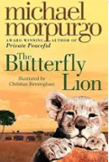 |  |  |  |  |  | 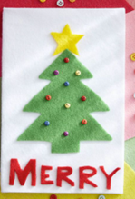
Setting description: fronted adverbials place, expanded noun phrases, prepositions, similes |  |  | Diary entry from Bertie’s perspective: past tense, fronted adverbials time and manner, expanded noun phrases, question, conjunctions (when, although), exclamatory sentences |  |  | Christmas Card

Spring 1
Guided Reading: Nim’s Island
Week 1 | Week 2 | Week 3 |  | Week 4 | Week 5 | Week 6
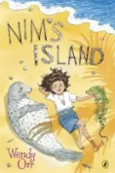

Non-chronological report of Nim’s Island (Wildlife, landscape, weather, infrastructure, sustainability): questions, conjunctions (however, because, although), fronted adverbials (place), expanded noun phrases, subheadings |  |  |  | Biography about Nim: fronted adverbials (time), conjunctions to include opening sentences with commas (when, although, but, however), paragraphs, expanded noun phrases
Spring 2
Guided Reading: Fortunately the Milk
Week 1 | Week 2 |  | Week 3 | Week 4 | Week 5
The Milk Jug by Oliver Herford |  |  | 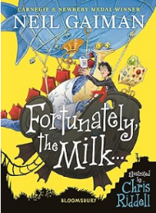
Poem about an everyday item: noun phrases, layout/punctuating a poem/rhythm, prepositions, onomatopoeia |  |  | Narrative (own adventure involving milk): punctuated speech, range of fronted adverbials, expanded noun phrases, paragraphs, conjunctions, adverbs

Summer 1
Guided Reading: Firework Makers daughter
Week 1 | Week 2 | Week 3 | Week 4 | Week 5 | Week 6 | Week 7
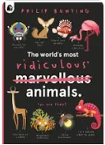 |  |  |  | 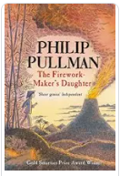
Non-chronological report (own fictional animal designed by pupils): expanded noun phrases, conjunctions, fronted adverbials, subheadings, bullet points, adverbs, questions, commas in lists, possessive apostrophe |  |  |  | Letter to Dad from daughter describing one part of her travels: fronted adverbials time, adverbs, expanded noun phrases, paragraphs, past tense, conjunctions, similes, punctuated speech
Summer 2
Guided Reading: Iron Man
Week 1 | Week 2 | Week 3 | Week 4 | Week 5 | Week 6 | Week 7
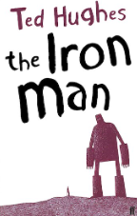 |  |  |  |  |  | Transition
Character description: expanded noun phrases, fronted adverbials, similes, conjunctions, onomatopoeia, metaphors, adverbs |  |  | Third person recount (news report script for the TV describing the damage caused by the iron man – to be recorded): fronted adverbials time, past tense, adverbs, conjunctions (while, when, if), expanded noun phrases, similes |  |  | Transition

