Autumn 1
Guided Reading: Revolting Rhymes
Week 1 | Week 2 | Week 3 | Week 4 | Week 5 | Week 6 |  | Week 7 | Week 8
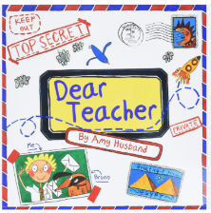 |  | 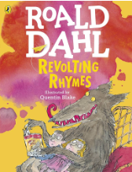  Short film clips from the fairy godmother scene in different versions of the Cinderella film. |  |  | Jack and the Beanstalk
Letter: fronted adverbials, adjectives, adverbs, conjunctions |  | Instructions (for the fairy godmother to get Cinderella ready for the ball): expanded noun phrases, questions, conjunctions, fronted adverbials (time and manner), adverbs |  |  | Narrative retell: punctuated speech (synonyms for said), fronted adverbials, expanded noun phrases, adverbs, paragraphs, conjunctions as sentence openers (while, when, although) – main and subordinate clauses
Autumn 2
Guided Reading: Max and the Millions
Week 1 | Week 2 | Week 3 | Week 4 | Week 5 | Week 6 |  | Week 7
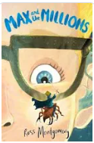 |  |  |  |  |  | 
Descriptive writing (pupils create a design for a miniature city/world made out of everyday objects in groups that they might discover in a classroom cupboard – write to describe opening a cupboard to find this miniature world): expanded noun phrases, fronted adverbials, adverbs, similes, prepositions |  |  | Diary entry (Written from the perspective of Max from the moment he discovers the miniature civilization on the school caretaker's floor): conjunctions (but, when, although, if), fronted adverbials, past tense, adverbs, expanded noun phrases, figurative language |  |  | Christmas Card

Spring 1
Guided Reading: The Wild Robot
Week 1 | Week 2 | Week 3 |  | Week 4 | Week 5 | Week 6
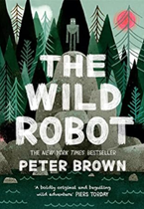

Setting description (chapter 1 and 2): Figurative language, synonyms and pronouns for cohesion, fronted adverbials, expanded noun phrases |  |  |  | Invented narrative based on chapters 14 and 15 (Who does Roz encounter? What is the danger? How does she feel? Does she escape? If so, how?): speech punctuation, vary sentence lengths, figurative language, expanded noun phrases, fronted adverbials, exclamation marks, adverbs, synonyms/pronouns for cohesion
Spring 2 (2027/28 to be replaced with Boy at the Back of the class)
Guided Reading: Fortunately the Milk
Week 1 | Week 2 |  | Week 3 | Week 4 | Week 5
The Milk Jug by Oliver Herford |  |  | 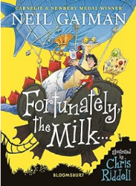
Poem about an everyday item: noun phrases, layout/punctuating a poem/rhythm, prepositions, onomatopoeia |  |  | Narrative (own adventure involving milk): punctuated speech, range of fronted adverbials, expanded noun phrases, paragraphs, conjunctions, adverbs

Summer 1 (2027/28 – to be replaced with Abominables)
Guided Reading: Firework Makers daughter
Week 1 | Week 2 | Week 3 | Week 4 | Week 5 | Week 6 | Week 7
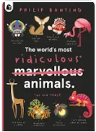 |  |  |  | 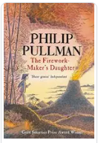
Non-chronological report (own fictional animal designed by pupils): expanded noun phrases, conjunctions, fronted adverbials, subheadings, bullet points, adverbs, questions, commas in lists, possessive apostrophe |  |  |  | Letter to Dad from daughter describing one part of her travels: fronted adverbials time, adverbs, expanded noun phrases, paragraphs, past tense, conjunctions, similes, punctuated speech
Summer 2
Guided Reading: The Witches
Week 1 | Week 2 | Week 3 | Week 4 | Week 5 | Week 6 | Week 7
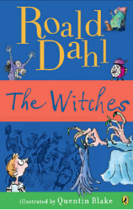 |  |  |  | 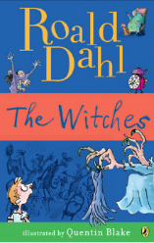 |  | Transition
Non-chronological report (About the witches: appearance, behaviour, powers…): conjunctions, expanded noun phrases, adverbs, subheadings, questions, fronted adverbials |  |  |  | Diary entry (from the boy’s – narrator – perspective): fronted adverbials, expanded noun phrases, figurative language, adverb, conjunctions, punctuated speech (1-2 lines only) |  | Transition

