Autumn 1
Guided Reading: Girl of ink and stars
Week 1 | Week 2 | Week 3 | Week 4 | Week 5 | Week 6 | Week 7 | Week 8
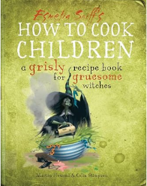 |  |  | 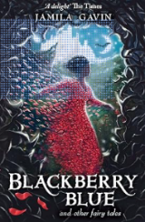
Instructions |  |  | Diary Entry |  | An alternative narrative ending (including dialogue and character description)
Autumn 2
Guided Reading: Cosmic
Week 1 | Week 2 | Week 3 | Week 4 | Week 5 | Week 6 | Week 7
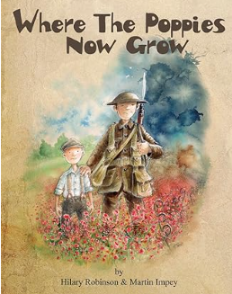 | 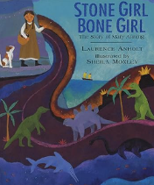  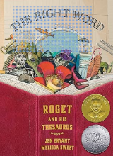  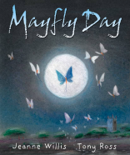  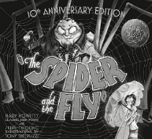  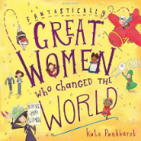 |  | 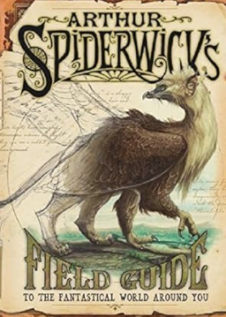
Cinquain Poetry | Biography |  | Non-chronological report on a creature (NOT a dragon)

Spring 1
Guided Reading: Boy in the tower
Week 1 | Week 2 | Week 3 | Week 4 | Week 5 | Week 6
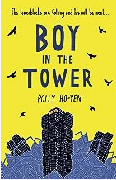  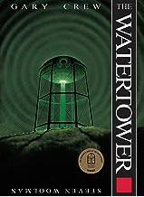 |  |  | 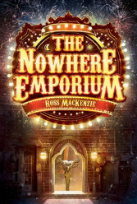
Diary entry |  |  | Narrative (to include dialogue)
Spring 2
Guided Reading: SATs reading paper practice
Week 1 | Week 2 | Week 3 | Week 4 | Week 5
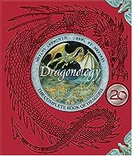 |  |  | Recount
Non-chronological report about a dragon they design |  |  | Recount of personal experience.

Summer 1
Guided Reading: Wonder
Week 1 | Week 2 | Week 3 | Week 4 |  | Week 5 | Week 6 | Week 7
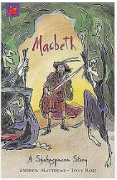  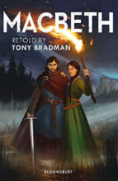  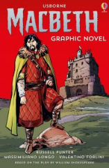  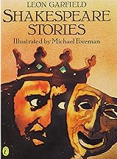 |  |  |  | SATS
Narrative – Macbeth (include dialogue) |  |  |  | SATS | Biography – Ade | Biography – Ade | Biography – Ade
Summer 2
Guided Reading: Wonder
Week 1 | Week 2 | Week 3 | Week 4 |  | Week 5 | Week 6 | Week 7
 |  | 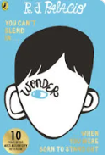
Biography |  | Poem for leavers assembly

