Autumn 1
15 minute handwriting to start every lesson / M: hold a sentence (to include proofread) Tu: hold a sentence (to include proofread) W: Build a sentence Th: Build a sentence F: Write about
Week 1 (3 days) | Week 2 | Week 3 | Week 4 | Week 5 |  | Week 6 | Week 7 | Week 8
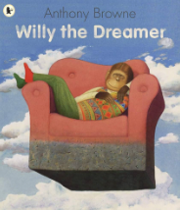 |  | 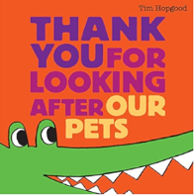 |  | 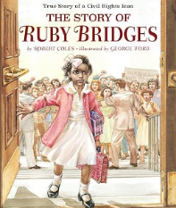 |  |  |  | Autumn Fires – Robert Louis Stevenson (poem)
Week 1: Handwriting focus  Week 2: Write present tense sentences using the ‘and’ conjunction to describe their dreams. (I am a ballerina and I perform on a stage) Write about: Describe their dreams for the future |  | Week 1: commands using conjunction ‘and’ (Give them breakfast and watch them eat.) Write about: Instructions (commands part only) for looking after an animal)  Week 2: commands using conjunction but and contractions (Put them to bed but don’t cover them up.) Write about: Instructions (commands part only) for looking after a different animal) |  | Week 1: Write questions (looking at pictures from the text, what do the children want to know about the girl) Write about: Historian questions about Ruby Bridges  Week 2: Write sentences using conjunctions (because, but, and) (information about Ruby Bridges) Write about: Facts about Ruby Bridges  Week 3: Write sentences using the conjunction ‘if’. (advice to children if see someone being mean) Write about: advice for children when see someone being mean |  |  |  | Write sentences with adjectives.  Write about: one verse of a poem about Autumn
Autumn 2
10 minute handwriting to start every lesson / M: read and explore Tu: build a sentence (to include proofread) W: Build a sentence (to include proofread) Th: Write about F: Write about
Week 1 | Week 2 | Week 3 | Week 4 | Week 5 |  | Week 6 | Week 7
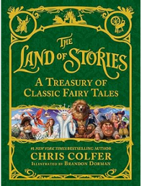 |  | 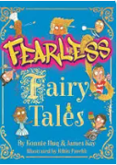 |  |  | 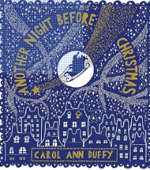  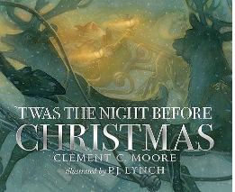
Retell Goldilocks and the three bears (section each day). Focus: conjunctions, adjectives, time adverbials, exclamation sentences |  | Retell Mouldysocks story with some of their own changes (section each day). Focus: conjunctions, adjectives, time adverbials, exclamation sentences |  |  | List poem about Christmas

Spring 1
Week 1 | Week 2 | Week 3 | Week 4 |  | Week 5
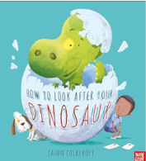 |  | 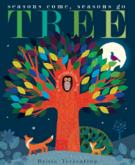  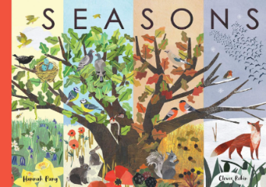  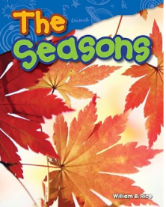
Main writing outcome: personal recount (1st person, past tense, ‘when’ conjunction, noun phrases, time adverbials) |  | Non-fiction booklet about the seasons: one page about weather; one page about clothes/accessories; one page about how trees change throughout the seasons. Focus: fronted adverbials (In Winter, In Summer), conjunctions (when, if, because, and), adjectives, questions (as subheadings), organising information using subheadings
Spring 2
Week 1 | Week 2 | Week 3 | Week 4 |  | Week 5 | Week 6
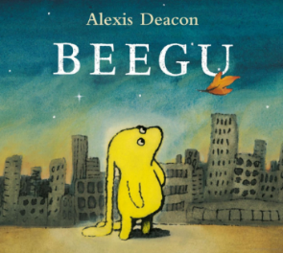  Poem: The aliens have landed by Kenn Nesbitt  https://poetry4kids.com/poems/the-aliens-have-landed/ |  |  | 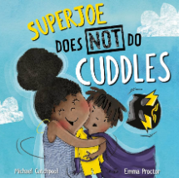  If I was a superhero by Sally  Gray (poem)
Personal recount (experience of looking after Beegu/alien and making him feel welcome after he crash lands at school) |  |  |  | Invented narrative (superhero story)

Summer 1
Week 1 | Week 2 | Week 3 | Week 4 | Week 5 | Week 6 | Week 7
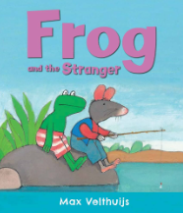

Persuasive letter from frog convincing the other animals to accept rat (persuasive language, conjunctions, adjectives, -ly words, question) |  |  | Narrative
Summer 2
Week 1 | Week 2 | Week 3 | Week 4 | Week 5 | Week 6 | Week 7
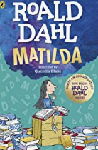 |  | 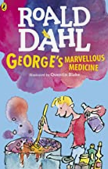 |  | 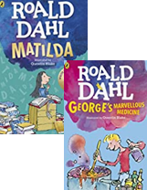
Letter to Mr Corteen to complain about Miss Trunchbull (a supply teacher) |  | Instructions of how to make their own potion to do something to Miss Trunchbull |  | Invented narrative about Miss Trunchbull (giving her a potion and what it does to her)

