Autumn 1
M: Hold a sentence Tu: Hold a sentence W: Hold a sentence and proofread Th: Build a sentence F: Build a sentence
Week 1 | Week 2 | Week 3 | Week 4 | Week 5 | Week 6 | Week 7 | Week 8
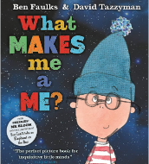 |  | 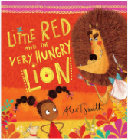 |  | 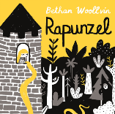 |  | 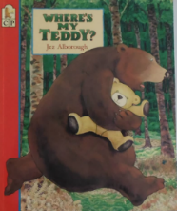
Week 1: Handwriting  Week 2: Write simple present tense sentences about themselves (1st person). |  | Week 1: Write simple sentences to describe the lion (3rd person) Build a sentence: Wanted poster to describe the lion  Week 2: Write a plan for the lion (simple commands). Build a sentence: instructions for the lion to follow |  | Week 1: Write thought bubble questions for Rapunzel when she first sees the world outside. Build a sentence: Thought bubble for Rapunzel  Week 2: Write simple past tense sentences to describe what Rapunzel did when she left the tower (use Tangled video clip). Build a sentence: 3rd person recount sentence. |  | Week 1: Write present tense sentences with adjectives to describe Fred. Build a sentence: Lost poster for Fred (describe Fred).  Week 2: Write past tense sentences to recount losing and finding Fred. Build a sentence: 1st person recount about losing and finding Fred.
Autumn 2
M: hold a sentence Tu: Hold a sentence and proofread W: Build a sentence Th: Build a sentence F: Write about
Week 1 | Week 2 | Week 3 | Week 4 | Week 5 | Week 6 | Week 7 | Week 8
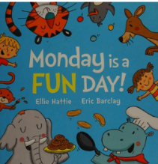 |  | 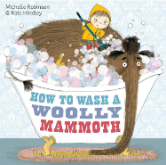 |  | 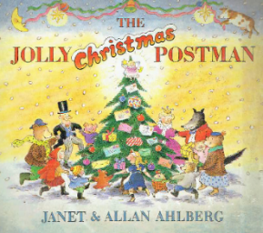 |  | 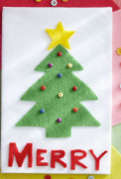
Week 1: Write simple sentences with the days of the week present tense (Monday is _________ day). Write about: Days of the week poem (Monday is a work day, Tuesday is swimming day,…)  Week 2: Write simple past tense sentences with the days of the week (recount). Write about: short diary of week (1st person recount) |  | Week 1: Write commands including some prepositions (how to wash a woolly mammoth) Write about: Instructions for looking after a mammoth (numbered commands only)  Week 2: Write commands including some prepositions (how to wash a sheep). Write about: Instructions for looking after a sheep (numbered commands only) |  | Week 1: Write questions (to ask Father Christmas). Write about: Interview questions for Father Christmas  Week 2: Write a list (list of things they would like for Christmas - letter to Father Christmas). Write about: short letter to Father Christmas (Provide the Dear and from parts) |  | Christmas cards
Spring 1
M: hold a sentence and proofread Tu: Build a sentence W: Build a sentence Th: Write about F: Write about
Week 1 | Week 2 | Week 3 | Week 4 | Week 5 | Week 6
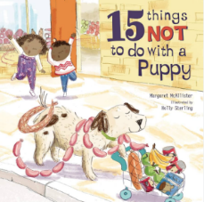 |  | 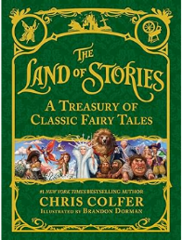  Jack and the Beanstalk
Week 1: commands for looking after a puppy. Write about: instructions for looking after a puppy (numbered commands only)  Week 2: commands for looking after a kitten. Write about (own book – 4 things not to do with a kitten). |  | Each week write sentences to retell Jack and the Beanstalk and each Write about, write a short part of the story so by the end of the 4 weeks, they have written their own story book. Week 1: focus adjectives/past tense/time adverbials Week 2 focus: -er/-ed suffixes/time adverbials Week 3 focus: and conjunction/-est suffix/time adverbials Week 4: adjectives/time adverbials
Spring 2
M: hold a sentence and proofread Tu: Build a sentence W: Build a sentence Th: Write about F: Write about
Week 1 | Week 2 | Week 3 | Week 4 | Week 5
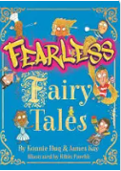  Jack and the Baked Beanstalk |  |  | 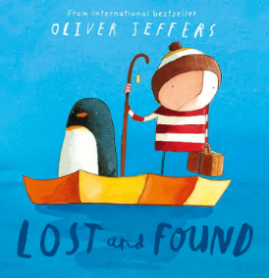
Each week write sentences to tell their invented story of Jack and the Baked Beanstalk (only a couple of inventions) and each Write about, write a short part of the story so by the end of the 4 weeks, they have written their own story book. Week 1: focus adjectives/past tense/time adverbials Week 2 focus: -er/-ed suffixes/time adverbials Week 3 focus: and conjunction/-est suffix/time adverbials Week 4: adjectives/time adverbials |  |  | Week 1: 1st person past tense sentences using and conjunction and prefix –un to recount the penguin arriving and one activity they did with the penguin. Write about: first half of 1st person recount  Week 2: 1st person past tense sentences using and conjunction/adjectives to recount two more activities they did with the penguin. Write about: second half of 1st person recount

Summer 1
M: hold a sentence and proofread Tu: Build a sentence W: Write about Th: Write about F: Write about
Week 1 | Week 2 | Week 3 | Week 4 |  | Week 5 | Week 6 | Week 7
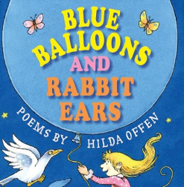
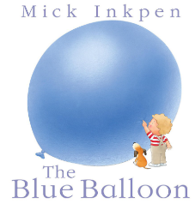

Week 1: sentences to describe what see from above using adjectives  Week 2: free verse poem (adjectives) |  |  | Week 1: write sentences to describe the size and appearance of the whale shark (-est/-er suffixes, adjectives). Write about: Page one of information booklet about whale sharks to describe appearance.  Week 2: write sentences to describe what whale sharks eat/herbivores and how they feed/how they find food (and conjunction). Write about: Page 2 of information booklet to describe their diet/feeding habits.  Week 3: write sentences to describe where in the world whale sharks can be found and how they travel (migrate) using and conjunction. Write about: Page 3 of information booklet to describe where they live and how they travel.
Summer 2
M: hold a sentence and proofread Tu/W: Build a sentence Th: Write about F: Write about
Week 1 | Week 2 | Week 3 | Week 4 |  | Week 5 | Week 6 | Week 7
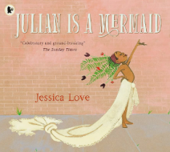

Narrative retell of story |  |  |  | Write an information booklet about themselves for their new teacher next year: family; likes and dislikes; hopes for next year (future tense)
