Autumn 1
Guided Reading: If poem |  | Guided Reading: One double page each week from Natural History of Magical Beasts |  |  | Guided Reading: Walter Tull’s scrapbook supplemented with extracts from other two texts.
Week 1 (4 days) | Week 2 | Week 3 | Week 4 | Week 5 | Week 6 | Week 7 |  | Week 8
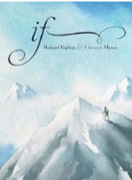  https://www.poetryfoundation.org/poems/46473/if--- |  | 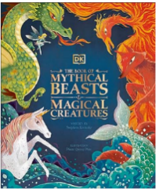  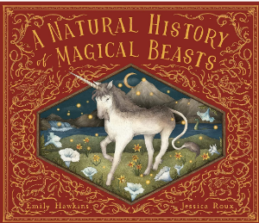 |  |  | 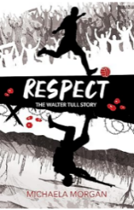  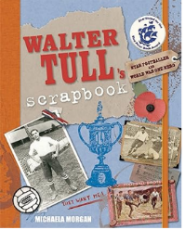  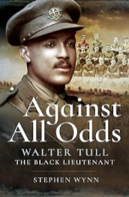
Main writing outcome: instructions (a recipe for success) |  | Main writing outcome: non-chronological report |  |  | Main writing outcome: biography Walter Tull
Autumn 2
Guided Reading: Holes
Week 1 | Week 2 | Week 3 | Week 4 | Week 5 | Week 6 | Week 7 |  | Week 8
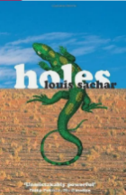 |  | 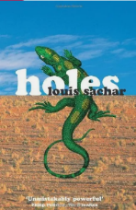 |  | 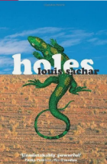
Main writing outcome: diary entry (Stanley’s perspective) of day travelling to Camp Green Lake and his arrival |  | Main writing outcome: letter written from Stanley to his parents, describing his 2nd day at Camp Green Lake (to include setting and character - X-Ray -descriptions). |  | Main writing outcome: narrative (How did Kissin’ Kate Barlow become an outlaw?)

Spring 1
Guided Reading: War Horse
Week 1 | Week 2 | Week 3 |  | Week 4 |  | Week 5 |  | Week 6
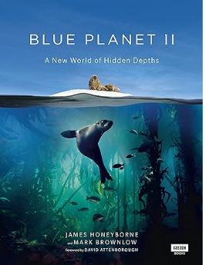 |  |  |  | 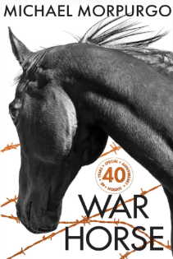
Main writing outcome: Script for a wildlife video audio description of an underwater animal (David Attenborough style) |  |  |  | Main writing outcome: narrative (short story based on the adventures of warhorse, from the point of view of the horse)
Spring 2 Guided Reading: The Light Jar
Guided Reading: The Light Jar
Week 1 | Week 2 | Week 3 |  | Week 4 | Week 5
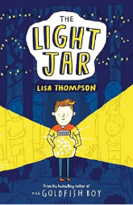 |  |  |  | 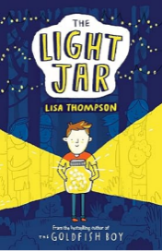
Main writing outcome: newspaper report about a missing boy |  |  |  | Main writing outcome: diary entry written from boy’s perspective when he is waiting for his Mum (to include setting description of the snow/cold and character description of his imaginary friends)
Summer 1
Guided Reading: Finish The Light Jar and The Tempest (compare Shakespeare extracts with all three texts)
Week 1 | Week 2 | Week 3 |  | Week 4 |  |  | Week 5 | Week 6 | Week 7
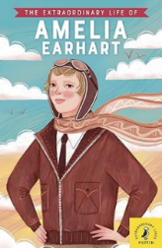
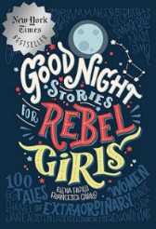

Main writing outcome: biography about fictional character Stanley Yelnats |  | Main writing outcome: narrative retell of the opening scene
Summer 2
Guided Reading: Cloud busting
Week 1 | Week 2 | Week 3 |  | Week 4 |  |  | Week 5 | Week 6 | Week 7
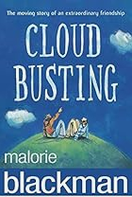

Main writing outcome: kennings poem |  |  | Main writing outcome: persuasive letter to a bully (stop bullying)

