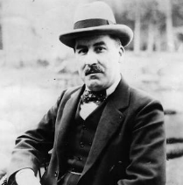
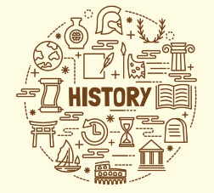

Subject Specific Skills

- To establish what society was like in Britain during the Ancient Egyptian civilisation.
- The achievements of the earliest civilizations –an overview of where and when the first civilizations appeared and a depth study of one of them
- Know and understand significant aspects of the history of the wider world: the nature of ancient civilisations; characteristic features of past non-European societies.
- Gain and deploy a historically grounded understanding of abstract terms such as ‘empire’ and ‘civilisation’.
- Understand historical concepts such as continuity and change, similarity, difference and significance.
- Gain historical perspective by placing their growing knowledge into different contexts, understanding the connections between short- and long-timescales.
- Gain historical perspective by placing their growing knowledge into different contexts, understanding the connections between economic, military and social history.

Prior Learning

- Use a timeline to place important events.
- Ask questions about the past.
- Understand and use the words past and present when telling others about an event

Key Vocabulary Empire, civilisation, timeline, BCE - Before the Common (or Christian) Era, BC (Before Christ), AD - Anno Domini: in the Year of Our Lord, CE – Common Era, society, Upper and Lower Egypt, terrain, River Nile, Pharaoh, Dynasty, Old Kingdom (2686-2181 BCE), Middle Kingdom (2055-1650 BCE) & New Kingdom (1550-1069 BCE), burial, tomb, mummification, Canopic jars, afterlife, pyramid,
Key Individual
Howard Carter
Born: 9 May 1874; Kensington‎, England‎
Died: 2 March 1939
Key Knowledge The children will build knowledge of the period when the Ancient Egyptians were a world power and compare the Ancient Egyptian civilisation with the society, climate and terrain of Britain at the time. Circa 3000 BCE Ancient Egypt was a civilised society. Britain was in the New Stone Age. People were just beginning to farm, stone circles would be under construction, people would be hunting for food, and there would be lakeside settlements and lots of woodland. Ancient Egypt was described as being part of the Fertile Crescent (Cradle of Civilisation); we will describe the terrain and climate of Egypt. The rulers of Ancient Egypt were divided into families or dynasties and the pharaohs were rich and powerful. We will discover about early burials in Ancient Egypt and explain why mummification was developed to preserve bodies for the afterlife;
We will then look at how the structure of pyramids developed over the years.
Year 3
Early civilisations – what did the Ancient Egyptians achieve?

