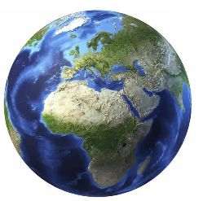

Prior Learning
The enquiry extends the study that pupils made at Key Stage 1 of continents and oceans, the distribution of hot and cold areas of the world and a contrasting locality outside of Europe.
Year 3 Geography
Knowledge Organiser
Beyond the Magic Kingdom: What is the Sunshine State really like?

Dr Archie Carr – Sea Turtle Conservancy

JoAnn Morgan –the only female engineer in the firing room during the launch of Apollo 11 on 16 July 1969.

Key Individuals: 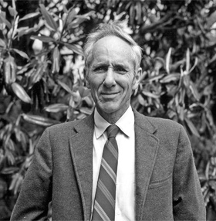

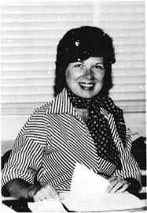
Key Vocabulary
Florida, USA, State, North America, Atlantic Ocean, Pacific Ocean, Population, Tourist, Climate, Environment, key, Quality of Life, Peninsula, Coast, Physical features, Human features, Equator, Pollution, Endangered, Hazard, Conflict, Everglades
Key Knowledge
This enquiry is designed to enable pupils to gain an understanding of the physical and human geographical features of a region in North America with which they can begin to compare and contrast the characteristics of a region of the United Kingdom. It begins by focusing on aspects of leisure and tourism with which pupils may be familiar both in the United Kingdom and overseas. Some may even have direct experience of visiting Florida and the Magic Kingdom. The objective of the investigation is to take the pupils beyond that with which they may be familiar and introduce them to different aspects of Florida’s physical and human geography.
Subject Specific Skills
Identify, describe and explain the function and attraction of theme parks around the world and in particular the Magic Kingdom in Florida;
Identify, locate, compare and contrast the constituent states of the United States of America and recognise and describe key geographical features of one state other than Florida;
Describe and explain the historical significance of the Maya civilisation and suggest reasons for its catastrophic end;
Observe, describe, explain and begin to draw conclusions about the geographical pattern of the origin of visitors to the Magic Kingdom from countries around the world;
Recognise and describe the key geographical features of a peninsula and compare and contrast the Floridian peninsula with a number of peninsulas at different locations around the world;
Recognise the key human and physical features and achievements of the Kennedy Space Centre in Florida and explain the geographical reasons for its location;
Describe and explain why sea turtles which live in the waters around Florida are endangered and reach a judgement as to how they might be conserved for the future;
Compare and contrast the climate of the United Kingdom and Florida and identify and explain the main differences particularly in relation to temperature and sunshine hours;
Reach a conclusion and make a judgement as to the best time climatically for British tourists to holiday in Florida;
Identify, describe and explain how hurricanes form and why they present such a threat to the people of Florida and understand the range of ways in which residents take measures to protect themselves and property from potential damage;
Locate, describe and explain why the Everglades are a National Park.

