
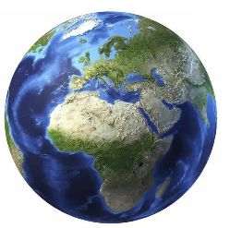
Subject Specific Skills
•Locate and describe the effects of the Christchurch earthquake of 2011 from a range of sources;
•Observe and record the distribution of earthquakes in New Zealand over the past two hundred years;
•Identify, describe and explain the causes of earthquakes;
•Describe and explain why New Zealand experiences earthquakes when they don’t occur at all in many other areas of the world;
•Understand through explanation and reaching conclusions why the most powerful earthquakes in the world do not necessarily cause the most deaths and destruction;
•Identify, describe and explain the causes of volcanoes;
•Explain why volcanoes often occur at the same location as earthquakes in places such as New Zealand;
•Locate, describe and explain why so many earthquakes and volcanoes occur around the Pacific Ring of Fire.

What is Seismology? Seismology is the study of earthquakes and seismic waves that move through and around the Earth. A seismologist is a scientist who studies earthquakes and seismic waves.
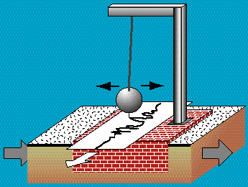
Year 3 Geography
Knowledge Organiser
Why do some earthquakes cause more damage than others?
Key Vocabulary
Earthquake; Volcano; Continent; Ocean; Latitude; Longitude; Northern Hemisphere; Southern Hemisphere; Political map; Evacuation; Infrastructure; Transport; Business; River; Flood; Search and rescue; Epicentre; Magnitude; Richter scale; Distribution; Location; Pattern; Energy; Projection; Tsunami; Plate; Inner core; Outer core; Mantle; Crust; Fault; Alpine Fault; Design; Homeless; Refugees; Wealth; Eruption; Magma; Lava; Rock; Dormant; Extinct; Cone; Vent; Gas; Cloud; Chamber; Pacific Ring of Fire; Technology; Quality of life; Distribution; Wealth; Gross National Income.
Key Knowledge
This enquiry introduces pupils to some key aspects of physical geography, in particular one of the major outcomes of tectonic activity in the world – earthquakes. Some work is also focused on volcanic activity, which is developed at greater depth at Upper Key Stage 2.
As they progress through the ancillary questions pupils come to understand why it is that earthquakes only tend to occur in particular areas of the world as a consequence of the pattern and movement of the tectonic plates of the Earth’s crust. The pupils initially investigate the causes and impact of one specific recent earthquake in one particular location in the world, where earthquakes occur frequently, before looking more widely at global patterns. At all points the people–environment relationship, which is the subject paradigm of geography, is maintained through the enquiries as pupils seek to understand the interaction of people and earthquakes.
The pupils are supported to develop and apply high-order thinking to a consideration of why some earthquakes of the largest magnitudes do not always cause as much death and destruction as earthquakes of lesser magnitude. Here, the centrality of the human condition in terms of quality of life in particular and also technological development is an important area for the pupils to begin to understand.
Prior Learning

The children can recognise and name some continents and oceans on a globe or atlas.

