
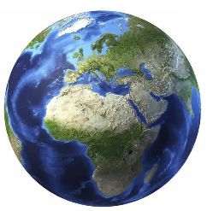
Key Individual
Robert Fitzroy – Meteorologist

Subject Specific Skills
- Name and locate the world’s seven continents and five oceans.
- Use basic geographical vocabulary to refer to key physical and human features.
- Use world maps, atlases and globes to locate continents and oceans.
- Use simple fieldwork and observational skills to study features of environments.

Key Knowledge
- Compare and contrast the environments of the Sahara Desert and Antarctica.

Key Vocabulary
Weather, rainfall, temperature, sunshine, wind, fog, snow, tornado, drought, cloud, thermometer, rain gauge, season, Equator, north pole, south pole, desert, continent, ocean, Sahara, Antarctica.
2022

Year 2 Geography
Knowledge Organiser
How does the weather affect our lives?
Prior Learning
Through the study of ‘What is the physical and human geography of my area like?’ in Y1, children will be familiar with their own location in the world, the UK and also Europe.

Key Knowledge
In this unit of study, children will:
- Identify and describe the basic atmospheric elements of the weather.
- Observe, measure and record the elements of daily weather.
- Observe how the weather in Formby changes during the four seasons of the year and offer some explanation as to why this happens.
- Observe and offer reasons for the distribution of hot and cold places in the world.
- Explain in simple terms why temperature decreases with distance from the Equator towards the north and south poles.

