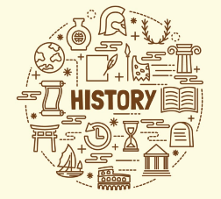**Autumn Term 2022**

**Ranulph Fiennes**

**Amelia Earhart**

**Christopher Columbus**

**Neil Armstrong**

**Prior Learning**

* Y1 – ‘History Makers’ – looking at key people from different decades – some which cross over with this topic.

**Subject Specific Skills**

* To know of some changes within living memory and these should be used to reveal aspects of change in national life.
* To know of some significant events beyond living memory.
* To know of the lives of some significant individuals in the past who have contributed to national and international achievements.

**Year 2 History**

**Knowledge Organiser**

**What does it take to be a great explorer?**

**Key Knowledge**

* Discover why Sir Ranulph Fiennes is described as being the ‘World’s greatest living explorer.’
* Compare the achievements of Ranulph Fiennes with those of Amelia Earhart.
* Consider why Christopher Columbus sailed across an unknown ocean.
* Discover why Neil Armstrong’s small step was also a ‘great leap’ forwards.
* Recognise, observe and suggest reasons for the particular challenges explorers venturing to Mars may face in the future and suggest personal qualities required.

**Key Individual**s:

**Key Vocabulary**

Explorer, expedition, Antarctica, North Pole, South Pole, resilience, pioneer, aviator, King, Queen, ship, voyage, indigenous, inhabitants, native, aircraft, NASA, astronaut, space, mission, Mars.

**Key Knowledge:**

* **In this topic, we will learn about:**
* changes within living memory
* events beyond living memory that are significant nationally or globally
* the lives of significant individuals in the past who have contributed to national and international achievements
* significant historical events, people and places.