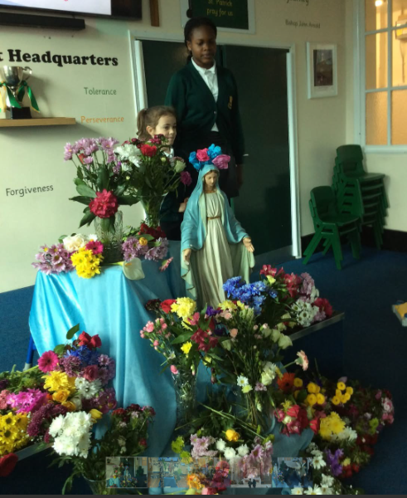
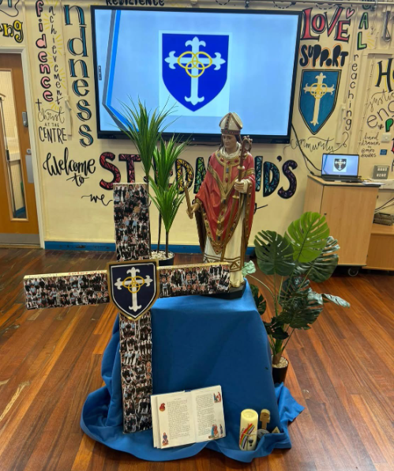
Prayer and Liturgy
Annual Plan of Provision 2026-27
ST EDMUND’S AND ST PATRICK’S

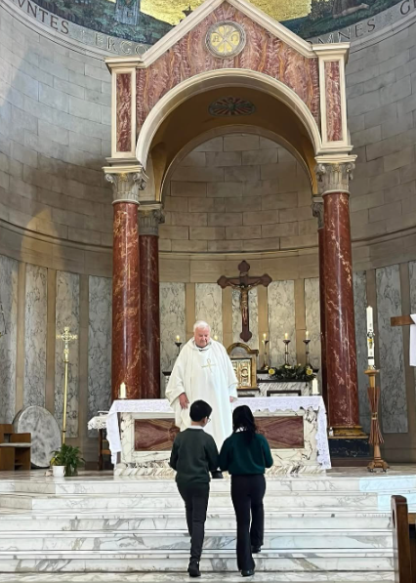
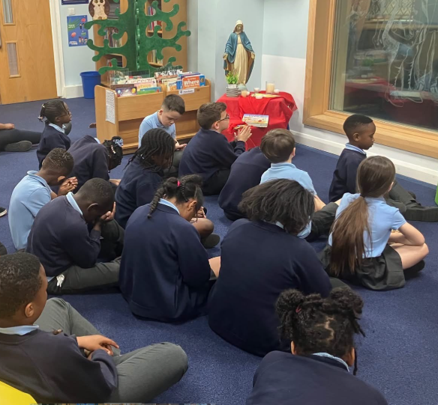

W/C and theme | Sunday Gospel/Liturgical Year | Catholic Feast Days | Assembly focus - SLT | Celebration of the Word – CT | Events | CST Focus - | CPD/RESOURCES
31st August 2026   | Matthew 16:21-27  ‘If anyone would come after me, let him deny himself.’ | (3rd) St Gregory the Great | Jesus, Our Perfect leader | THEME:  Beginnings  Matthew 16:21-27 | Season of Creation  (1st Sept – 4th Oct)  (1st) World Day of Prayer for the Care of Creation | Dignity of the Human person | INSET Day – CLM/P&L/RE  Season of Creation  Laudato Si’ Centre - Laudato Si’ Centre  The God Who Speaks
7th September 2026   | Matthew 18:15-20  ‘If he listens to you, you have gained your brother.’ | (8th) The Birthday of the Blessed Virgin Mary | Gathered in His Name | THEME: Reconciliation  Matthew 18:15-20 |  | Stewardship | Caritas | Diocese Of Salford
14th September 2026  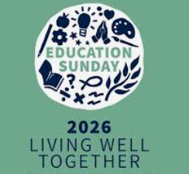 | Matthew 18:21-35  ‘I do not say to you seven times, but seventy times seven.’ | (14th) The Exaltation of the Holy Cross  (17th) St Hildegard of Bingham, patron saint of ecology | Forgive-Reset-Repeat | THEME: Forgiveness  Matthew 18:21-35 | (13^{th)} Education Sunday  Start of Year Mass in both schools | Dignity of Work | Catholic Bishops Conference: Education Sunday 2026
21st September 2026  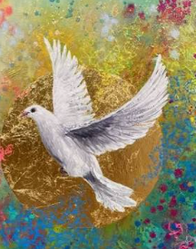 | Matthew 20:1-16  ‘Do you begrudge my generosity?’ | (21st) St Matthew  (24th) Our Lady of Walsingham | Generous and Just | THEME: Peace  Matthew 20:1-16 | 21st - UN International Day of Peace  22nd- 28^{th -} Recycle week  22nd -5th Oct - Fairtrade Fortnight | Rights and responsibilities | Evangelii Gaudium Day  Peace one Day
28th September 2026   | Matthew 21:28-32  ‘He changed his mind and went. The tax collectors and the prostitutes go into the kingdom of God before you.’ | (27^{th)} St Vincent de Paul  (29th) Saints Michael, Gabriel and Raphael  (2nd) The Holy Guardian Angels | Actions Louder than Words | THEME: Harvest /Thanksgiving  Matthew 21:28-32 | (29th) World Day of Migrants & Refugees  (1st-31st) Black History month  2nd) CAFOD Harvest Fast | Options for the Poor | Gather Together this Harvest  What You Can Do - World Vegetarian Day
5th October 2026   | Matthew 21:33-43  ‘He will let out the vineyard to other tenants.’ | (4th) St Francis of Assisi, patron saint of environment, animals and birds  (7th) Our Lady of the Rosary  (9th) St John Henry Newman | Love and Respect | THEME:  Environment  The Rosary  Matthew 21:33-43 | CREATION walk  GIFT Team – Rosary – lunchtime and in class  10th) UN World Mental Health Day  (10th) World Homeless Day  October – month of the Rosary | Solidarity and the common good | Cycle to School Week - Bikeability
12th October 2026   | Matthew 22:1-14  ‘Invite to the wedding feast as many as you find.’ | (12th) St Carlo Acutis  (15th) St Teresa of Avila | Come to the Party! | THEME:  Invitation  Matthew 22:1-14 | Collection for CARITAS – Lally Centre  17th) UN International Day for the Eradication of Poverty | Family and Community | Week of Prayer for Prisoners & their Dependants
19th October  2026  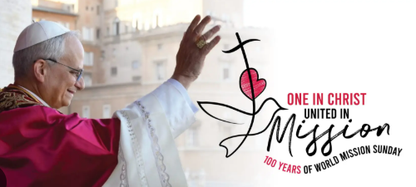 | Matthew 22:15-21  ‘Render to Caesar the things that are Caesar’s, and to God the things that are God’s.’ | (18th) St Luke | We Belong to God | THEME: Mission  Matthew 22:15-21 | (19th) World Mission | Dignity of the Human person | World Mission Sunday - Catholic Bishops' Conference)  What is World Mission Sunday? - Missio
2nd November  2026  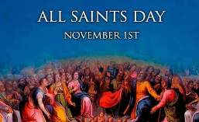 | Matthew 5:1-12  ‘Rejoice and be glad, for your reward is great in heaven.’ | (1st ) All Saints  (2nd) All Souls | All Holy Men and Women | THEME: All Saints  All Saints Celebration of the Word: Cafod | All Saints / All Souls Day 2nd November  Diwali Festival | Rights and responsibilities | The God Who Speaks: All Saints and All Souls
9th November  2026   | Matthew 25:1-13  ‘Here is the bridegroom! Come out to meet him.’ | (9th) Dedication of the Lateran Basilica  (10th) St Leo the Great  (11th) St Martin of Tours | Waiting Wisely | THEME:  Dialogue  25:1-13  Remembrance  Matthew 5:1-12 | Remembrance Service – Whole School  (8th) Remembrance Sunday  (8th – 15th) Interfaith week.  (10th) Caritas’ Advent Appeal launch.  (13th) World Kindness Day | Options for the Poor | Caritas Appeal information at www.caritassalford.org.uk
16th November  2026  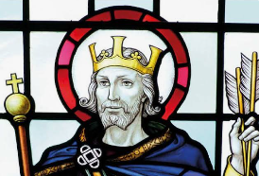 | Matthew 25:14-30  ‘You have been faithful over a little, enter into the joy of your master.’ | 17th St Elizabeth | Unique Gifts | THEME:  Gifts  Matthew 25:14-30 | Mass – Feast of St Edmund  (16th) World Day of the Poor  (17th- 21st) Anti Bullying Week | Solidarity and the common good | Anti-Bullying Alliance  Aid to the Church in Need Red Wednesday  Cymfed World Funday resources  World Philosophy Day | UNESCO
23rd November  2026  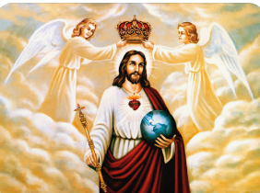 | Matthew 25:31-46  ‘He will sit on his glorious throne and he will separate people one from another.’ | (22nd) Our Lord Jesus Christ  (22nd) St Cecilia | His Glorious Throne | THEME:  Christ the King  Matthew 25:31-46 | Youth Sunday  National Tree Week | Family and Community | Cymfed Youth Sunday resources  National Tree Week - join the UK's largest tree celebration
30th November  2026   | Mark 13:33-37  ‘Stay awake - for you do not know when the master of the house will come.’ | 1st Week of Advent  (30th) St Andrew | 1st Sunday of Advent  How Am I Faithful? | THEME: Advent – Hope  Mark 13:33-37 | Journey to Bethlehem – prayer stations | Dignity of the Human person | Cafod Refugee Resources for secondary schools  Cafod refugee resources Primary schools
7th December  2026   | Mark 1:1-8  ‘Make straight the paths of the Lord.’ | (8th) The Immaculate Conception | What Am I Hearing? | THEME: Advent – Peace  Mark 1:1-8 | Advent Mass | Stewardship | ACN Advent primary Resources  Cafod: Primary Advent resources
14th December  2026  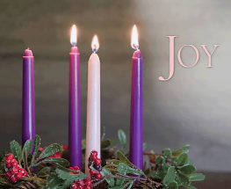 | John 1:6-8. 19-28  ‘Among you stands one you do not know.’ |  | Who Am I called to be? | THEME: Advent – Joy  John 1:6-8  19-28 | Carol Service  KS1 Nativity | Dignity of Work | The God who speaks : Advent  Mission Together: Advent

SPRING
W/C and theme | Sunday Gospel/Liturgical Year | Catholic Feast Days | Assembly focus - SLT | Celebration of the Word - CT | Events this week | CST Focus | CPD/RESOURCES
4th January 207  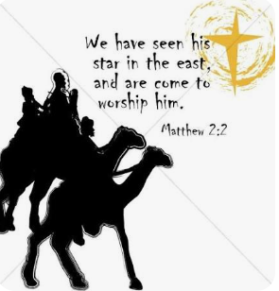 | John 1:1-18  ‘The Word became flesh and dwelt among us.’ | (6th) Epiphany | Epiphany | THEME: Epiphany  Matthew 2:1-12 | During January Big School Birdwatch | Dignity of the Human person | re: Worship: Epiphany  Roots on the Web: Epiphany  Big Garden Birdwatch  Veganuary
11th January 2027  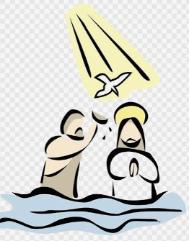 | Mark 1:7-11  ‘You are my beloved Son; with you I am well pleased.’ | (10th) the Baptism of the Lord |  | THEME: The Baptism of the Lord  Luke 3:15-16 | Whole School Mass | Stewardship | Laudato Si' animation for children
18th January 2027  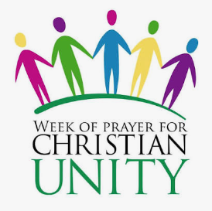 | John 1:35-42  ‘They came and saw where he was staying, and they stayed with him.’ | (20th) St Sebastian – patron saint of sport |  | THEME: Unity  John 17:20-26 | (17th) Peace Sunday  (18th -25th ) Octave of Prayer for Christian Unity | Dignity of Work | Pax Christi Peace Sunday Resources
25th January 2027   | Mark 1:14-20  ‘Repent and believe in the gospel.’ | (24th) Our Lady of Peace  (25th) The Conversion of St Paul, Apostle  (28th) St Thomas Aquinas |  | THEME: St Paul  Mark 16:15 (theme of being chosen to do God’s work) | 24th) Word of God Sunday  (27th) Holocaust Memorial Day | Rights and responsibilities | Bishop’s Conference resources: Word of God  www.caritassalford.org.uk
1st February 2027  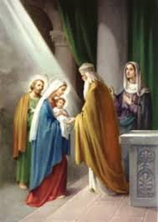 | Mark 1:21-28  ‘He taught them as one who had authority.’ | (31st) St John Bosco  (2nd) The Presentation of the Lord |  | THEME: Bury the Alleluia  Matthew 6:1-6 and 16-18 | 31st) Caritas Sunday - parish appeal | Options for the Poor | Caritas Sunday resources for schools will be available www.caritassalford.org.uk
8th February 2027  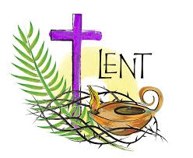 | Mark 1:29-39  ‘He healed many who were sick with various diseases.’ | (8th) St Josephine Bakhita  11th Ash Wednesday  (11th) Our Lady of Lourdes |  | THEME: Lent/St Joseph’s Penny  Matthew 25:31-46 | Lenten Friends  7th) Day for the Unemployed  (8th) Day for Victims of Trafficking  (11th) World Day for the Sick | Solidarity and the common good | St Joseph’s Penny resources, including collective worship  Young Catholics: Ash Wednesday Alliance to End Human Trafficking Feast of Saint Josephine Bakhita  Mission Together - World Day for the Sick Liturgy
22nd February 2027   | Mark 9:2-10  ‘This is my beloved Son.’ | (22nd) The Chair of St Peter |  | THEME: Lent – fasting and giving linked to options for the poor (CST)  Luke 4:16-21 | Lent Mass  Rainbow Fridays  (26th) Lent Fast Day  (27th) Women’s World Day of Prayer | Family and Community | Women’s World Day of Prayer
1st March 2027  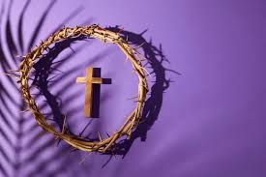 | John 2:13-25  ‘Destroy this temple, and in three days I will raise it up.’ | (1^{st)} St David |  | THEME: CST – Dignity of the Human person  Luke 10: 25-37 – The Good Samaritan | LENT prayer Stations | Dignity of the Human person | Catholic Social Teaching pack for children
8th March 2027 | John 3:14-21  ‘God sent his Son in order that the world might be saved through him.’ | (8th) St John of God |  | THEME: God’s love for the world  John 3:14-21 | (8th) International Women’s Day  (12th -19th) Dementia Prayer Week | Stewardship | Catholic Social Teaching pack for children  IWD: When is International Women's Day (IWD)?
15th March 2027  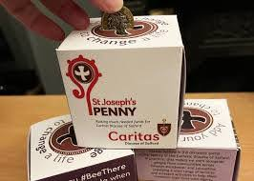 | John 12:20-33  ‘If a grain of wheat falls into the earth and dies, it bears much fruit.’ | (17th) St Patrick  (19th) St Joseph |  | THEME: St Patrick  Matthew 28:16-20 | Mass for the Feast of St Patrick | Dignity of Work | Catholic Social Teaching pack for children
22nd March 2027  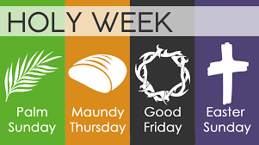 | Procession: Mark 11:1-10  ‘Blessed is he who comes in the name of the Lord!’  Mass: Mark 14:1-15:47  The Passion of our Lord Jesus Christ. | Palm Sunday of the Passion of the Lord  (24th) St Oscar Romero  (25th) The Annunciation of the Lord |  | THEME: St Oscar Romero  Matthew 5:1-12 - The Beatitudes – link to the sacrifice Jesus made during this Holy Week. | Stations of the Cross led by GIFT Team | Rights and responsibilities | Young Catholics: Palm Sunday  The God Who Speaks: Lent and Easter  Mission Together: Holy Week and Easter  St Oscar Romero Prayers: Cafod  Archbishop Romero Trust Prayers and Liturgies

SUMMER
W/C and theme | Sunday Gospel/Liturgical Year | Catholic Feast Days | Assembly focus - SLT | Celebration of the Word - CT | Events this week | CST Focus | CPD/RESOURCES
12th April 2027  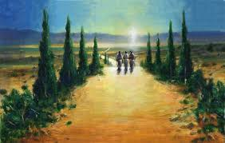 | Luke 24:35-48  ‘Thus it is written, that the Christ should suffer and on the third day rise from the dead.’ | (13th) St Martin  (16th) St Bernadette |  | THEME: The Resurrection  John 20:1-9 |  | Options for the Poor | Catholic Social Teaching pack for children
19th April 2027  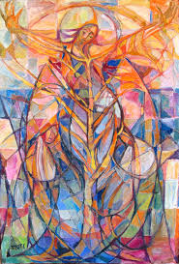 | John 10:11-18  ‘The good shepherd lays down his life for the sheep.’ | (23rd) St George  (25^{th)} St Mark |  | THEME: The Road to Emmaus  Luke 24:13-35 | 18th) World Day of Prayer for  Vocations | Solidarity and the common good | Catholic Social Teaching pack for children  Home - World Day of Prayer for Vocations
26th April 2027  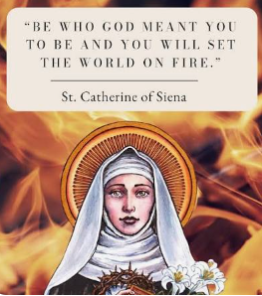 | John 15:1-8  ‘Whoever abides in me and I in him, he it is that bears much fruit.’ | (29th) St Catherine of Siena  (1st) St Joseph the Worker. |  | THEME: St Catherine of Siena  Matthew 5:13-16 |  | Family and Community | Catholic Social Teaching pack for children  Celebrate St. Catherine of Siena - Teaching Catholic Kids
3rd May 2027  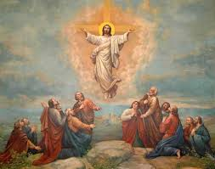 | John 15:9-17  ‘Greater love has no one than this, that someone lay down his life for his friends.’ | (3rd) Ss Philip and James, Apostles  (4th) The English Martyrs  (6th) The Ascension of the Lord |  | THEME: The Ascension  Luke 24:46-53 | Crowning of Our Lady  May - Mary’s month  No Mow May  (4th-10th) Deaf Awareness Week  (9th) World Communications Day | Dignity of the Human person | Plantlife: No Mow May  Resources Deaf Awareness
10th May 2027  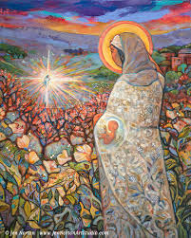 | John 17:11b-19  ‘May they be one, even as we are one.’ | (10th) St Damien of Molokai  (13th) Our Lady of Fatima |  | THEME: Mary our Mother  Luke 1:26-38 |  | Stewardship | St. Damien of Molokai: A saint for the forgotten and abandoned - Teaching Catholic Kids
17th May 2027  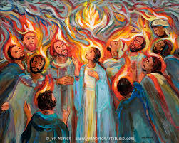 | John 15:26-27; 16:12-15  ‘The Spirit of truth will guide you into all the truth.’ | Pentecost |  | THEME: Gifts of the Spirit  Galatians 5:22-25 | 17th) Blessed Virgin Mary, Mother of the Church  (20th) World Bee Day | Dignity of Work | Cafod Pentecost prayers  Traditional Prayers to the Holy Spirit: Liturgy Office  The God Who Speaks: Pentecost  British BeeKeepers Association: Events  UN World Bee Day
24th May 2027   | Matthew 28:16-20  ‘Baptise them in the name of the Father and of the Son and of the Holy Spirit.’ | (23rd) The Most Holy Trinity  (25th) St Bede the Venerable  (27th) St Augustine |  | THEME: Catholic Social Teaching – rights and responsibilities  Matthew 25:14-30 | 17th - 21st May: Walk to school week | Rights and responsibilities | Catholic Social Teaching pack for children
7th June 2027  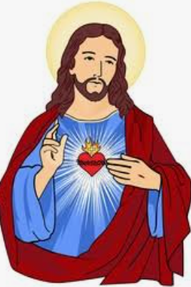 | Mark 3:20-35  ‘Satan is coming to an end.’ | (13th) St Anthony of Padua |  | THEME: Trust in God  2 Corinthians 5:7 |  | Dignity of the Human person | Catholic Social Teaching pack for children
14th June 2027   | Mark 4:26-34  ‘The smallest of all the seeds on earth becomes larger than all the garden plants.’ | (20th) St Helena |  | THEME: Stewardship  Genesis 2:15 |  | Stewardship | Catholic Social Teaching pack for children
21st June 2027   | Mark 4:35-41  ‘Who is this, that even the wind and the sea obey him?’ | (22nd): Ss John Fisher and Thomas More  (24th) The Birthday of St John the Baptist |  | THEME:  Jesus calms the storm  Mark 4:35-41 | (21st) Day for Life | Dignity of Work | Bishops Conference: Day for Life
28th June 2027  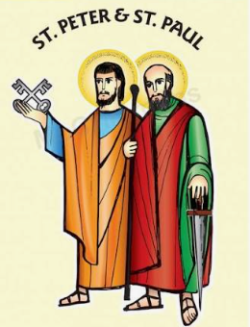 | Mark 5:21-43  ‘Little girl, I say to you, arise.’ | (29th) SS Peter and Paul  (3rd) St Thomas, Apostle |  | THEME: St Peter and St Paul  Matthew 16:13-19 | Mass for St Peter and Paul | Rights and responsibilities | Saints Peter and Paul Celebration of the word: Cafod  Mission Together St Peter and St Paul
5th July 2027   | Mark 6:1-6  ‘A prophet is not without honour, except in his home town.’ | 6th – St Maria Goretti |  | THEME: be courageous  Matthew 14: 22-33 | Plastic Free July | Stewardship | Plastic Free July
12th July 2027  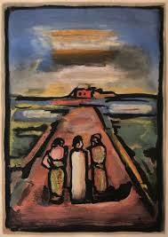 | Mark 6:7-13  ‘He began to send them out.’ | (11th) St Benedict  (14th) St Kateri Tekakwitha, patron saint of ecology |  | THEME: Go forth  Matthew 28:16-20 | Leavers Assembly and Leaver’s Masses | Rights and responsibilities

Weekly Prayer and Liturgy timetable
Monday | WHOLE SCHOOL FAITH ASSEMBLY | SLT
Tuesday | CLASS CELEBRATION OF THE WORD – timetabled | Class teachers/Pupils/Gift team
Wednesday | HYMN PRACTICE  WHOLE SCHOOL CELEBRATION OF THE WORD – parents invited | RE lead  SLT/Gift Team
Thursday | BIBLE STUDY – GIFT Team | RE Lead/P&L lead and Gift Team
Friday | WHOLE SCHOOL CELEBRATION ASSEMBLY - parents invited | SLT
Regular opportunities for the GIFT Team to lead activities during the liturgical year – this to include open chapel time at lunchtimes, leading prayer trails in Advent and Lent, leading the Rosary in October – leading and supporting with Celebration of the Word and masses.
Masses are timetabled with Father Paul during the year.

HYMNS
ORDINARY TIME | ADVENT | CHRISTMAS | LENT | MAY | EASTER-PENTECOST
- I will be with you  - All that I am  - Let there be love  - Be still for the presence of the Lord  - Laudato Si  - My God loves me  - This is my will, my one command  - Holy forever  - How great is our God  - Here I am Lord  - Christ be beside me  - Do not be afraid  - Be not afraid  - A new commandment  - Jesus remember me  - Bind us together  - One bread, one body | - My soul is filed with joy  - Christ be our Light  - Prepare the way  - The Angel Gabriel  - Mary did you know?  - O come O come Emmanuel | - Away in a manger  - Silent night  - It was on a starry night  - We three kings  - O little town of Bethlehem  - Love shone down  - Go tell it on the mountain  - Mary had a baby  - While shepherds watched | - From heaven you came  - Were you there?  - Be still and know that I am God | - As I kneel before you  - Bring flowers of the rarest  - Hail Mary…  - My soul is filled with joy  - Gentle woman | - Give me joy  - Alleluia, Alleluia  - This is the day  - Lord of the dance  - The Spirit lives to set us free

