
RAINOW LONG TERM CURRICULUM PLAN
CLASS 1
 | AUTUMN TERM |  | SPRING TERM |  | SUMMER TERM
 | Autumn 1 | Autumn 2 | Spring 1 | Spring 2 | Summer 1 | Summer 2
ENGLISH  Key text and outcomes  Literacy Counts | The Naughty Bus  - Narrative  - Instructions |  | The Last Wolf  - Narrative  - Recipes | There’s a Tiger in the Garden  - Diary  - Setting description  - Newspaper report | The Secret of Black Rock  - Postcard  - Return narrative | Where the Wild Things Are  - Letters  - Poetry  - Speech bubbles
MATHS  WRM planning | Place value within 10  Addition and subtraction within 10  Geometry (shape) |  | Addition and subtraction within 20  Place value within 50  Length and height  Mass and volume |  | Multiplication and division  Fractions  Geometry (position and direction)  Place value within 100  Money  Time
SCIENCE | Animals, including humans | Animals, including humans | Everyday Materials |  | Plants | Revision
SCIENCE | Seasonal Changes (throughout the year)
GEOGRAPHY | THE NAUGHTY BUS  (Geography – directions/map use) |  | OUR LOCAL AREA  (Geog/hist of local area) |  | TOYS / COMING TO ENGLAND  (Comparison to small area in Trinidad)
HISTORY
ART | Drawing |  | Colour |  | Sculpture
DT  Projects on a Page | Templates and joining |  | Freestanding structures |  | Preparing fruit and veg
COMPUTING | Technology around us | Digital painting | Moving a robot | Grouping data | Digital writing | Programming animations
MUSIC | Fireworks and Fantasy | Christmas Show | Changes |  | Blast Off!
PE | Gymnastics  Invasion | Gymnastics  Invasion | Fitness  Net and wall | Tennis  Striking and Fielding | Athletics  Dance | Striking and fielding  Dance
MFL | STORY AND/OR SONG (per term)
RE | CHRISTIANITY  What do many Christians believe about God? What do different religions believe about creation? | CHRISTIANITY  How do people celebrate special times? (Christmas) | FREE CHOICE  How do people decide what is right and wrong? | CHRISTIANITY  How does a celebration bring a community together? (Easter) | CHRISTIANITY  What do different Christians mean by the word church? | JUDAISM  What do Jewish people remember on Shabbat?
PSHE | RELATIONSHIPS |  | HEALTH & WELLBEING |  | LIVING IN THE WIDER WORLD
RSE | DIFFERENT FRIENDS |  | GROWING AND CHANGING |  | FAMILIES AND CARE
SEMH  (Mind Up) | GETTING FOCUSED |  | SHARPENING YOUR SENSES |  | ALL ABOUT ATTITUDE / TAKING ACTION MINDFULLY
No Outsiders | Elmer | Going to the Volcano | Want To Play Trucks? | Hairs, It’s a Family Affair | My World, Your World | Errol’s Garden
CORE LEARNING VALUES | 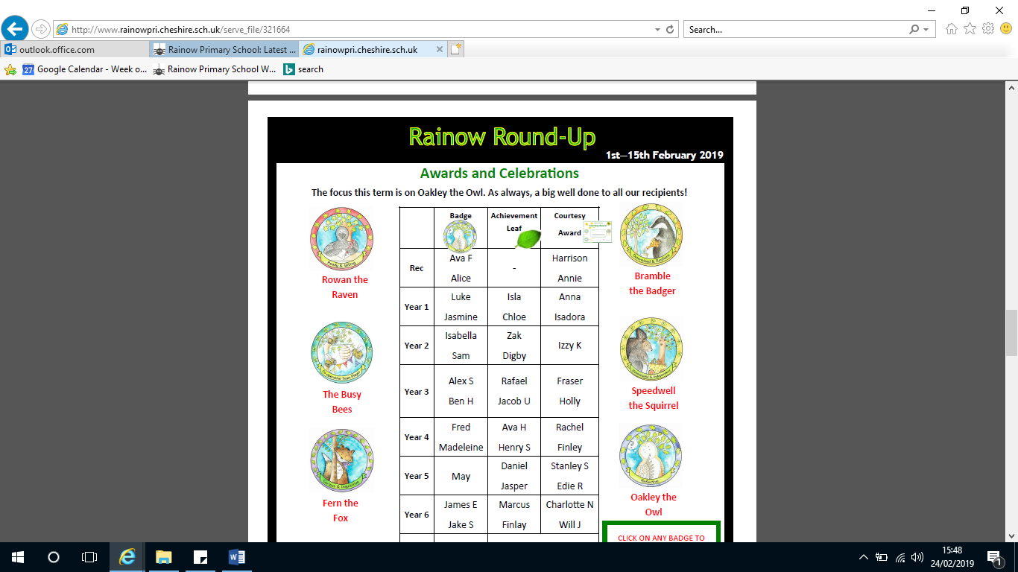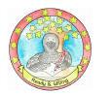
ENRICHMENT  Visits/trips | Christmas Topic  Christmas Nativity  Children in Need  Harvest  Bonfire night  Remembrance day  Anti-bullying week |  | Theatre trip  STEM week  World Book Day |  | Sports day  KS1 singing concert
OUTDOOR LEARNING | White Nancy Walk  Well-being focus (particularly first term)  Animals in the outdoor environment |  | Seasonal changes (Science) - learning about weather and changes  Walk around Rainow (local history) |  | Aerial views, map drawings of the school and surrounding area  Explore/ walk Rainow area (Geography)  Woodland walk  Observe plants/trees in or local area (Science)
SIGNIFICANT INDIVIDUALS  (Humanities)  (Science) | Guy Fawkes  Moina Belle Michael  Joan Beauchamp Procter  Jane Goodall |  | Charles Roe (Silk industry)  Charles Macintosh  George James Symons |  | Wangari Maathai

