
RAINOW LONG TERM CURRICULUM PLAN
CLASS 3
 | AUTUMN TERM |  | SPRING TERM |  |  | SUMMER TERM
 | Autumn 1 | Autumn 2 | Spring 1 |  | Spring 2 | Summer 1 | Summer 2
ENGLISH  Key text and outcomes | Fox  - Information Report | Dear Earth  An environment letter | Seen Not Heard  Character narrative |  | Rhythm of the Rain  Information Leaflet | The Iron Man  Approaching Threat Narrative | Egyptology  Mystery Narrative
MATHS  WRM planning | Place Value  Addition and subtraction  Multiplication and Division |  | Multiplication and division  Money  Statistics  Length and perimeter  Fractions |  |  | Fractions  Time  Properties of shape  Mass and capacity
SCIENCE | Animals including humans | Light | Forces and magnets |  | Rocks and fossils | Plants | Working scientifically
GEOGRAPHY | Linked to history  How has the landscape and land use of the United Kingdom changed over time? |  | Linked to history  Is the United Kingdom the same all over? |  |  | Linked to history  What do the locations of the earliest settlements in the UK and global civilizations have in common?  Are all coasts the same in the UK?
HISTORY | Stone Age |  | Bronze Age to Iron Age |  |  | Ancient Civilisation Overview  Ancient Egyptians Study
ART | Drawing |  | Colour |  |  | Sculpture
DT | Healthy and varied diet |  | Leavers and linkages |  |  | 2D to 3D shape
COMPUTING | Connecting Computers  Stop-Frame Information |  | Sequencing Sounds  Branching Databases |  |  | Desktop Publishing  Events and Actions in programs
MUSIC | Sporting Anthems unit LMT  Christmas Singing and performing-School Play |  | Peter and the Wolf Unit LMT |  |  | Learn an instrument-recorder
PE | Swimming  Rugby | Swimming  Rugby |  | Swimming  Dance |  | Swimming  Gymnastics | Swimming  Gymnastics
MFL | Getting to Know You |  | All About Me  Numbers 1-20  Food Glorious Food |  |  | All Around Town
RE | Why is the concept of God important to most Jewish people and Christians?  Why do Christians call Jesus saviour at Christmas? |  | What does it mean to be religious according to most Muslims?  Why do Christians call the day Jesus died Good Friday? |  |  | How do people show they belong to a community?  Do all Jewish groups mark important events in the same way?
PSHE | RELATIONSHIPS  TEAM  How can we be a good friend? | RELATIONSHIPS  BE YOURSELF  How can I express myself? | HEALTH AND WELLBEING  SAFETY FIRST  How can we keep safe in our local area? |  |  | LIVING IN THE WIDER WORLD  MONEY MATTERS  How can we manage money? | LIVING IN THE WIDER WORLD  AIM HIGHER  What are my goals and aspirations?
RSE | Body Differences |  | Personal Space |  |  | Help and Support
NO OUTSIDERS  (Diversity) | To understand what discrimination means  ‘This is Our House’ | To understand what a bystander is  ‘We’re All Wonders’ | To be welcoming  ‘Beegu’ |  | To recognise a stereotype  ‘The Truth About Old People’ | To recognise and help and outsider  ‘The Hueys in the New Jumper | To consider living in Britain today  ‘Planet Omar: Accidental Trouble Magnet’
SEMH | UNIT 1 GETTING FOCUSED | UNIT 1 GETTING FOCUSED | UNIT 2 SHARPENING YOUR SENSES |  | UNIT 2 SHARPENING YOUR SENSES | UNIT 3 ALL ABOUT ATTITUDE | UNIT 4 TAKING ACTION MINDFULLY
CORE LEARNING VALUES | 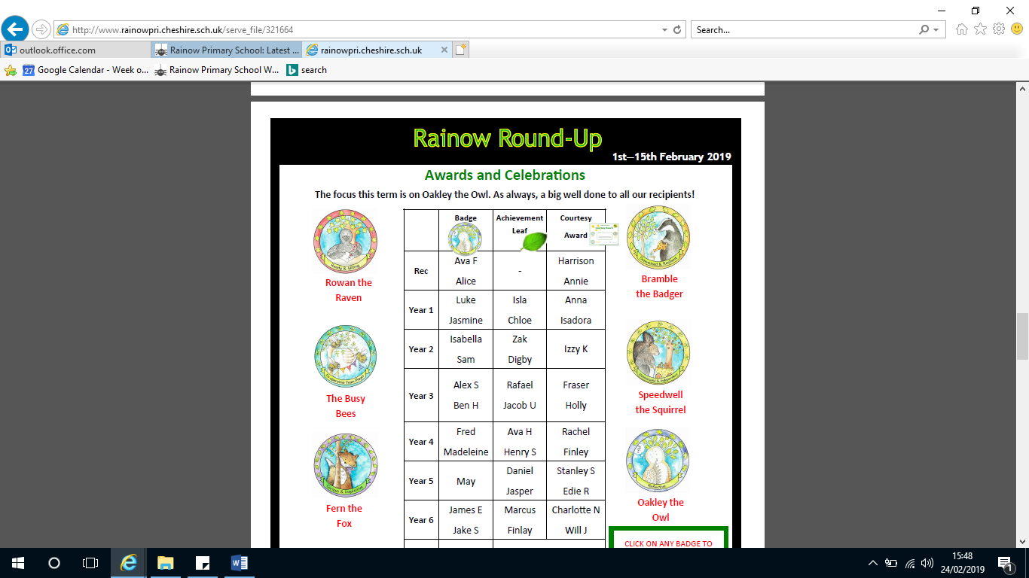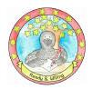
ENRICHMENT  Visits/trips | Christmas Nativity  Children in Need  Harvest  Bonfire night  Remembrance day  Anti-bullying week  Christmas pantomime |  | New Vic Theatre  RE Week  STEM Week  World Book Day  Sports/ Comic relief  International Women’s Day |  |  | residential  Sports day
OUTDOOR LEARNING | Woodland wellbeing week  Woodland School: Outdoor Relationships, Knowledge & Skills  (Mrs De R) |  | Map work – local environment  Woodland School: Outdoor Relationships, Knowledge & Skills  (Mrs De R) |  |  | Fieldwork – map sketching  Riverside walk  Water wheel experiment  Painting ‘en plein air’  Woodland School: Outdoor Relationships, Knowledge & Skills  (Mrs De R)
SIGNIFICANT INDIVIDUALS | Scientists-Wilhelm Conrad Rontgen-Animals  Justus von Liebig- Light  Art – Le Corbusier |  | Scientists-Michael Faraday Forces  Mary Anning and Holly Betts-Rocks |  |  | Scientists-Joseph Dalton Hooker and Monique Simmonds-Plants

