Instructions for Booking your Appointment for Parents’ Evening

You will already have received your user-id and password via pupil post. Enter www.rainowpri.cheshire.sch.uk and click on the PARENT LOGIN option shown below.

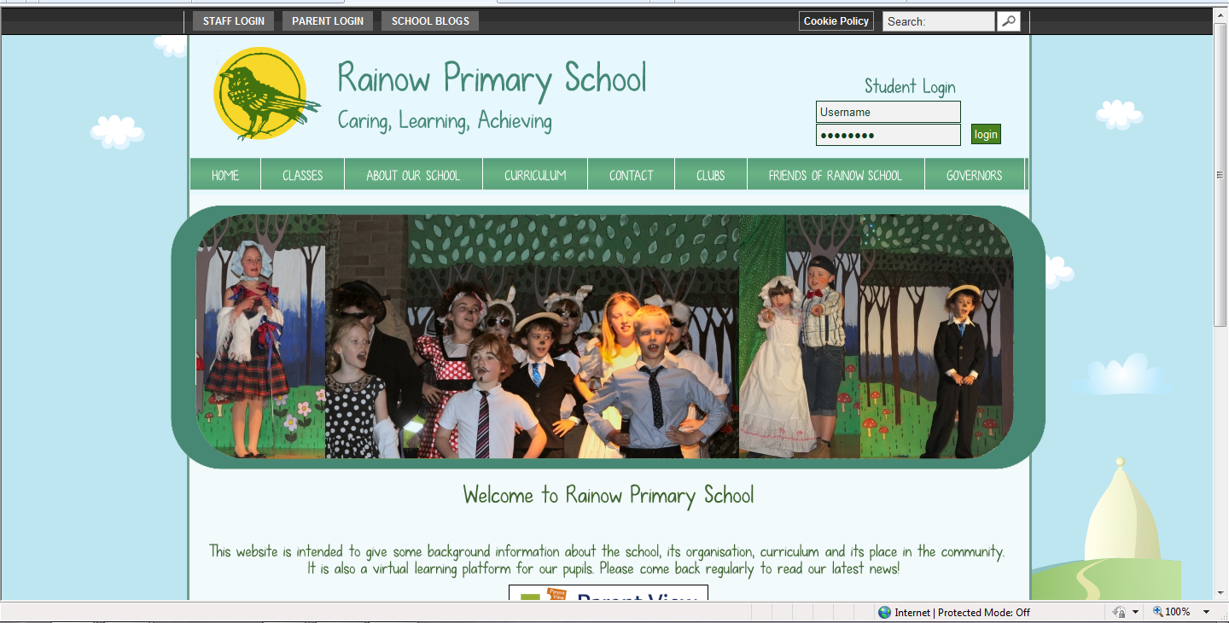
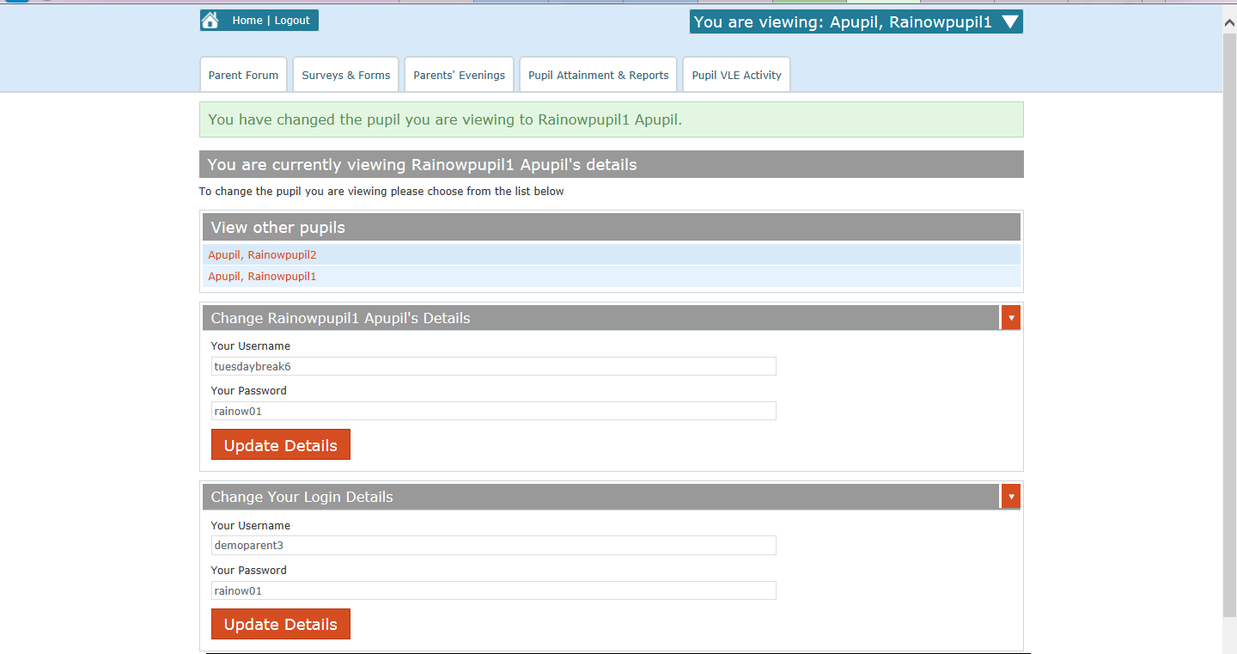
You will then be presented with the screen below which will list all the pupils you are associated with. Click on the Parents’ Evenings option

You will then see the screen below. The blue drop down box will show which child you are making an appointment for.
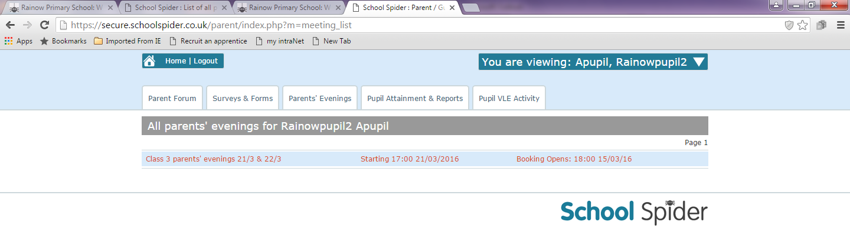
Please note that the view you see relates to this child only.

Click on the parents’ evening link as shown above in red. PLEASE NOTE THAT THIS LINK WILL NOT BE AVAILABLE UNTIL 6PM ON SEPTEMBER 28TH.

You will then see the screen below. Please note that there has been a change since the Autumn term, and there is now just one parents’ evening link for each class which will include all the appointments for both evenings. (To find available slots for the second evening, simply scroll down on the screen below).
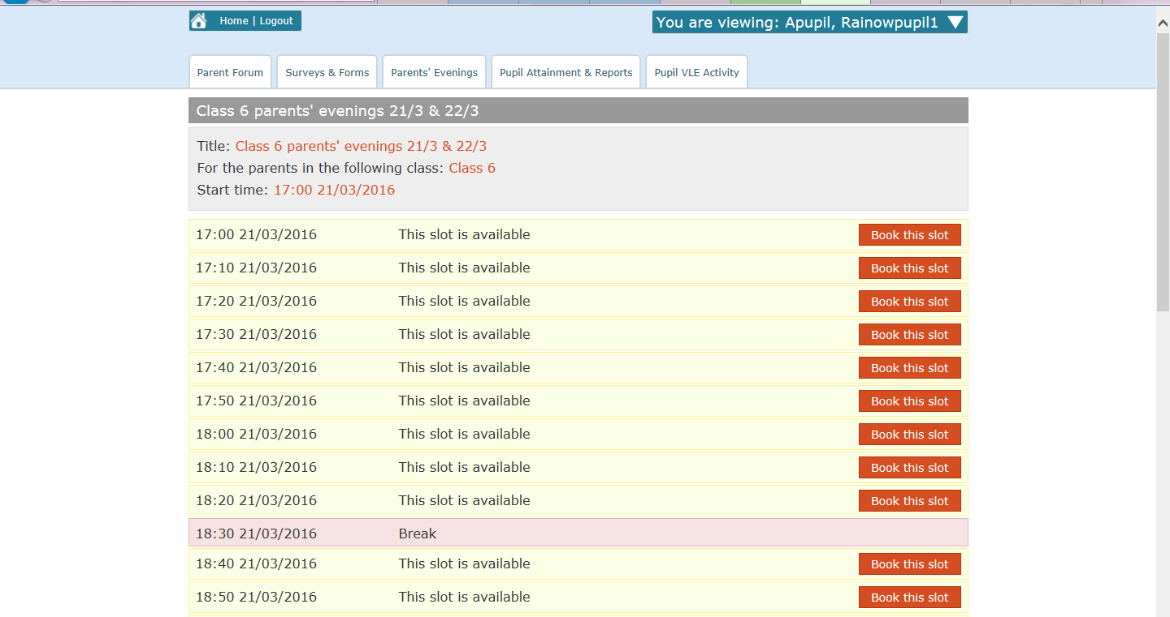
All available slots are show in red and you can select your preferred time by clicking on the relevant red slot box.

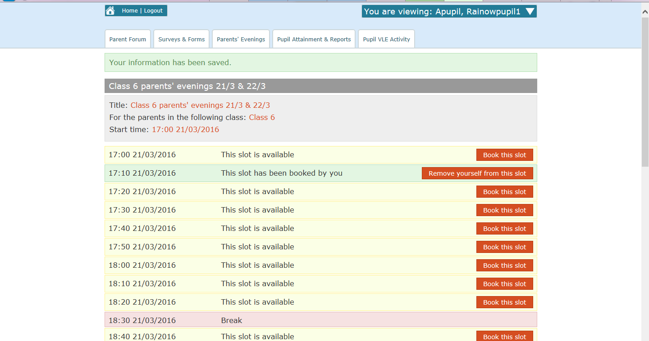
Once you have booked your slot you will see the screen below. If you have more than one child in school please click on the white arrow in the blue drop down box to select a sibling and repeat the process from the top of page 2.

As shown in the screen above, the slot has been booked and once you have finished booking your appointment times you can log out of the system.

Please note that the system will not send you email confirmation of your appointment time, however you can check this at any point by simply logging back into the system as shown above.

