YEAR 4 CURRICULUM OVERVIEW

NORTH WALKDEN PRIMARY SCHOOL

 | AUTUMN 1 | AUTUMN 2 |  | SPRING 1 | SPRING 2 |  | SUMMER 1 | SUMMER 2
ENGLISH  Core texts | The story of Tutankhamun  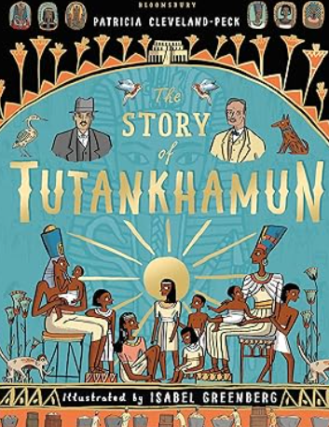  Non-fiction texts about Ancient Egyptian life  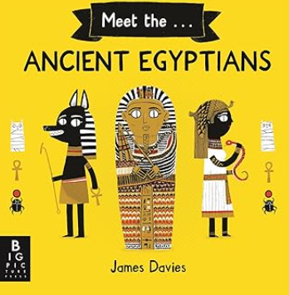 |  | There’s a rang-tan in my bedroom  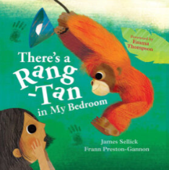  The Emerald Forest  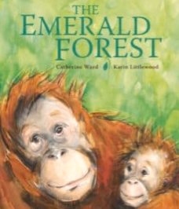  The Great Kapok Tree The Great Kapok Tree  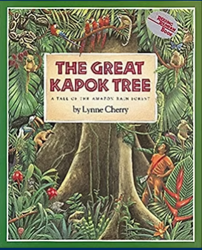 | The Deadman’s Cove  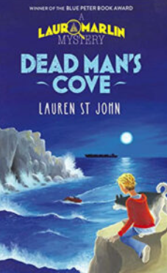  The Old Mill by Pie Corbett  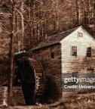  The Lighthouse film clip on Literacy Shed  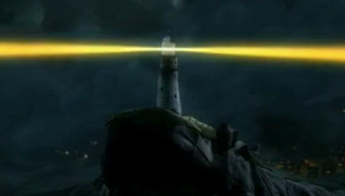 |  | The Stroodle Text by Jane Considine  .  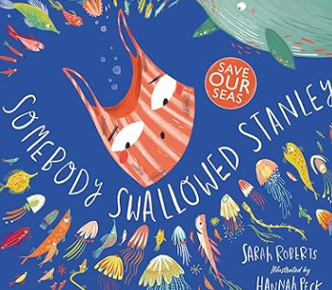  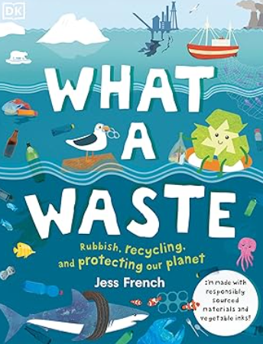  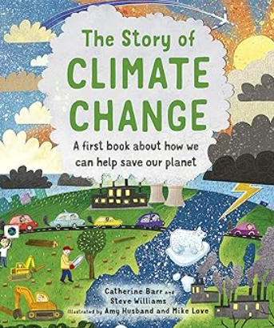 | The River  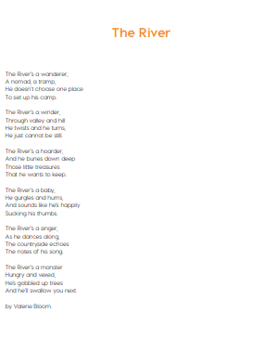  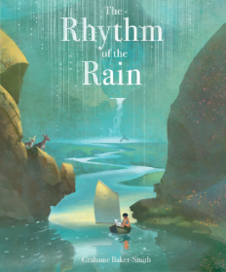  Journey of a river - film clip | 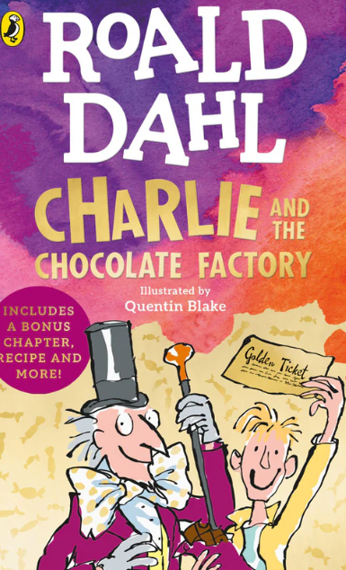  Charlie and the chocolate factory  Film clip to show when Charlie finds the golden ticket    How is chocolate made?  
Writing genre covered throughout the year | Descriptions, instructions, recounts, narratives, informative, poetry, explanations, diary, advert

MATHS
Programme of study (Statutory requirements)- Most children will
Data  - interpret and present discrete data using bar charts and continuous data using line graphs  - solve comparison, sum and difference problems using information presented in bar charts, pictograms, tables and simple line graphs.  - Measures  - convert between different units of measure (e.g. kilometre to metre; hour to minute)  - measure and calculate the perimeter of a rectilinear figure (including squares) in centimetres and metres  - find the area of rectilinear shapes by counting  - estimate, compare and calculate different measures, including money in pounds and pence  - read, write and convert time between analogue and digital 12 and 24-hour clocks | Number, place value, approximation and estimation  - count in multiples of 6, 7, 9, 25 and 1000  - find 1000 more or less than a given number  - count backwards through zero to include negative numbers  - recognise the place value of each digit in a four-digit number (thousands, hundreds, tens, and ones)  - order and compare numbers beyond 1000  - identify, represent and estimate numbers using different representations  - round any number to the nearest 10, 100 or 1000  - solve number and practical problems that involve all of the above and with increasingly large positive numbers  - read Roman numerals to 100 (I to C) and understand how, over time, the numeral system changed to include the concept of zero and place value.  Fractions  - count up and down in hundredths; recognise that hundredths arise when dividing an object by a hundred and dividing tenths by ten  - solve problems involving increasingly harder fractions to calculate quantities, and fractions to divide quantities, including non-unit fractions where the answer is a whole number  - identify, name and write equivalent fractions of a given fraction, including tenths and hundredths  - add and subtract fractions with the same denominator. Decimals and fractions  - recognise and write decimal equivalents of any number of tenths or hundredths  - recognise and write decimal equivalents to 1/4; 1/2; 3/4  - find the effect of dividing a one- or two-digit number by 10 and 100, identifying the value of the digits in the answer as units, tenths and hundredths  - round decimals with one decimal place to the nearest whole number  - compare numbers with the same number of decimal places up to two decimal places | Addition and subtraction  - add and subtract numbers with up  to 4 digits using the efficient written methods of columnar addition and subtraction where appropriate  - estimate and use inverse operations to check answers to a calculation  - solve addition and subtraction twostep problems in contexts, deciding which operations and methods to use and why.  Multiplication and division  - recall multiplication and division facts for multiplication tables up to 12  - use place value, known and derived facts to multiply and divide mentally, including: multiplying by 0 and 1; dividing by 1; multiplying together three numbers recognise and use factor pairs and commutativity in mental calculations  - multiply two-digit and three-digit numbers by a one-digit number using formal written layout  - solve problems involving multiplying and adding, including using the distributive law and harder multiplication problems such as which n objects are connected to m objects. | Geometry-property of shape  - compare and classify geometric shapes, including quadrilaterals and triangles, based on their properties and sizes  - identify acute and obtuse angles and compare and order angles up to two right angles by size  - identify lines of symmetry in 2-D shapes presented in different orientations  - complete a simple symmetric figure with respect to a specific line of symmetry Geometry-position, direction, motion  - describe positions on a 2-D grid as coordinates in the first quadrant  - describe movements between positions as translations of a given  unit to the left/right and up/down  - plot specified points and draw sides to complete a given polygon.

 | AUTUMN 1 | AUTUMN 2 |  | SPRING 1 | SPRING 2 | SUMMER 1 | SUMMER 2
HISTORY | How have children’s lives changed? |  |  | - British history 3: What changed in Britain after the Anglo-Saxon invasion? |  | - How did the achievements of the ancient Maya impact their society and beyond?
GEOGRAPHY |  |  | Why are rainforests important to us? |  | What are rivers and how are they used? |  | Where does our food come from?
ART | Craft & Design:  Ancient Egyptian scrolls |  |  | Drawing :  Exploring tone, texture and proportion |  | Craft & Design:  Fabric of nature
DESIGN TECHNOLOGY |  |  | Structure:  Pavilions |  | Mechanical Systems:  Making a slingshot car |  | Electrical systems:  Torches
SCIENCE | Animals, including humans:  Digestion & Food |  | Energy:  Electricity & Circuits | Materials:  States of matter | Energy:  Sounds & Vibrations | Living things:  Classification & Changing Habitats | Making connections:  How does the flow of liquids compare?
COMPUTING | Digital Literacy:  Online safety |  | Computer Science:  Coding | Computer Science:  Logo/ Microbits | Information Technology:  Making music/ animation | Information Technology:  Effective Searching/ AI | Information Technology:  Writing for different purposes
MUSIC | Rock & Roll |  | Body & Tuned Percussion  (Rainforest) | Changes in pitch, tempo & dynamics  (Rivers) | Front Row Music  Learning to play an instrument | Front Row Music  Learning to play an instrument | Front Row Music  Learning to play an instrument
RE | What does it mean to be a Hindu in Britain today? |  | How do people from religious communities celebrate key festivals? | What does it mean to be a Christian in Britain today? | Why is Jesus inspiring to some people? | Why do some people think that life is like a journey and what significant experiences mark this? | What can we learn from religions about deciding what is right and wrong?
PSHE | Family & Relationships |  | Family & Relationships  Health & Wellbeing | Health & Wellbeing  Safety & the Changing Body | Safety & the Changing Body | Citizenship | Citizenship  Economic wellbeing  Transition
PE | Invasion games |  | Dance | Gym  Swimming | Net and wall games  Swimming | Strike and field games  Swimming |  | Athletics  Swimming
MODERN FOREIGN LANGUAGES – FRENCH  Language Angels Scheme of Work | - Les Couleurs (Colours)  - Les Nombres (Numbers)  - Les Jours (Days of the Week)  - Les Mois (Months of the Year)  - Le Phonetique (Phonics and Pronunciation) Lesson 1 and 2 |  | Intermediate  Language Teaching:  Je me Presente | Intermediate  Language Teaching:  La Famille | Intermediate  Language Teaching: En Classe | Intermediate  Language:  Teaching:  As-tu U  animal? |  | Intermediate Language  Teaching:  Au salon de the

