Key Knowledge: Can show using diagrams the movement of the Earth and moon. Can explain the rotation of the Earth and how this causes night and day. Can explain evidence gathered about the position of shadows in terms of movement of the Earth. Can explain how a sundial works. Can explain why we have time zones.

Knowledge Organiser-
Year 5: Earth and Space

rnnh
The Solar System
VOCABULARY
planets- celestial body moving in an elliptical orbit round a star
celestial- positioned in the sky, or outer space as observed in astronomy.
spherical- shaped like a sphere.
Solar System- collection of eight planets and their moons in orbit around the sun, together with smaller bodies in the form of asteroids, meteoroids, and comets.
rotates- move or cause to move in a circle round an axis or centre.
galaxy- a system of millions or billions of stars, together with gas and dust, held together by gravitational attraction.
hemisphere- half of the Earth, usually divided into Northern and Southern.
orbit- curved path of celestial object or spacecraft round a star, planet or moon.
lunar- determined by or resembling the moon.
revolve- move in a circle on a central axis.

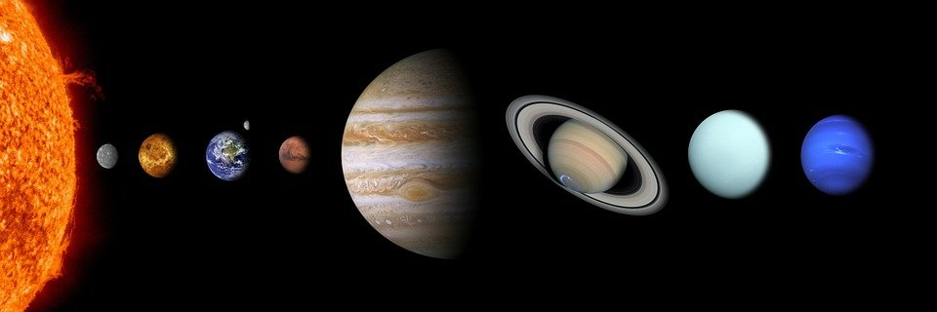

Sun Mercury Venus Earth Mars Jupiter Saturn Uranus Neptune

Rocky planets- Mercury, Venus, Earth and Mars
Gas Giants- Jupiter, Saturn, Uranus, Neptune
Pluto is no longer classed as a planet due to its size.

Here are some examples of each.
Planet, Star, Moon.
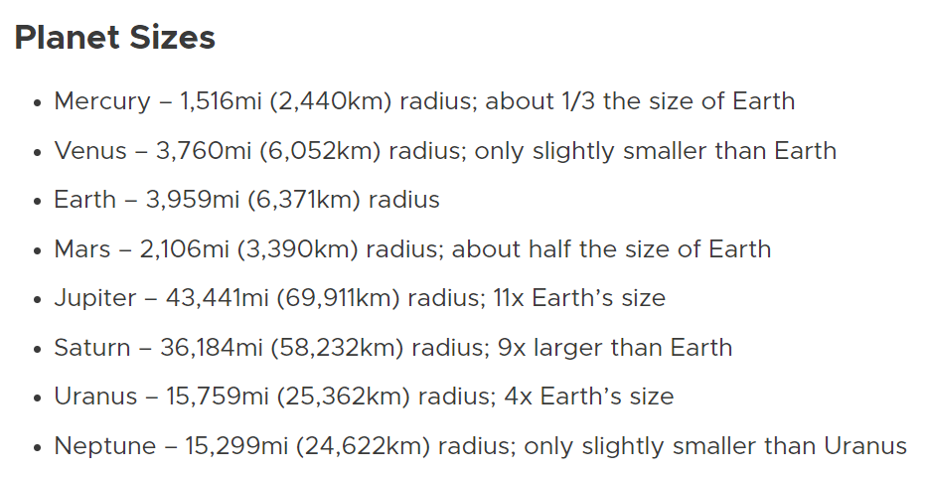
Planet | Star | Moon
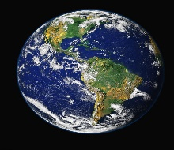  Earth  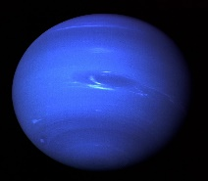  Neptune | 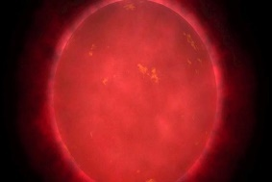  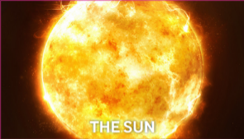  VY Canis Majoris | 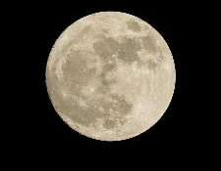  Moon  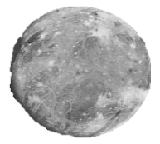  Ganymede









Year 5- Earth and Space
Moon Phases

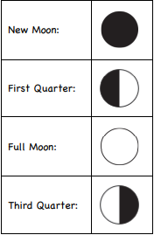
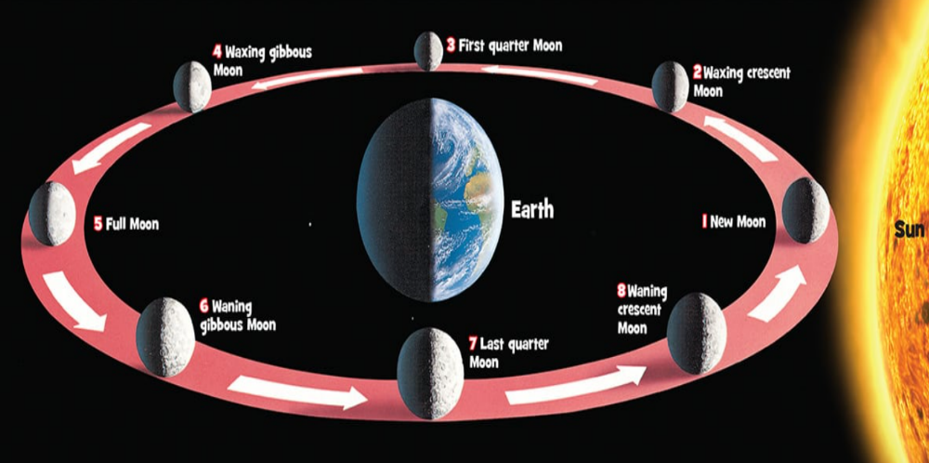
Facts
-One million Earths could fit inside the sun- and the sun is considered an average-size star.
-Comets are leftovers from the creation of our Solar System 4.5 billion years ago- they consist of sand, ice and carbon dioxide.
-There are more stars in the universe than grains of sand on all the beaches on Earth. That’s at least a billion trillion.
-The sunset on Mars appears blue.

The Moon has no light of its own. Moonlight is sunlight reflecting off the Moon’s surface. As the Moon orbits the Earth the sun lights up whatever side of the Moon is facing it.

The moon takes 27.322 days to orbit the Earth. Some sources quote 27 days and other 28 days.
Day and Night



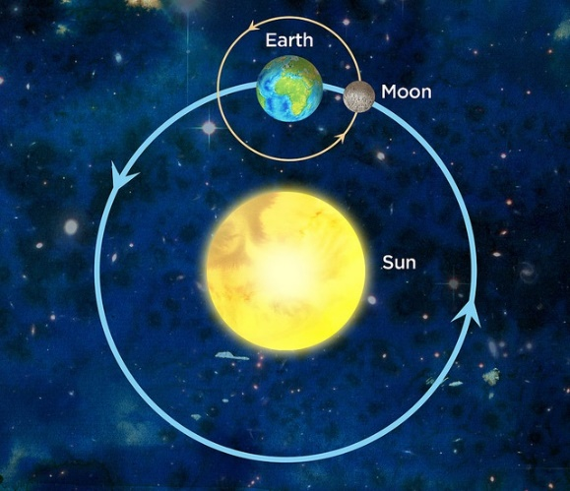
First human being to travel into space. First man to orbit the planet.
Yuri Gagarin
1961-1968

First British person and first privately funded women in space. First women to visit the Mir Space station in 1991.
Helen Sharman
1963
Made 3 space walks. Apollo 11 mission. First two people to land on the moon.
Buzz Aldrin
1930-
American astronaut- the first person to walk on the moon.
Neil Armstrong
1930-2012
First British ESA astronaut. The second astronaut to bear a flag of the United Kingdom
Tim Peake
1972
Science Capital- Astronauts
The Earth rotates around the sun once every 24 hours.
The Moon rotates around the Earth once every 27.3 days (28 days).

