Prior Learning: To name living things in a range of habitats, giving key features that helped identify them. To give examples of how an environment may change both naturally and due to human impact. To use classification keys to identify unknown plants and animals.
Knowledge Organiser
Year 5: Living things and their habitats

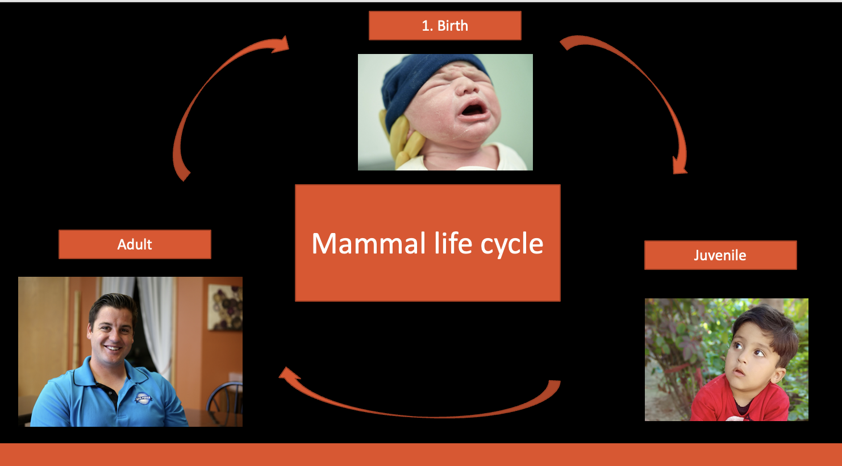
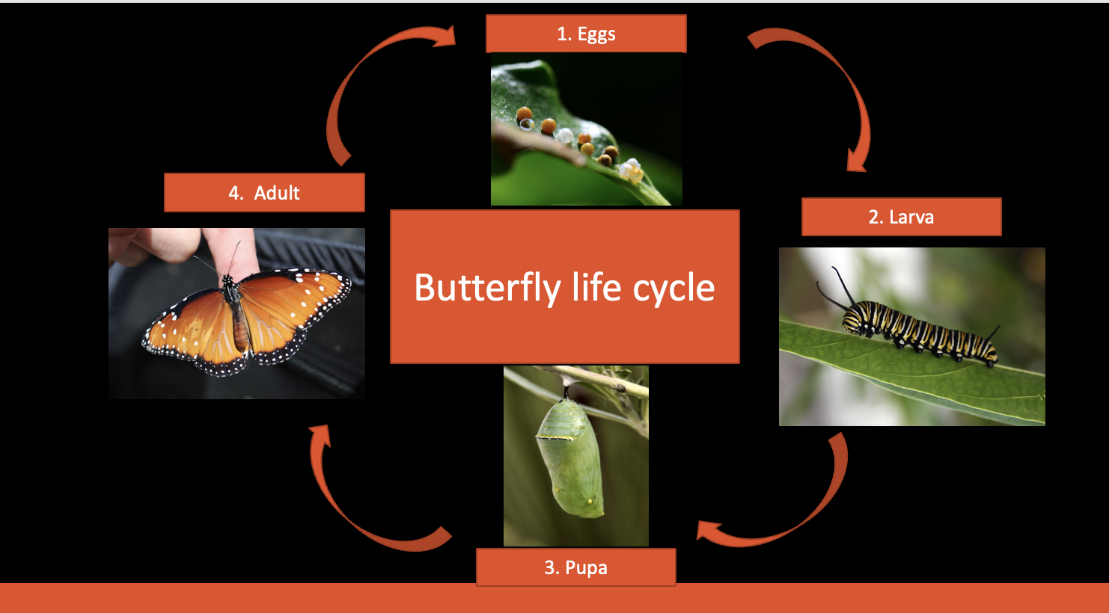
rnnh
VOCABULARY
life cycle- course of events that brings a new living thing into existence.
fertilises- to develop a new individual by introducing the male sperm to the female egg
reproduce- produce offspring by a sexual and asexual process
sexual reproduction- method of producing plants and animals in which male sperm and a female egg join
asexual reproduction- method of producing new offspring with a single parent.
sperm- male reproductive cell.
egg- female reproductive cell.
live young- when animals give birth to live offspring (do not lay eggs)
metamorphosis- to process of transformation from an immature form to an adult
gestation- the time it takes for a baby to develop inside the mother’s body.

Animal reproduction and life cycles
A life cycle is the different stages of life for a living thing. All animals, including humans, have a life cycle as all animals are born, grow, reproduce and die. In science, it’s usually displayed as a circular diagram showing each stage in words and/or pictures.
English naturalist, geologist and biologist, known for his contributions to the science of evolution. He transformed the way we understand the natural world.
He gave us an insight into diversity of life on Earth and its origins.

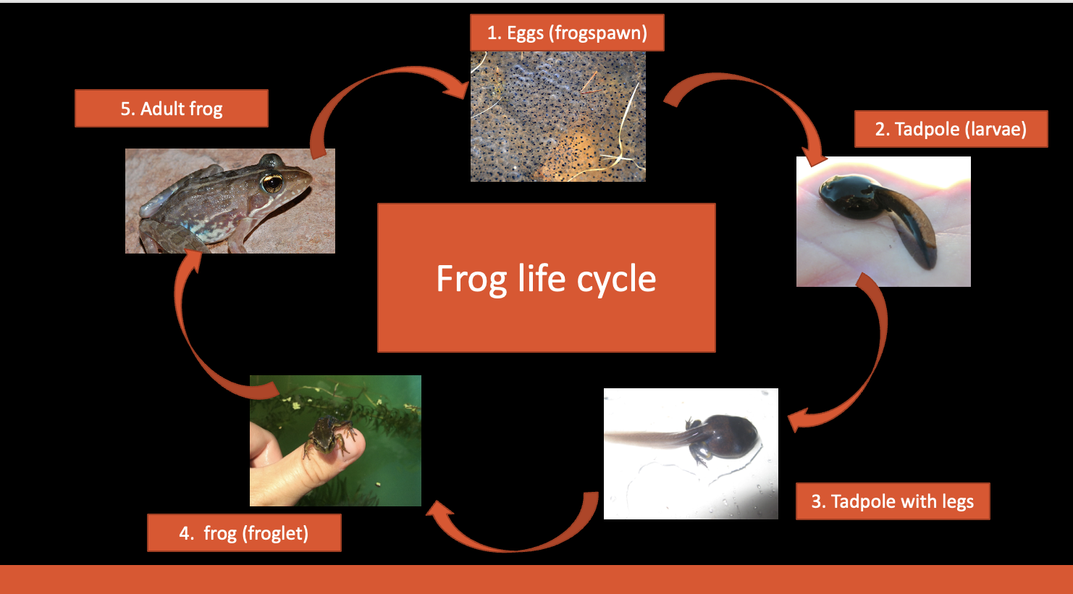

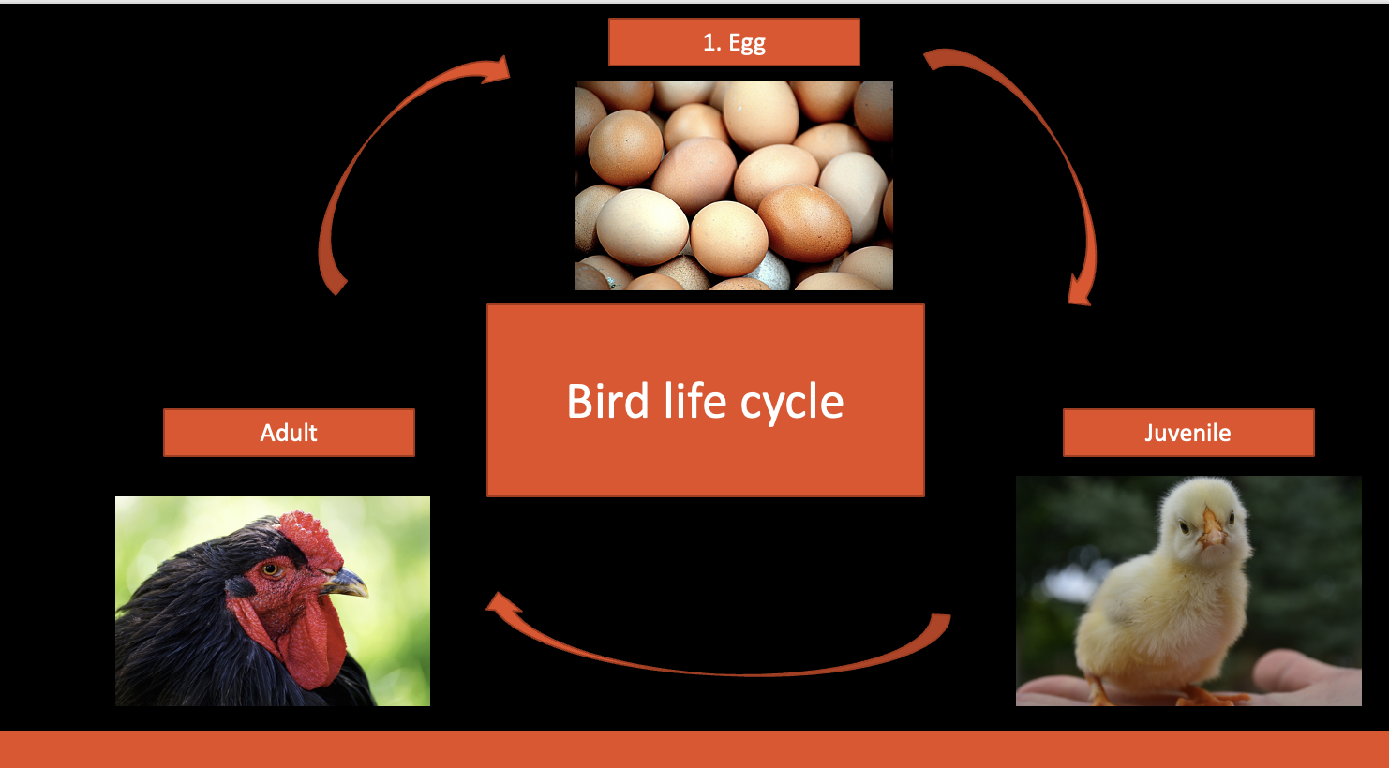

Science Capital (Scientists)

David Attenborough
1926- present
Jane Goodall
1934-present
English conservationist whose ground-breaking research on chimpanzees has shaped our understanding of what it is to be human.





English broadcaster and naturalist. Best known for his educational tv programmes.





Key Knowledge: Describe the differences in life cycles of a mammal, an amphibian, an insect and a bird. Describe the life process of reproduction in some plants and animals

Sexual reproduction in plants

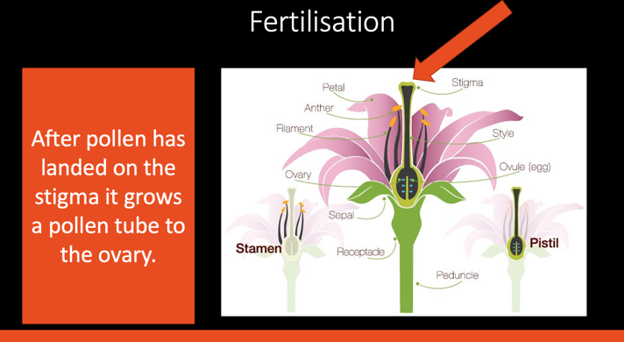
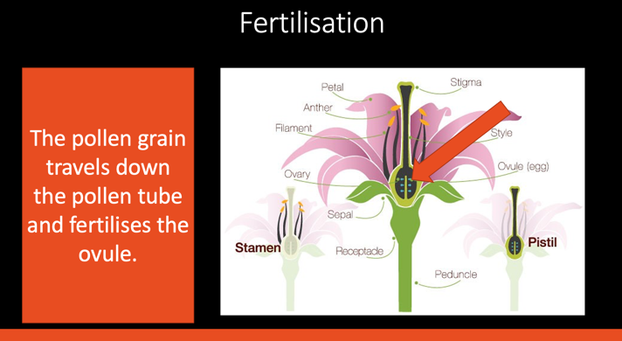
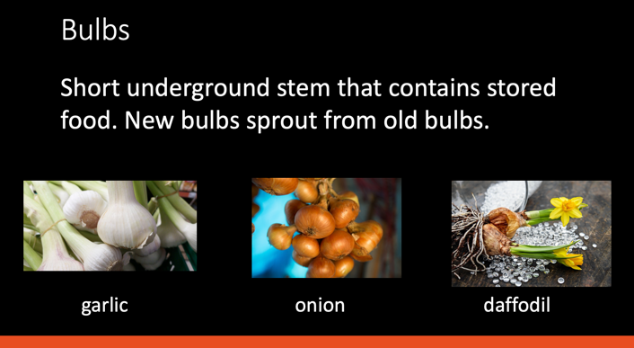





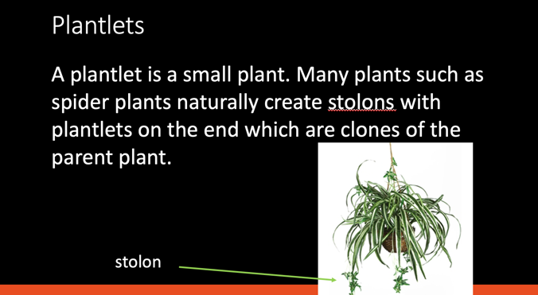
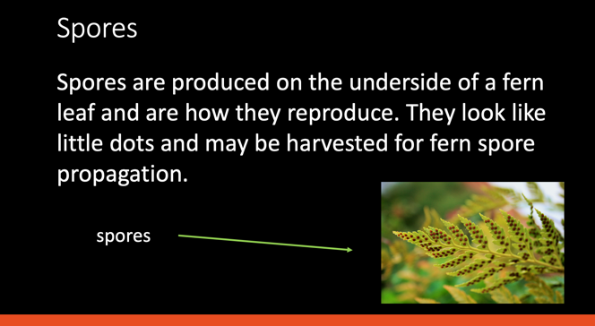
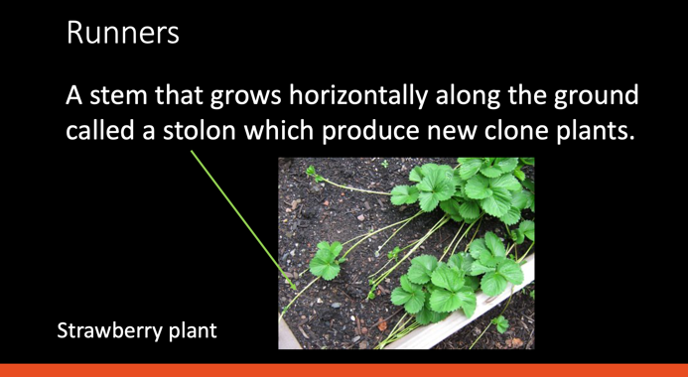
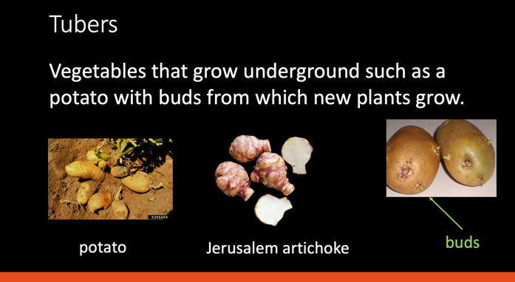
Asexual reproduction in plants

